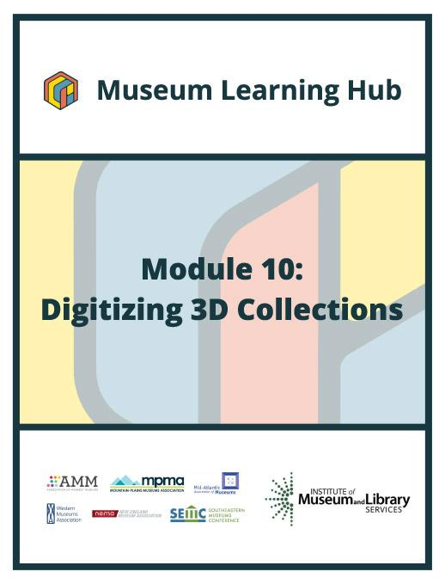

**Table of Contents**



* About This Module
* Learning Objectives
* Module Contributors
* Supplemental Resources
* Related Training

# 

# 

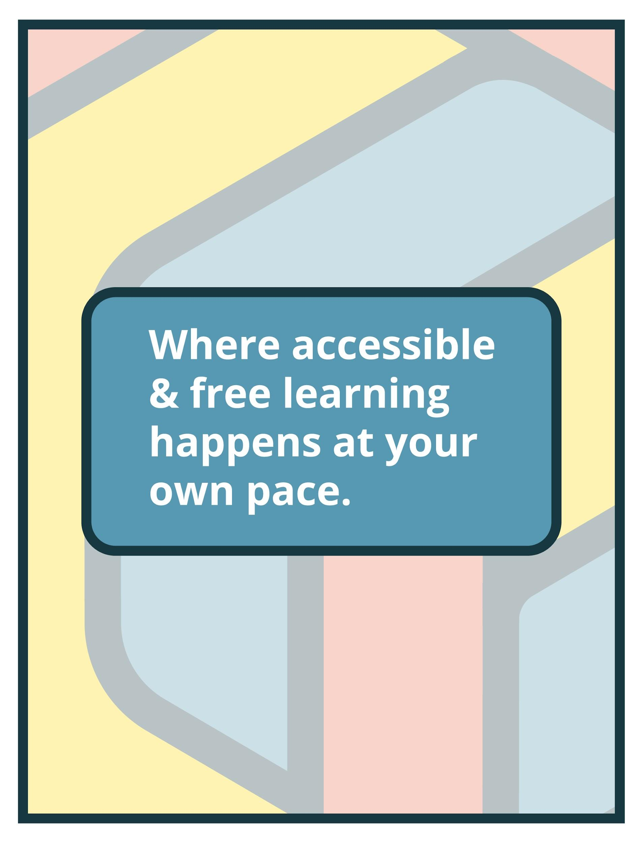

# About This Module

| **Focus Area:** | Digitizing 3D Collections |
| --- | --- |
| **Learning Level:** | Beginner, Intermediate, and Advanced |
| **Module Description:** | There are many advantages to the digitization of museum collections including making collections more accessible and providing an option for museum professionals to handle and examine replicas of fragile artifacts, aiding in long-term preservation. The first step to starting any digitization work is to scan an object. This module will focus on the particulars of scanning three-dimensional objects and volumetric spaces. |
| **Search Terms:** | Digitization, 3D Objects, Collections, Accessibility |

**Sessions found in this Module:**

| **Session 1** | Get Inspired! |
| --- | --- |
| **Technical Workshop 1** | How to Use Digital Assets for Documentation, Promotion, and Programs |
| **Technical Workshop 2** | Image Based Approaches to Documenting 3D Collections |
| **Technical Workshop 3** | 3D Data Applications in Cultural Heritage |

**The views, findings, conclusions or recommendations expressed in this series and toolkit do not necessarily represent those of the Institute of Museum and Library Services.**

# Learning Objectives

**Upon completion of this module, you will have gained the skills and practical knowledge to organize 3D digitization projects and how to scan 3D objects.**

| **Session 1: Get Inspired!** | The necessity for museums to activate, promote and share their collections in creative and innovative ways has never been greater. Digitizing museum collections makes objects accessible to a broader global audience and can also assist with long-term preservation. Tune in for the Module 10 introductory session to hear how one small museum (with an equally small staff) tackled digitization of its collections in a big way! Learn how the team at the Hutchings Museum Institute determined the ultimate purpose (and use) for 3D digitization and navigated the challenges of scanning collections of all shapes, sizes, textures and fragility with technology that fit the museum's budget. Join this session to get inspired by a small museum digitization success story! |
| --- | --- |

| **Technical Workshop 1:**  **How to Use Digital Assets for Documentation, Promotion, and Programs** | Last year the world art museums dropped 77% in attendance. At most one can see 5% of a fashion collection in a museum display and it can take years to see a specific piece. This fact should remind us we need alternatives and that we can show the world our collection if we can get it on a digital platform. Documenting historical fashion with existing softwares has been my passion and in the last year we have created a VR Fashion Museum. The Fashion Innovation Centre is creating valuable documentation of museum assets for the future. Involving students, business and community to create the digital assets. This is a new alternative of showing these garments or other historical assets in Virtual Reality, mobile and Augmented Reality. Once you have those assets you can use them in multiple ways for promotion, documentation and even schooling. Eventually, in the future these same people will come to the museums again to see the real thing.  [Visitor Figures 2020: top 100 art museums revealed as attendance drops by 77% worldwide](https://www.theartnewspaper.com/2021/03/30/visitor-figures-2020-top-100-art-museums-revealed-as-attendance-drops-by-77percent-worldwide?utm_source=pocket_mylist) |
| --- | --- |

| **Technical Workshop 2:**  **Image Based Approaches to Documenting 3D Collections** | This session will provide an overview of photography based approaches to documenting, sharing, and digitally archiving 3D collections. Examples of different techniques including Reflectance Transformation Imaging (RTI) and photogrammetry will be presented. The session will include a discussion on needed equipment, basics of image capture, and an approach to metadata and archiving for photography based documentation. |
| --- | --- |

| **Technical Workshop 3:**  **3D Data Applications in Cultural Heritage** | This webinar will review projects that cover a broad range of Cultural Heritage applications for 3D data. 3D Digitization offers a myriad of uses and technical choices. While there are no easy one-size-fits–all-solutions, the technology is only getting better and more accessible. Your use of “3D” should be driven by your organization's goals, not by the technology itself. This presentation will help clarify when and how 3D can help.  Applications reviewed will include:   * Digital Archiving of Physical Objects * Online Collections * Open Source Distribution * Object Provenance and Process Research * Digital Restoration * Mounts and Crate Design * Immersive display AR/VR * Exhibition Copies * Promotions/Engagement * Accessibility * Education |
| --- | --- |

# 

# 

# Module Contributors

**These are the experts and presenters who are involved in the development and presentation of each session, workshop, resource, and activity you find within this module.**

| **Daniela Larsen**  **Executive Director,**  **Hutchings Museum Institute**  **Saratoga Springs, Utah** | Daniela Larsen is a certified National Geographic Educator specializing in digital media and cultural diplomacy. As the Director of the Hutchings Museum Institute, she has created virtual reality experiences, 3D exhibitions, and digital knowledge banks for cultural preservation. Daniela has led expeditions to Everest Base Camp, Madagascar, Mongolia, and several other locations for educational and cultural exchange. She has implemented conservation projects in Utah, empowering participants to use technology for citizen science and impact in their local communities. She has created several online science and history programs for local schools, provided internships, and has created several opportunities for municipalities to participate in conservation and geographic education. Daniela has experienced firsthand the power of technology in allowing diverse cultures and geographies to collaborate on identifying and solving our world's issues together. |
| --- | --- |
| **Webinar(s)** | Session 1: Get Inspired! |

| **Roz McNulty**  **CLO 3D Designer, Consultant and Online course teacher**  **MOTIF.org** | Roz McNulty did her first illustration of clothing on a computer in 1983. Always a bit ahead of the curve in terms of VR, AR, digital photography and even 360 photography. Roz is a talent and teacher in the digital apparel profession; teaching CLO 3D apparel software online at Motif.org. Roz does consulting for private clients that want ‘digital doubles,’ promotional video and information on the world of 3D apparel. Roz spoke at the Electronic Visualization and Arts conference 2019 about the importance of 3D archiving for costumes using 3D apparel software. She is a past president of the local historical fashion museum and does historical fashion photography for published catalogs and web pages. Roz has developed a beta version of a VR museum of historical fashion for the Oculus headset, [www.VRfashionmuseum.com](http://www.vrfashionmuseum.com) Roz’s passion is historical fashion – in 3D. |
| --- | --- |
| **Webinar(s)** | Technical Workshop 1: How to Use Digital Assets for Documentation, Promotion, and Programs |

| **Carla Schroer**  **Co-Founder and Director**  **Cultural Heritage Imaging**  **San Francisco, California** | Carla Schroer is co-founder and director of Cultural Heritage Imaging (CHI) a non-profit corporation that develops and implements imaging technologies for cultural, historic, and artistic heritage and scientific research. Carla leads the training programs at CHI along with working on field capture projects with Reflectance Transformation Imaging and photogrammetry. She also leads CHI’s software development activities. She spent 20 years in the commercial software industry, managing and directing a wide range of software development projects. |
| --- | --- |
| **Webinar(s)** | Technical Workshop 2: Image Based Approaches to Documenting 3D Collections |

| **Marlin Lum**  **Imaging Director**  **Cultural Heritage Imaging**  **San Francisco, California** | Marlin Lum is responsible for improving digital documentation techniques and raising awareness in communities and organizations concerned with the preservation of cultural artifacts and heritage locations. By applying digital documentation techniques to the cultural heritage community, Marlin hopes to help raise the artistic standards by which museums, archaeologists, and historians document materials.  Marlin has proven abilities in digital documentation techniques and brings a unique blend of creative imaging expertise and professional photographic knowledge to CHI. He has been a creative director and imaging professional for over 10 years and has industry experience in photography, graphic design, streaming video, immersive technologies, 3D modeling, and web development in both corporate and nonprofit sectors.  Marlin graduated with a B.A. in Fine Arts and a Minor in Art History from Loyola Marymount University in Southern California and has a Masters in Fine Arts in Computer Animation and 3D modeling from the Academy of Art University in San Francisco. |
| --- | --- |
| **Webinar(s)** | Technical Workshop 2: Image Based Approaches to Documenting 3D Collections |

| **Harry Abramson**  **3D Imaging and Digital Manufacturing Consultant**  **Direct Dimensions**  **Owings Mills, Maryland** | As the director of Art Services, Harry Abramson provides project-specific workflows with 3D imaging, digital modeling and fabrication to make, document, study, conserve, and restore sculptures, monuments, historic artifacts, buildings, and antiquities. Over the course of 18 years he has helped hundreds of artists, museums, foundries, and institutions from all around the world with projects ranging in scale from insects, coins, cuneiforms and jewelry, to colossal sculptures, locomotives, and buildings. Harry earned his Bachelor of Science degree in Economics from James Madison University. |
| --- | --- |
| **Webinar(s)** | Technical Workshop 3: 3D Data Applications in Cultural Heritage |

**Created by the Museum Learning Hub. Made possible by the Institute of Museum and Library Services.**

# 

# Supplemental Resources

**These supplemental resources are designed to deepen your understanding on the module’s subject matter and help you to complete this module to the best of your ability.**

**Articles**

* Museum Next:
  + [Virtual Reality is a big trend in museums, but what are the best examples of museums using VR?](https://www.museumnext.com/article/how-museums-are-using-virtual-reality/)
  + [How Museums are using Augmented Reality](https://www.museumnext.com/article/how-museums-are-using-augmented-reality/)
  + [How Are Museums Putting the AR into Arts and Culture](https://www.museumnext.com/article/how-are-museums-putting-the-ar-into-arts-and-culture/)
* AAM: [Immersion in Museums: AR, VR, or Just Plain R?](https://www.aam-us.org/programs/center-for-the-future-of-museums/immersion-in-museums-ar-vr-or-just-plain-r/)
* Overly: [7 augmented reality ideas for interactive museum experiences](https://overlyapp.com/blog/7-augmented-reality-ideas-for-interactive-museum-experiences/)
* Beaconstac: [QR Codes for Museums: Improve Visitor Experience](https://blog.beaconstac.com/2021/03/qr-codes-for-museums/)
* Aniwaa: [3D printing and 3D scanning for archeology and museums](https://www.aniwaa.com/guide/3d-printers/3d-printing-for-archeology-and-museology/)
* Design Museum Everywhere: [Designing Hybrid Learning for Roomies and Zoomies (podcast)](https://designmuseumfoundation.org/065-hybrid-learning/)
* Terry Kilby: [Scanning Robert E. Lee](https://terrykilby.com/2020/07/09/scanning-robert-e-lee/)
* Conserve ART: [Soldier Replication for Deerfield Civil War Monument](https://www.deerfieldma.us/sites/g/files/vyhlif3001/f/uploads/civil_war_monument_blurb.pdf)
* Blackbird Archive: [Portrait Statue of Caligula](https://blackbird.vcu.edu/v12n2/gallery/schertz_p/caligula.shtml)

**Websites**

* Scanners
  + [FARO](https://www.faro.com/en)
  + [Artec3D](https://www.artec3d.com/)
* Software
  + [CLO 3D: Fashion Design Software](https://www.clo3d.com/)
  + [Sketchfab: VR & 3D for Cultural Heritage](https://sketchfab.com/museums)
    - [Photogrammetry Examples](https://sketchfab.com/nashpartnership/collections/photogrammetry-examples)
  + [Shape Spark: Virtual Exhibitions and Museums](https://www.shapespark.com/industries-exhibitions-and-museums)
  + [3D Look: Virtual Fitting Room](https://3dlook.me/)
  + [3DHeritage Online Presenter](https://www.3dhop.net/)
  + [Voyager: Editing Tool (offered by the Smithsonian)](https://smithsonian.github.io/dpo-voyager/)
  + [Agisoft: Photogrammetry](https://www.agisoft.com/)
* Digital Experience Agencies
  + [EDM Studio](https://www.edmstudio.com/)
  + [Poplar Studio](https://poplar.studio/campaign/augmented-reality-art-experiences/?utm_term=ar%20museum&utm_campaign=Retail&utm_source=adwords&utm_medium=ppc&hsa_acc=1617047241&hsa_cam=12733380463&hsa_grp=124994335675&hsa_ad=533851717364&hsa_src=g&hsa_tgt=kwd-1027427771407&hsa_kw=ar%20museum&hsa_mt=p&hsa_net=adwords&hsa_ver=3&gclid=Cj0KCQiAoNWOBhCwARIsAAiHnEhElenBxI7OqsB6A_L9C8_G2YFgkCTHZYmqH2XNyW4CxsSrXDmHO4kaAs0iEALw_wcB)
* QR code generator
  + [Flow Code](http://www.flowcode.com)

**Guides & Books**

* Cultural Heritage Imaging
  + [Capture Guide and videos](http://culturalheritageimaging.org/What_We_Offer/Downloads/)
  + [Digital Lab Notebook](http://culturalheritageimaging.org/Technologies/Digital_Lab_Notebook/)
  + [Photogrammetry](http://culturalheritageimaging.org/Technologies/Photogrammetry/)
  + [Performing Reflectance Transformation Imaging](https://www.youtube.com/watch?v=zddxcSayxcg)
* [3D Scanning and Replication for Museum and Cultural Heritage Applications](https://www.si.edu/content/MCIImagingStudio/papers/scanning_paper.pdf)

**Media**

* Examples of using 3D collections in museums
  + [British Museum in London](https://sketchfab.com/britishmuseum/models)
  + [Brooks Museum](https://www.brooksmuseum.org/interactive-timeline)
  + [Clyfford Still Museum](https://bwco.info/work/still-interactive-timeline/)
  + [Smithsonian 3D Digitization](https://3d.si.edu/)
  + [Dumbarton Oaks](https://www.doaks.org/resources/seals/byzantine-seals#b_start=0)
  + [The Art Institute of Chicago](https://archive.artic.edu/matisseinteractive/backp0.html)
* Examples of virtual tours in museums
  + [Wing Luke Museum of the Asian Pacific American Experience](https://digitalwingluke.org/virtual-tour)
  + [National Museum of Modern and Contemporary Art in Cheongju, Korea](https://artsandculture.google.com/story/KAUBHML057jQHg?hl=en)
  + [The Strong National Museum of Play](https://artsandculture.google.com/partner/the-strong)
  + [The Frick Collection](https://www.frick.org/interact/virtual_tours/tfc)
  + [Diplomatic Reception Rooms Virtual Tour](https://diplomaticrooms.state.gov/)
* Examples of virtual museums
  + [We Wear Culture](https://artsandculture.google.com/project/we-wear-culture)
  + [The Queen and The Crown](http://www.thequeenandthecrown.com/)
  + [Fashion Innovation Centre](http://www.vrfashionmuseum.com)
  + [Cuseum App](https://cuseum.com/ar-museum-from-home)

# Related Training

**Interested in learning more on related topics?**

**On the Museum Learning Hub, you’ll find a variety of free sessions, workshops, and resources that are similar in subject matter and content. We recommend the following Museum Learning Hub sessions and modules:**

| **Module 1: Digital Accessibility and Inclusion** | Digital accessibility ensures access to information and all functions of digital tools, irrespective of a person’s specific needs. This module will provide training on how to integrate accessibility and inclusion into digital programs, social pages, and websites. |
| --- | --- |

| **Module 3: Managing Digitization Projects** | Many museums, archives and cultural institutions have digital collections. This module focuses on tools, resources, best practices, and descriptive standards for building a robust digital collection program and structuring digital collection projects correctly covering common decision points in digital project planning, project implementation, and long-term maintenance of digitized records. |
| --- | --- |

| **Module 5: Virtual Exhibitions** | Digital exhibitions can offer unprecedented access to museum collections that might never be seen otherwise except by those with physical access. This module will explore how to build an online exhibition and introduce open-source and free software tools available to create exhibition narratives and layouts for online display. |
| --- | --- |

