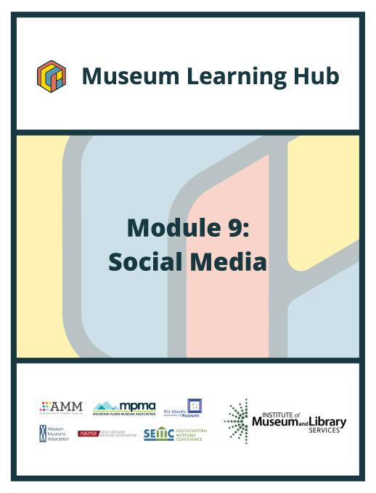

**Table of Contents**



* About This Module
* Learning Objectives
* Module Contributors
* Supplemental Resources
* Related Training

# 

# 

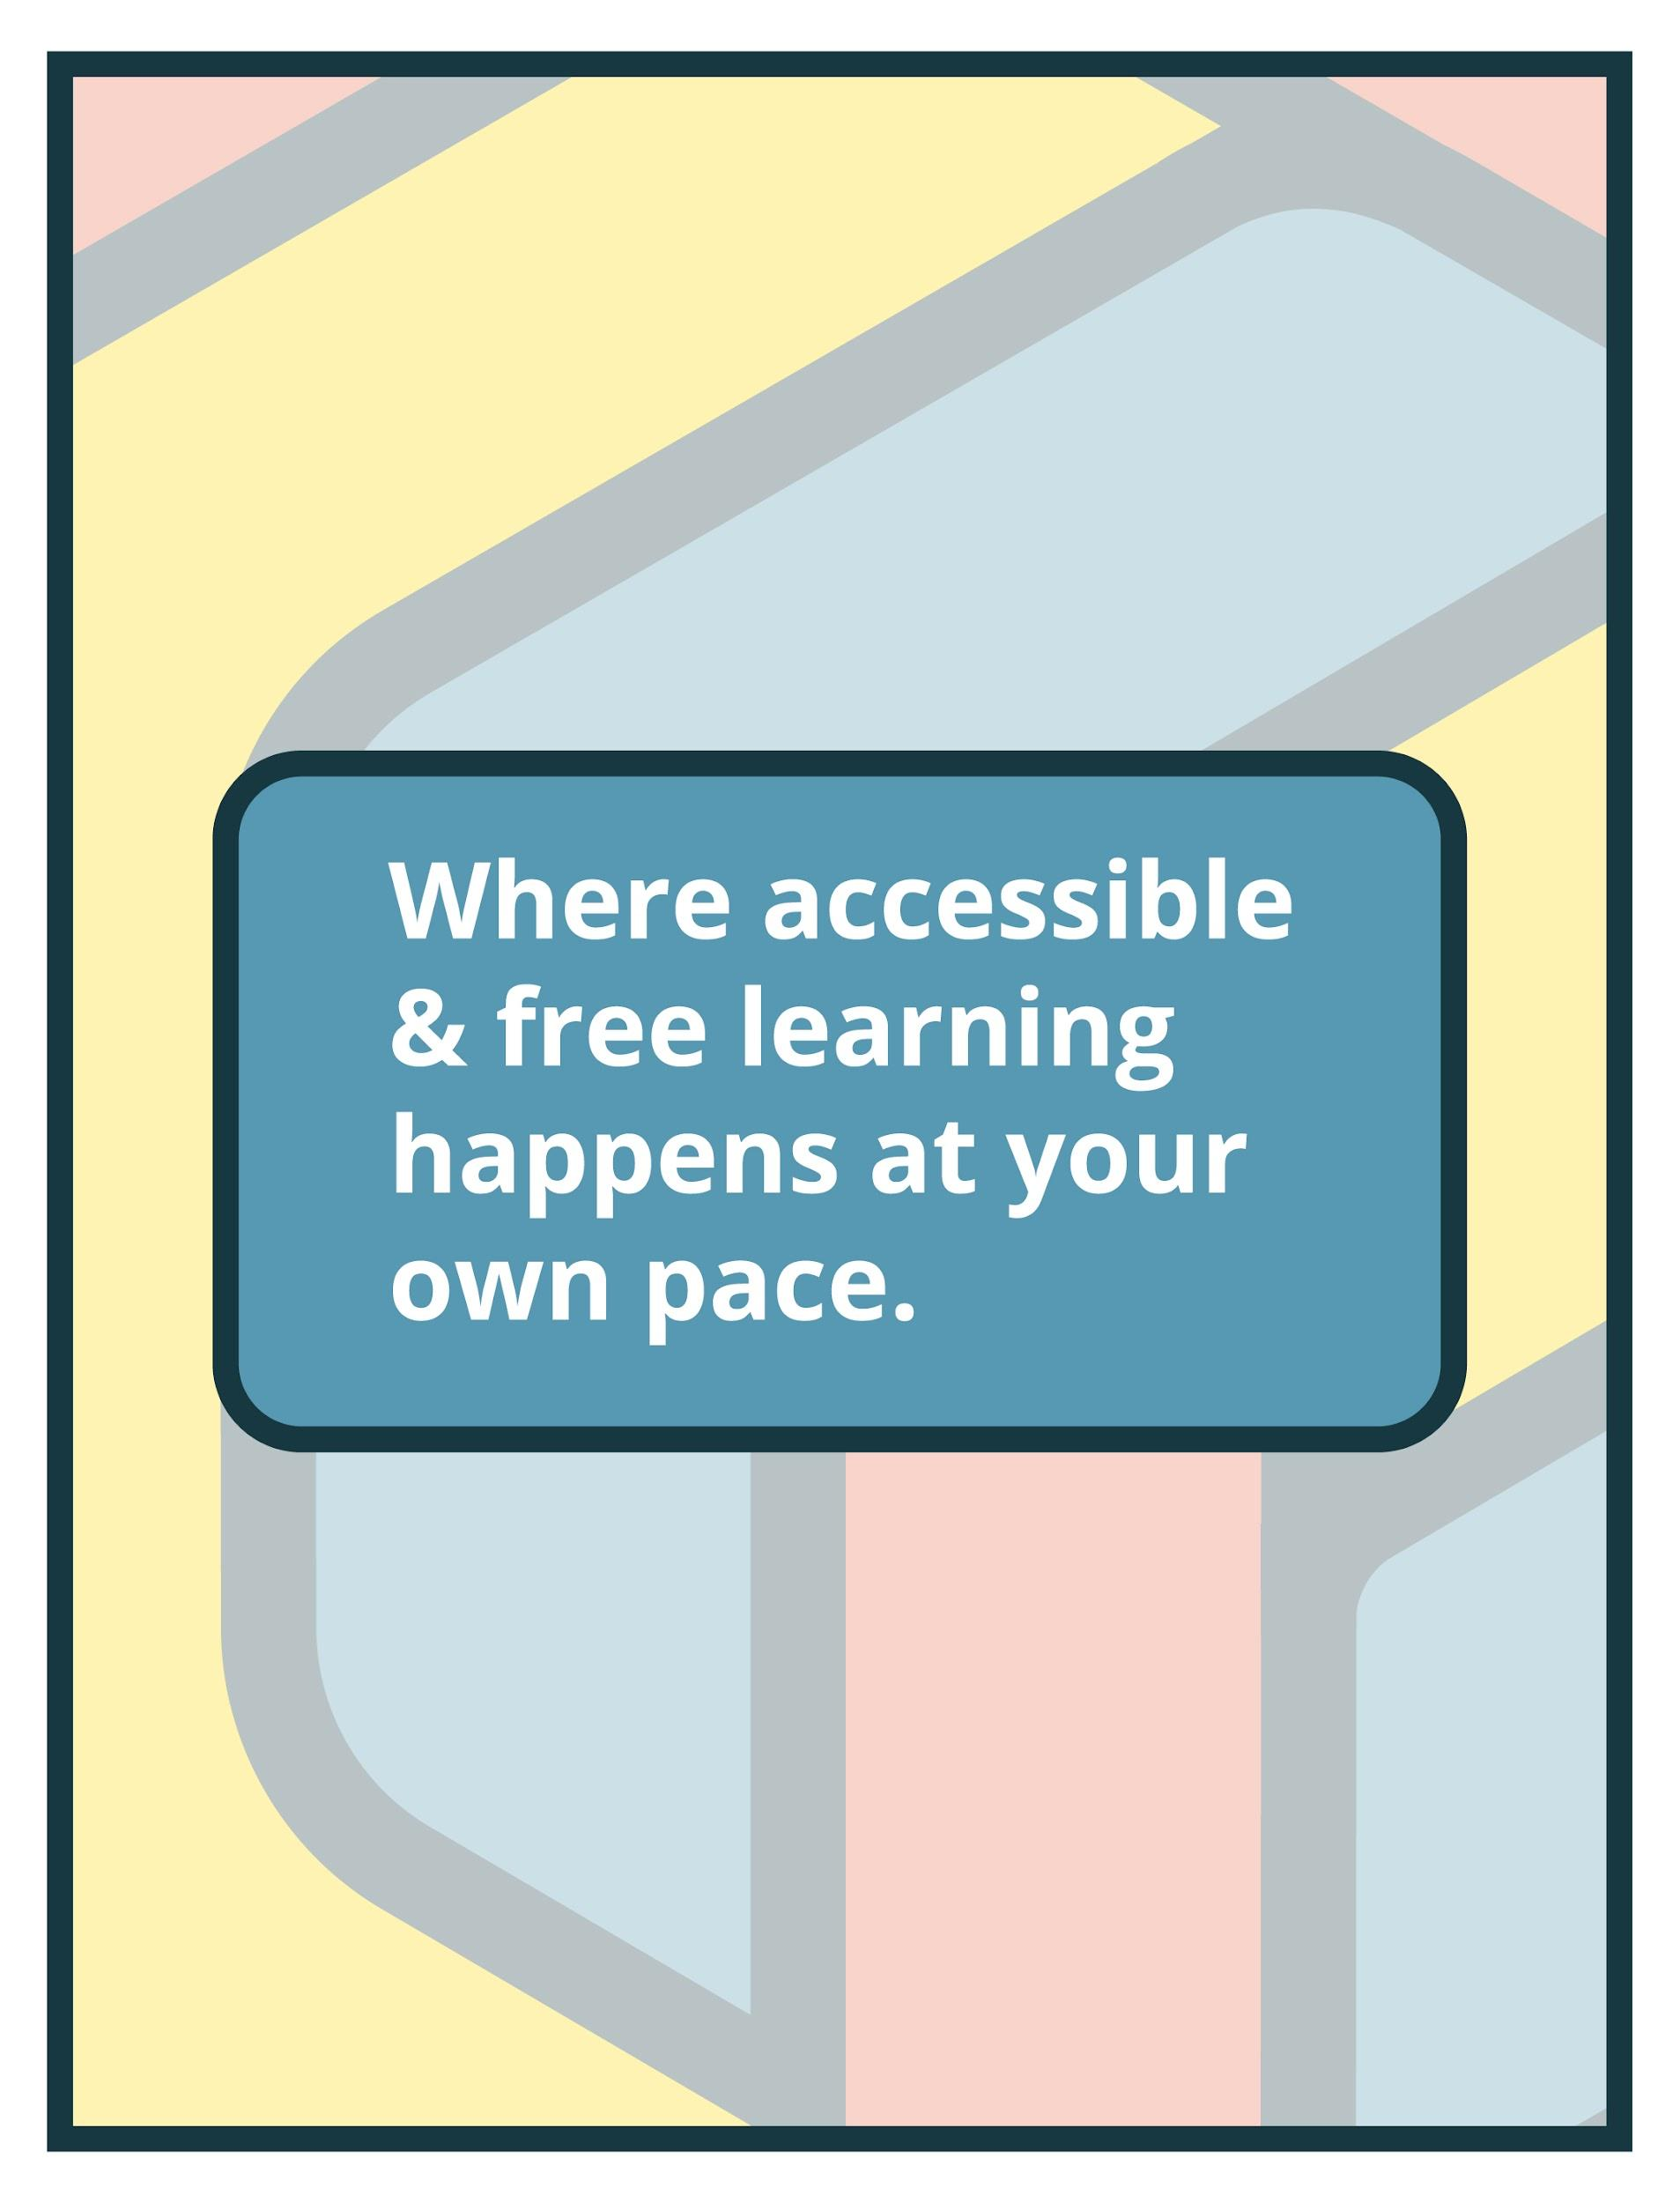

# About This Module

| **Focus Area:** | Social Media |
| --- | --- |
| **Learning Level:** | Beginner, Intermediate, and Advanced |
| **Module Description:** | How can you use different social media platforms to build awareness of your organization, programs, and online resources? This module covers common social media sites, and how they appeal to different audiences. Learn about common social media channels including user demographics, how to set up pages as well as available options for nonprofits that encourage inclusivity, and the best practices approach for institutions without a dedicated social media manager. |
| **Search Terms:** | Audiences, Analytics, Digital, Social Media |

**Sessions found in this Module:**

| **Session 1** | Get Inspired! |
| --- | --- |
| **Technical Workshop 1** | Build a Simple Social Media Strategy |
| **Technical Workshop 2** | Time-Saving Social Media Tools & Cross-Channel Integration |
| **Technical Workshop 3** | Creating Engaging Social Media Campaigns |

**The views, findings, conclusions or recommendations expressed in this series and toolkit do not necessarily represent those of the Institute of Museum and Library Services.**

# Learning Objectives

**Upon completion of this module, you will have gained the skills and practical knowledge to make the most of your social media strategies.**

| **Session 1: Get Inspired!** | Social media is the perfect platform to communicate the passion behind a museum’s mission and to tell stories in a way that can resonate with diverse audiences. Join the Module 9 introductory session to hear from two museum professionals (representing truly small museums) who have learned to harness the power of social media. See examples of their social media strategies and posts, and learn about their use of social media to highlight the unique aspects of their museum collections, locations, and histories in order to connect with existing and potential visitors. |
| --- | --- |

| **Technical Workshop 1: Build a Simple Social Media Strategy** | Social media is essential to remain connected with your audiences. But the endless possibilities can quickly become overwhelming. Where do you even begin? A simple strategy will help establish your goals, online audiences, and the specific social media platforms that are right for your organization. These steps include identifying your low-hanging-fruit content and creating a plan of action for when things go wrong online. This session will help you streamline your social media plan so you can go from surviving to thriving in your social media channels. |
| --- | --- |

| **Technical Workshop 2: Time-Saving Social Media Tools & Cross-Channel Integration** | Join this session to learn about free and inexpensive tools for managing multiple types of social media platforms and actionable tips for integrating social media with key audience channels including your website, newsletter, and advertising. Instruction will include an overview of common social media tools and an example workflow geared towards busy museum professionals without a dedicated social media manager. |
| --- | --- |

| **Technical Workshop 3: Creating Engaging Social Media Campaigns** | How do we use our objects to tell stories, create buy-in, and preserve culture on social media? Join this session to learn how to create impactful social media campaigns for day-to-day and special projects at your cultural institution. Building on our social media strategy and social media tools workshops, we'll explore how to ideate, create, and launch campaigns that are creative, engaging, efficient, and effective no matter your team's size. |
| --- | --- |

# 

# Module Contributors

**These are the experts and presenters who are involved in the development and presentation of each session, workshop, resource, and activity you find within this module.**

| **Emily Stone**  **Naturalist/Education Director,**  **Cable Natural History Museum**  **Cable, Wisconsin** | Emily Stone is a naturalist by birth, training, profession, and passion. She teaches kids of all ages about nature in beautiful places. She earned a degree in Outdoor Education-Natural History Northland College and a M.S. in the Field Naturalist Program at the University of Vermont. As the Naturalist/Education Director at the Cable Natural History Museum since 2011, Emily coordinates school programs, public programs, exhibit development, and more. As part of Museum outreach, Emily writes an award-winning “Natural Connections” column for more than 20 newspapers across 3 states. Her second Natural Connections book won an Excellence in Craft award from the Outdoor Writers Association of America. |
| --- | --- |
| **Webinar(s)** | Session 1: Get Inspired! |

| **Melissa Kiewiet**  **Director of Development and Community Engagement,**  **Dyckman Farmhouse Museum**  **New York, New York** | Melissa Kiewiet is the Director of Development and Community Engagement at the Dyckman Farmhouse Museum Alliance. Upon coming to the Dyckman Farmhouse Museum in 2018, Kiewiet was tasked with creating and implementing a social media strategy for the organization. The site had a very small following and minimal activity, but in under four years, Kiewiet has increased the following and engagement by 400%. Her use of economically efficient tools has enabled her small institution to grow rapidly.  Kiewiet earned her Bachelors degree in History from Maryville College and her Masters degree in Museum Studies from the Cooperstown Graduate Program at the State University of New York College at Oneonta. She has worked in various development departments in the arts and culture sector and serves on the Diversity Task Force for the Maryville College Alumni Board. |
| --- | --- |
| **Webinar(s)** | Session 1: Get Inspired! |

| **Lori Byrd-McDevitt**  **Co-Founder,**  **1909 Digital**  **Indianapolis, Indiana** | Lori is the co-founder of 1909 DIGITAL, an end-to-end digital marketing agency that supports many museums and non-profits. She is a longtime #musesocial community organizer thanks to her decade as Social Media Manager at The Children's Museum of Indianapolis. She is a former Museum Computer Network board member and co-founded and admins the Museum Social Media Managers Facebook Group. She's passionate about self-care for museum professionals, audience engagement, cross-institutional collaboration, crisis communications, & Agile leadership. |
| --- | --- |
| **Webinar(s)** | Technical Workshop 1: Build a Simple Social Media Strategy |

| **Sewon Chung Barrera**  **Senior Manager of Digital Marketing & Content Strategy,**  **Exploratorium**  **San Francisco, California** | Sewon Chung Barrera is a digital marketing strategist with over a decade of experience launching multichannel marketing campaigns and developing results-driven content strategies. Currently she oversees the digital marketing department at the Exploratorium, a San Francisco-based museum of science, art, and human perception described by the New York Times as the most important science museum to have opened since the mid- 20th century. Previously, Sewon led global content marketing campaigns at Samsung and developed content strategies for startups, eCommerce businesses, and Fortune 500 companies at Brafton. Sewon holds a Master of Arts from Columbia University’s Graduate School of Arts and Sciences, and a dual B.A. in Literary & Cultural Studies and Sociology from The College of William & Mary. |
| --- | --- |
| **Webinar(s)** | Technical Workshop 2: Time-Saving Social Media Tools & Cross-Channel Integration |

| **Jessica Johnson**  **Creative Strategist**  **Landover, Maryland** | Jessica Johnson is a Creative Strategist at Snap, Inc. Prior to beginning work in the tech industry, she was an award-winning Social Engagement Producer at the Smithsonian National Museum of African American History and Culture. Jessica holds a master’s degree in Journalism from Temple University and earned her Bachelor of Science in Fashion and Textile Management at North Carolina State University. Jessica has worked in multiple industries including fashion, higher education, and advertising. She is interested in exploring practical uses for new media and finding new ways to communicate across audiences. Jessica is also passionate about fashion history from the African American perspective and activating archives in the digital world. |
| --- | --- |
| **Webinar(s)** | Technical Workshop 3: Creating Engaging Social Media Campaigns |

**Created by the Museum Learning Hub. Made possible by the Institute of Museum and Library Services.**

# 

# Supplemental Resources

**These supplemental resources are designed to deepen your understanding on the module’s subject matter and help you to complete this module to the best of your ability.**

**Articles**

* Liana Tech - [10 Tips for Creating a Content Calendar](https://www.lianatech.com/resources/blog/10-tips-for-creating-a-content-calendar.html)
* Digital Marketing Institute
  + [Which Social Media Platforms Should You Use for Your Business?](https://digitalmarketinginstitute.com/blog/which-social-media-platforms-should-you-use-for-your-business)
  + [The Beginner’s Guide to Evergreen Content](https://digitalmarketinginstitute.com/blog/the-beginners-guide-to-evergreen-content)
* Iconic Digital - [The Importance of Brand Guidelines](https://iconicdigitalagency.com/blog/branding/the-importance-of-brand-guidelines/)
* Sprout Social - [How to set (and achieve) meaningful social media goals](https://sproutsocial.com/insights/social-media-goals/)
* Hootesuite - [9 Social Media Goals to Help Keep Your Strategy on Track](https://blog.hootsuite.com/smart-social-media-goals/)

**Websites**

* Social Media Planning & Scheduling Tools
  + [Linktree](https://linktr.ee/) (One central link to compile all links and social media)
  + In-app (free)
    - [Facebook Creator Studio](https://business.facebook.com/creatorstudio/home) - schedules Instagram and Facebook
    - [Twitter ad campaign](https://business.twitter.com/en/campaign/welcome-to-twitter-ads.html?ref=us-en-google-b-mf-ao&utm_source=&utm_medium=cpc&utm_campaign=always-on&gclid=Cj0KCQiA5OuNBhCRARIsACgaiqVk_pFXInR9mr0c-drX63UEqVZkcfGezKgAD3gLxGUFOEDHIVfUnmwaAjs2EALw_wcB)
  + [Hootsuite](http://www.hootsuite.com) (free/$49+)
    - 1 user, up to 2 profiles
    - 5 scheduled posts/month
    - Instagram, Facebook, Twitter, LinkedIn, Youtube, Pinterest
  + [Buffer](http://www.buffer.com) (free/$5+)
    - 1 user, up to 3 profiles
    - 10 scheduled posts/month
    - Instagram, Facebook, Twitter, LinkedIn, Pinterest
  + [SproutSocial](https://sproutsocial.com/) ($89/month)
    - 1 user, up to 3 profiles
    - 10 scheduled posts/month
    - Instagram, Facebook, Twitter, LinkedIn, Pinterest
* Sourcing Free Visuals
  + [Unsplash](https://unsplash.com/)
  + [If Then Collection](https://www.ifthencollection.org/) (Images of women in STEM)
  + [Shutterstock](http://www.shutterstock.com)
  + [iStock](http://www.istockphoto.com)
  + [Pixabay](https://pixabay.com)
* Content Creation & Design
  + [Audacity](https://www.audacityteam.org/) (Audio Editor)
  + [Canva](https://www.canva.com/) (Design Tools)

**Guides & Books**

* [Social Media Marketing for Dummies (2012)](https://www.amazon.com/Social-Media-Marketing-Dummies-Singh/dp/111806514X)
* Understanding your audience
  + Facebook - [Understand Audiences](https://www.facebook.com/business/learn/lessons/identify-target-audience)
  + Hootsuite - [How to Use Twitter Analytics: The Complete Guide for Marketers](https://blog.hootsuite.com/twitter-analytics-guide/)
  + YouTube - [Find My Audience](https://www.thinkwithgoogle.com/feature/findmyaudience/?utm_medium=cpc&utm_source=paid-media&utm_team=twg-us&utm_campaign=twg-cpc-us-2021q3-ASC-find-my-audience-tool&gclid=Cj0KCQiAzMGNBhCyARIsANpUkzMx5ldtTsVom6bKOkkn4s1eJhfSAS9ZMScld_FBVu-ZvVh2crcIO2oaAgHHEALw_wcB&gclsrc=aw.ds)
* [Social Media Content Calendar Template](https://offers.hubspot.com/social-media-content-calendar?hubs_post=blog.hubspot.com%2Fmarketing%2Fsocial-media-calendar-tools&hubs_post-cta=HubSpot%27s%20Downloadable%20Template%20for%20Excel&_ga=2.58135465.2050886750.1639576788-809695471.1639576788)
* [Social Media Strategy Template](https://docs.google.com/document/d/19xMiXdlxHtNQYNX1_sr-q2pRPJ-6QHz9T0cfkiC9w18/copy)
* [Examples of Responding to Current Events](http://midatlanticmuseums.org/resources/responding-to-current-events/)
* Brand Style Guide Examples
  + [21 Brand Style Guide Examples for Visual Inspiration](https://blog.hubspot.com/marketing/examples-brand-style-guides)
  + [Starbucks Style Guide](https://creative.starbucks.com/logos/)
  + [NASA Style Guide](https://brandingstyleguides.com/guide/nasa/)
  + [Audi Style Guide](https://www.audi.com/ci/en/renewed-brand.html)

**Media**

* Cable Natural History Museum Social
  + [Website](http://www.cablemuseum.org)
  + [Instagram](http://www.instagram.com/cable.natural.history.museum)
  + [Facebook](http://www.facebook.com/CableNaturalHistoryMuseum)
  + [Twitter](https://twitter.com/CableNHMuseum)
  + [Youtube](https://www.youtube.com/user/CableMuseum/featured)
* Dyckman Farmhouse Alliance Social
  + [Website](http://www.dyckmanfarmhouse.org)
  + [Instagram](http://www.instagram.com/dyckmanfarmhouse)
  + [Facebook](http://www.facebook.com/DyckmanFarmhouseMuseum)
  + [Twitter](http://www.twitter.com/dyckmanfarm)
  + [LinkedIn](https://www.linkedin.com/company/dyckman-farmhouse-museum)
  + [Youtube](https://www.youtube.com/channel/UCxoCG3iYjUKUYYea-Kebr7w)
* Exploratorium
  + [Website](https://www.exploratorium.edu/)
  + [Facebook](https://www.facebook.com/exploratorium)
  + [Instagram](https://www.instagram.com/exploratorium/)
  + [Twitter](https://twitter.com/exploratorium)
  + [Youtube](https://www.youtube.com/user/Exploratorium)
  + [Tumblr](https://exploratorium.tumblr.com/)
  + [Pinterest](https://www.pinterest.com/exploratorium/_shop/)
* New acquisitions/Exhibitions/Special projects Content Examples
  + [LA County Museum of Art](https://www.instagram.com/p/CWZATvZlIaq/?utm_source=ig_web_copy_link)
  + [Museum of the City of New York](https://www.instagram.com/p/CWqnxlZrMTr/?utm_source=ig_web_copy_link)
* Campaign hashtags
  + [#FossilFridays](https://www.instagram.com/p/CXT44dNMwdf/?utm_source=ig_web_copy_link) at the Houston Museum of Natural Science
  + [#RelistWolves](https://www.instagram.com/p/CXYwQ_IMNN7/?utm_source=ig_web_copy_link) at the Woodland Park Zoo
* Content Examples
  + Collections metadata: [Professor McGonagall’s hat on display at MoPOP](https://www.instagram.com/p/CXKT7SCFGpa/?utm_source=ig_web_copy_link)
  + Blogs: [M Blog at the Minnesota Museum of American Art](https://mmaa.org/learn-do/the-m-blog/)
  + Exhibit labels: [Facebook post from Met Museum](https://www.facebook.com/metmuseum/posts/10158865049382635)
  + Staff research: [Staff in action at Hearst Museum of Anthropology](https://www.instagram.com/p/COdV_UUA3-h/?utm_source=ig_web_copy_link)
* [Museum Social Media Managers Facebook Group](https://www.facebook.com/groups/musesocial/about/)

# 

# 

# Related Training

**Interested in learning more on related topics?**

**On the Museum Learning Hub, you’ll find a variety of free sessions, workshops, and resources that are similar in subject matter and content. We recommend the following Museum Learning Hub sessions and modules:**

| **Module 1: Digital Accessibility & Inclusion** | Digital accessibility ensures access to information and all functions of digital tools, irrespective of a person’s specific needs. This module will provide training on how to integrate accessibility and inclusion into digital programs, social pages, and |
| --- | --- |

| **Module 4: Managing Website Projects** | A good project management process with a checklist of essential elements to cover can help organizations successfully create and/or optimize a website. Whether using a website developer or managing all website content in-house, this module will provide training sessions to help users develop a project with time devoted to planning and execution including collecting information (what are the purpose, goals and target audience), organizing a design (prototyping and wire frames), development, project schedules, milestones and future expectations. |
| --- | --- |

| **Module 8: Audiences & Analytics** | This module will cover how to identify your target audience, which is essential for knowing where to focus your communication efforts. You will learn to access and interpret analytics/data from social media pages and websites as well as how to collect additional audience information using digital media and technology platforms based on community demographics to better understand “who are we and how we communicate that.” |
| --- | --- |

