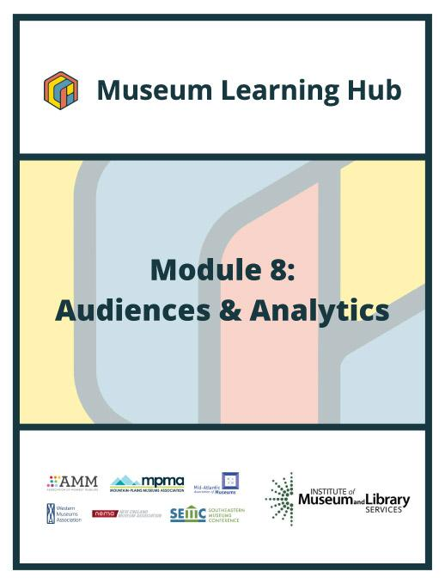
Table of Contents

- About This Module
- Learning Objectives
- Module Contributors
- Supplemental Resources
- Related Training

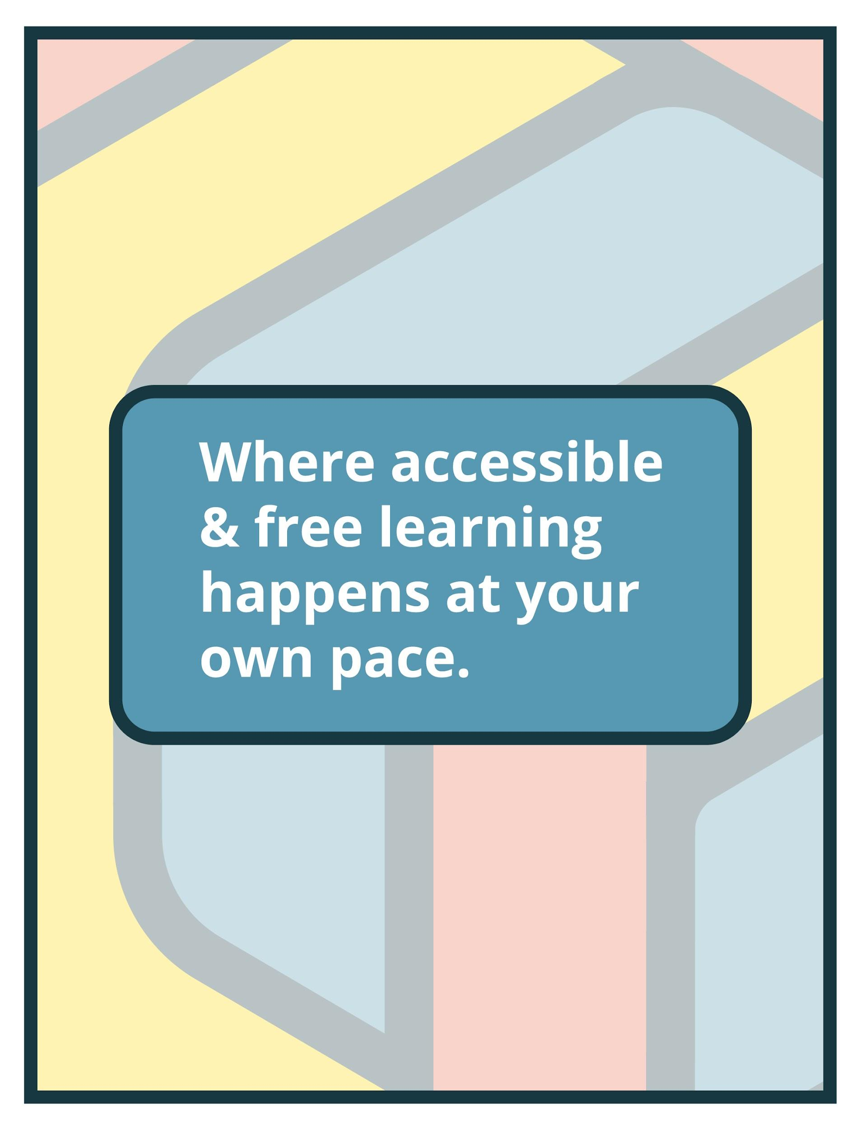

About This Module

Focus Area: | Audiences & Analytics
Learning Level: | Beginner, Intermediate, and Advanced
Module Description: | This module will cover how to identify your target audience, which is essential for knowing where to focus your communication efforts. You will learn to access and interpret analytics/data from social media pages and websites as well as how to collect additional audience information using digital media and technology platforms based on community demographics to better understand “who are we and how we communicate that.”
Search Terms: | Audience, Analytics, Digital, Social Media

Sessions found in this Module:

Session 1 | Get Inspired!
Technical Workshop 1 | Creating An Analytics Toolbox to Evaluate Museum Digital Experiences
Technical Workshop 2 | Building Digital Strategies and Interpreting Social Media Analytics
Technical Workshop 3 | Using Web Analytics to Understand Audiences and Optimize Your Efforts
The views, findings, conclusions or recommendations expressed in this series and toolkit do not necessarily represent those of the Institute of Museum and Library Services.

Learning Objectives

Upon completion of this module, you will have gained the skills and practical knowledge to deliver the right message to the right people at the right time.

Session 1: Get Inspired! | In today’s technology-driven world many museums have begun to explore the possibilities offered by data analytics to better understand how to best serve their potential audiences. Like any business with financial needs, museums can collect and analyze data to help determine how to improve the user experience to attract visitors and even drive revenue. If this seems daunting, join the Module 8 intro session to hear from two museum professionals who have embraced analytics and taught themselves and others to get excited about the valuable insights that data can provide! Get inspired by their confidence and passion for (simple) analytic tools that can help you gain actionable insights into your museum and achieve marketing objectives.

Technical Workshop 1: | In this session, we will learn about the different user research and evaluation methods and tools that will help you to better understand your audiences and evaluate your museum’s digital programs. This workshop will share examples of the application of different methods and a case study about how to develop a user segmentation. We will cover the user research process from the study design to the communication of insights, and discuss how to best integrate evaluation in the digital production process. Attendees will come away with the confidence to evaluate their digital programs and create their analytics toolbox.

Technical Workshop 2: | Digital strategies help organizations plan and execute their marketing approach on web and social platforms. Analytics, however, are used to measure the success or failure of your digital strategy. In this session, we will learn the fundamentals of building or reanalyzing digital strategies while considering the tools needed to execute and interpret the results for each social channel.

Technical Workshop 3: | Beginning with web analytics, we will discuss the importance of a research question in guiding your analysis of user behavior data. We will cover how to: understand landing pages and their relationship to search engine optimization, track conversion rates on key pages, and use behavior funnels. From there, we will explore the importance of using data across platforms to better understand our audiences and to visualize them through the creation of user personas and customer journeys. Finally, we’ll look at how data can drive continuous improvement towards your goals.

Module Contributors

These are the experts and presenters who are involved in the development and presentation of each session, workshop, resource, and activity you find within this module.

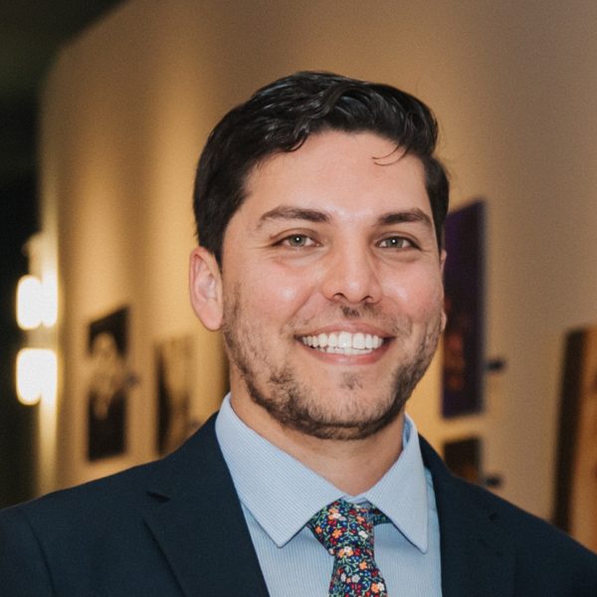  Arturo Garcia  Manager of Marketing and Communications,  Museum of Photographic Arts  SanDiego, California | Arturo Garcia is the manager of marketing and communications at the Museum of Photographic Arts in San Diego’s Balboa Park. He is also a board member at the Public Relations Society of America San Diego and Imperial Counties Chapter, serving under the professional development committee, in addition to supporting the board’s efforts toward equity, inclusion, and diversity.
Webinar(s) | Session 1: Get Inspired!

Emily Robertson  Independent Consultant,  Studio Robertson  Boston, Massachusetts | Emily Robertson is the Marketing Manager for Gore Place in Waltham, Massachusetts as well as the founder of Studio Robertson, a creative project management studio based in Boston. For more than 20 years, Emily has helped museums give voice to great ideas and bring life to their great projects with a focus on data and accessibility. Emily earned her MBA in Business Analytics at Babson College. Visit studiorobertson.net to learn more.
Webinar(s) | Session 1: Get Inspired!

Elena Villaespesa  Assistant Professor,  School of Information, Pratt Institute  New York, New York | Elena Villaespesa works as an Assistant Professor at the Pratt Institute School of Information. Her research and teaching areas of interest include digital strategy, data analytics, and user experience research, and applied evaluation within the museum sector. Elena is co-founder of the Museums + AI Network, which is funded through an AHRC Network Grant. She completed a Ph.D. in Digital Heritage at the School of Museum Studies, University of Leicester (United Kingdom) and an MA in Arts Management, Universidad Carlos III, Madrid (Spain). She has previously worked as a Digital Analyst at the Metropolitan Museum of Art and Tate. In these roles, she was in charge of establishing and overseeing an analytics program to monitor and assess museum digital channels, platforms, and programs.
Webinar(s) | Technical Workshop 1: Creating An Analytics Toolbox to Evaluate Museum Digital Experiences

Acacia Berry  Founder, Archaeological Analytics | Acacia Berry is the founder of Archaeological Analytics, a company that supports U.S. and Canadian cultural heritage on the web and social media. She is a trained archaeologist with 15 years of experience doing fieldwork, managing collections, and creating public programming for the American Museum of Natural History, NYC’s Landmarks Preservation Commission, and other cultural heritage firms in the tri-state area. Following her last job as a digital collections assistant in 2015, Acacia became a digital strategist and built Archaeological Analytics to act as a support network for cultural organizations and their digital assets.
Webinar(s) | Technical Workshop 2: Building Digital Strategies and Interpreting Social Media Analytics

Dana Allen-Greil  Vice President of Marketing,  Monteray Bay Aquarium  Monterey, California | Dana Allen-Greil is Vice President of Marketing at the Monterey Bay Aquarium. Dana has led web and social media efforts at the National Archives, National Gallery of Art, Ogilvy Public Relations, the Smithsonian’s National Museum of American History, and the Kaiser Family Foundation. Dana holds a B.A. in English from St. Mary’s College of Maryland and an M.A. in Museum Studies from George Washington University. She has taught graduate museum studies courses for Johns Hopkins University, Georgetown University, George Washington University, and Tufts University and served on the boards of the Museum Computer Network (MCN) and the Mid-Atlantic Association of Museums (MAAM).
Webinar(s) | Technical Workshop 3: Using Web Analytics to Understand Audiences and Optimize Your Efforts

Created by the Museum Learning Hub.
Made possible by the Institute of Museum and Library Services.

Supplemental Resources

These supplemental resources are designed to deepen your understanding on the module’s subject matter and help you to complete this module to the best of your ability.

Articles
- 2U, Inc. - What is Data Analytics?
- Harvard Business Review - What’s Your Data Strategy?
- How museums use data
  - Museum Next - Big Data and Museums
  - TechTarget - Museums and data: A powerful combination
  - Medium - How 7 Museums Used Data Analytics to Fix Real Problems
- Usability Testing
  - Nielson Norman Group - When to Use Which User-Experience Research Methods
  - Shane Doyle - How to perform unmoderated usability testing with Zoom
  - Optimizely - A/B testing
  - Google - About Optimize
  - UX Matters - Dancing with the Cards: Quick-and-Dirty Analysis of Card-Sorting Data
  - Techradar - Best survey tools in 2021
  - Rev - How to Analyze Interview Transcripts in Qualitative Research
  - Qualtrics - Survey data analysis: Best practices, helpful tips, and our favorite tools
  - Pointillist - ​​Everything You Need to Know about Customer Journey Analytics
  - Askattest - 6 of The Best Market Research Tools for 2021
- MuseWeb - The Met’s Object Page: Towards a New Synthesis of Scholarship and Storytelling
- Adoric - 25 Hacks to Convert Your Traffic Into Leads and Sales
- Social Media
  - Hubspot
    - What a Social Media Target Audience Is and How to Find It
    - How to Develop a Unique (& Memorable) Brand Identity in 2021
  - Success Agency - Sealing the Deal: 10 Ways to Create a Clickable Call-to-Action
  - Investopedia - Best Social Media Management Software
  - Adobe - Why You Need a Facebook Business Page: 6 Steps to Launch
  - YouTube - How To Start a YouTube Channel 2021: Beginner's Guide to Growing from 0 Subscribers
  - McGaw.io - The Dummies’ Guide To UTM Tracking For Google Analytics

- Social Key Performance Indicators (KPIs)
  - 16 Facebook metrics every brand needs to track for success
  - How to Use Instagram Analytics to Grow Engagement and Followers
  - Twitter metrics: How & why you should track them
  - YouTube - Understand audience engagement

Websites
- User Analytic & Usability Tools
  - Google
    - The Ultimate Guide to Google Analytics in 2021
    - Campaign URL Builder
    - Google Analytics
    - Google Search Console Insights
    - Google Data Studio
  - Pratt DX Center
  - Crazyegg
  - Hotjar
  - Contentsquare
  - Smartlook
  - Omniture
  - Adobe Analytics
  - Tobii Eye-tracking
  - PageSpeed
- Website Platforms
  - Wordpress
  - Squarespace
  - Wix
  - Drupal
- Social Media & User Engagement Tools
  - Convert audiences to members and donors
    - Tiltify
    - Tessitura
  - Engage & Inspire
    - Sprout Social
    - WordFly
  - Social Media Management
    - Meltwater
    - Later
    - Buffer
    - Hootsuite
    - Sprout

Guides & Books
- Search Engine Optimization (SEO) Starter Guide
- Optimization Report Template
- Social Media Engagement Tracking Sheet
- Setting baseline and benchmarks for analytics:
  - M+R Annual Benchmarks report
  - Conversion rate benchmarks

Media
- Digital Cultural Heritage Platforms
  - @archeanalytics
  - @usartifacts
  - @openartifactusa
- Museum Social Media Managers network

Related Training

Interested in learning more on related topics?

On the Museum Learning Hub, you’ll find a variety of free sessions, workshops, and resources that are similar in subject matter and content. We recommend the following Museum Learning Hub sessions and modules:

Module 1: Digital Accessibility & Inclusion | Digital accessibility ensures access to information and all functions of digital tools, irrespective of a person’s specific needs. This module will provide training on how to integrate accessibility and inclusion into digital programs, social pages, and

Module 4: Managing Website Projects | A good project management process with a checklist of essential elements to cover can help organizations successfully create and/or optimize a website. Whether using a website developer or managing all website content in-house, this module will provide training sessions to help users develop a project with time devoted to planning and execution including collecting information (what are the purpose, goals and target audience), organizing a design (prototyping and wire frames), development, project schedules, milestones and future expectations.

Module 9: Social Media | How can you use different social media platforms to build awareness of your organization, programs, and online resources? This module will cover common social media sites, how they appeal to different audiences.

