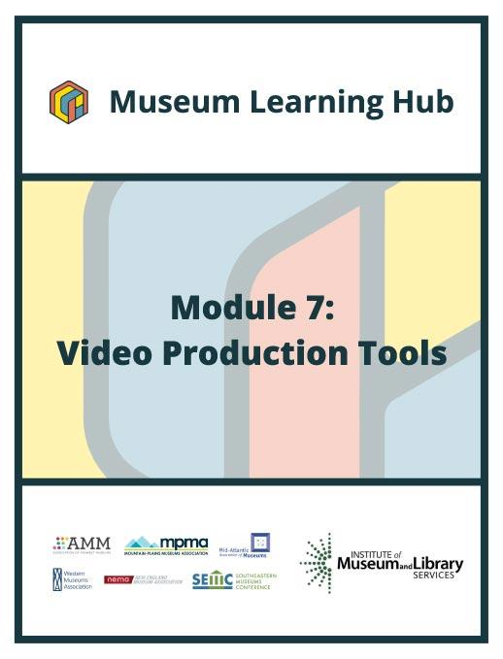
Table of Contents

- About This Module
- Learning Objectives
- Module Contributors
- Supplemental Resources
- Related Training

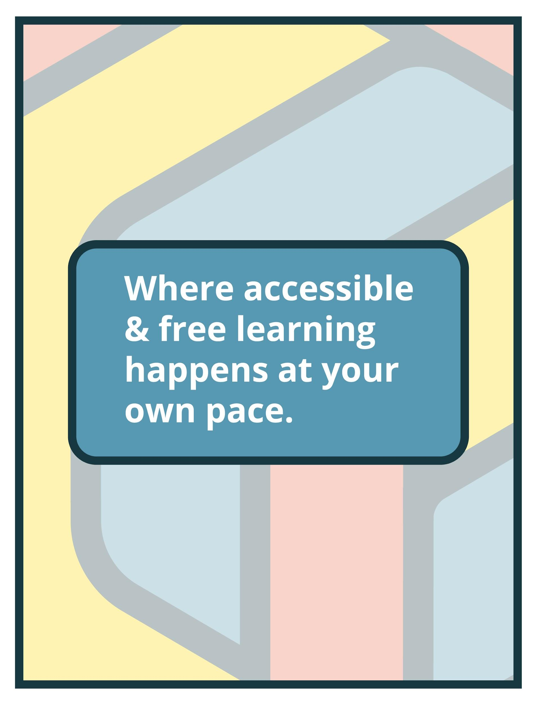

About This Module

Focus Area: | Video Production Tools
Learning Level: | Beginner, Intermediate, and Advanced
Module Description: | Creating a quality online program does not require you to have the most expensive, top-of-the-line equipment. Nor do you have to hire a professional crew or go to film school. Techniques that are popular amongst experienced video production professionals have become available to beginners too. Affordable software and easy-to-use apps can empower anyone to unleash their creativity with video production. Whether a museum is interested in creating videos, virtual hands-on activities or interactive video lessons, there's no shortage of production tools to assist. This module will offer training and guidance on where to begin and cover available video production tools to move education programs and tours (pre-recorded and 360 videos) to a virtual realm.
Search Terms: | Video, audiences, storytelling, technology

Sessions found in this Module:

Session 1 | Get Inspired!
Technical Workshop 1 | Video Production Basics
Technical Workshop 2 | Video Planning and Distribution
Technical Workshop 3 | Emerging Technology in Video Production
The views, findings, conclusions or recommendations expressed in this series and toolkit do not necessarily represent those of the Institute of Museum and Library Services.

Learning Objectives

Upon completion of this module, you will have gained the skills and practical knowledge to reach your audiences through video content.

Session 1: Get Inspired! | Storytelling through moving images can be a powerful tool for museums to engage current audiences and attract new ones. An investment in video production can pay big dividends and increase an organization’s reach beyond its physical location. With tight budgets and even tighter schedules, how can museums tell great stories with video? Join this session to hear from two museum professionals who have successfully integrated video production and digital storytelling into their education, programming and communication plans. Get inspired by the Module 7 intro speakers who have found creative, resourceful, ways to create terrific video content on limited budgets.

Technical Workshop 1:  Video Production Basics | This session will address the basic tools needed to produce videos for your museum including cameras, microphones and lighting equipment and offer low-cost suggestions for those who want to create amazing content, but are not quite ready to spend buckets of money on gear or outsourcing. Instruction will also review general workflow for video production providing attendees with an overview of what goes into a video project.

Technical Workshop 2:  Video Planning and Distribution | Media is the literacy of the 21st century and with new technologies and approaches anyone can take video communications into their own hands. This session will cover planning for video production including the use of production templates as well as the different platforms used to distribute videos. Attendees will learn to differentiate between various types of low-cost video creation and distribution tools and how to set up simple video content structures.

Technical Workshop 3:  Emerging Technology in Video Production | Join this session to learn about new and emerging video formats, tools and platforms such as 360, volumetric video and virtual tour services. Technical instruction will include examples of recent video work in museums with small production teams and discuss considerations in planning for the future scalability and sustainability of a museum’s video production tools with discussion of uses and caveats of current technologies and outsourced solutions as well as ways to create immersive video experiences with few staff and resources.

Module Contributors

These are the experts and presenters who are involved in the development and presentation of each session, workshop, resource, and activity you find within this module.

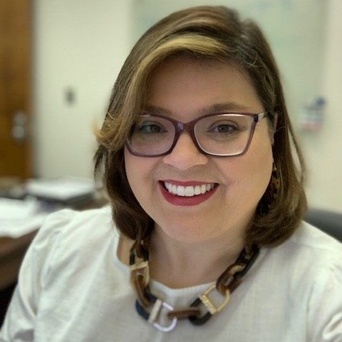  Nancy Strickland Fields, M.A., (Lumbee)  Director/Curator  Museum of the Southeast American Indian,  The University of North Carolina at Pembroke  Pembroke, North Carolina | Nancy Strickland Field’s 18-year museum career has been focused in museum education and administration. She has worked at the Museum of Contemporary Native Art in Santa Fe, New Mexico; The National Museum of the American Indian in Washington, D.C.; and The American Indian Cultural Center and Museum in Oklahoma City. Her current role is Director and Curator of The Museum of the Southeast American Indian in Pembroke, North Carolina. She is the first Lumbee graduate of the Institute of American Indian Arts in Santa Fe, New Mexico where she earned a bachelor’s degree in Museum Studies. Nancy earned a master’s degree in History from the University of North Carolina at Wilmington. Nancy’s area of research focuses on Southeastern Native peoples and the American colonial experience.  Nancy is a member of the Lumbee Tribe. Her family resides in and around the Pembroke area. She was raised in Charlotte with very close ties to her family in Robeson County.  Nancy's teaching Interests include, Indigenous Museum Methodologies, Cultural Inclusion and Indigenous Voice in Museums and Historic Sites, Southeastern American Indian History During the American Colonial Period, American Indian Slavery and Colonial Food Commodities. Her current research projects are in partnership with NC State agriculture professor Dr. Holland surrounding ancestral corn reclamation among the North Carolina tribes. In addition, working with the Waccamaw-Siouan community to research and help restore riparian traditions on Lake Waccamaw and the Cape Fear River.  Nancy received a BA in Museum Studies at the Institute of American Indian Arts, earned a master’s degree in history from the University of North Carolina at Wilmington and is currently a doctoral student in the public history program at North Carolina State University, as well as a 2019 graduate of SEMC’s Jekyll Island Management Institute.
Webinar(s) | Session 1: Get Inspired!

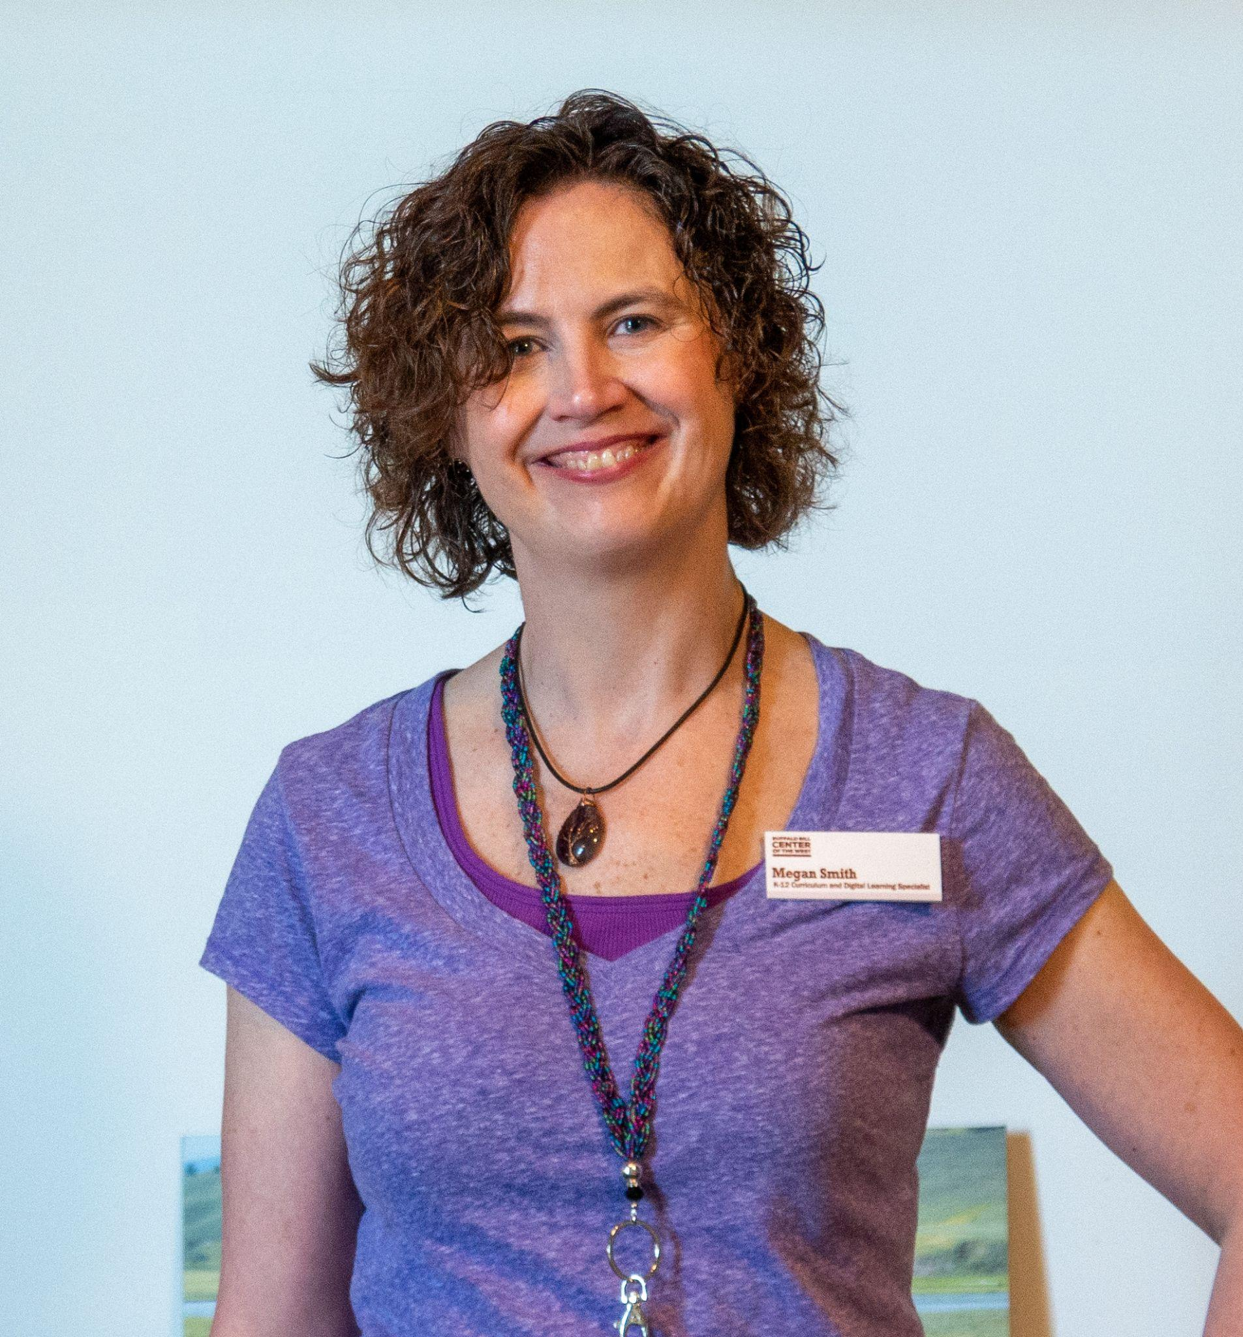  Megan Smith  K-12 Curriculum and Digital Learning Specialist,  Buffalo Bill Center  of the West  Cody, Wyoming | Megan Smith joined the education staff at the Buffalo Bill Center of the West in 2006. Smith previously worked as the Assistant Director at The Nature of Things, an environmental education outreach organization, in New York. She has dedicated her twenty plus years career to interpretive education at museums, nature centers, and other organizations. Smith earned a B.S. in Environmental Science from Indiana University and a M.S. in Ecology from the University of New Haven.  As the K-12 Curriculum & Digital Learning Specialist, Smith manages the direction, development, and implementation of all K-12 curriculum and digital learning initiatives at the Buffalo Bill Center of the West. This includes all outreach, on-site, and digital learning services and resources. She employs innovative and best practices in both museum and K-12 education to lead the Center’s K-12 program using immerging and groundbreaking 21st century education principles in the classroom, at the Center, and through digital learning. Curriculum development enriches and empowers teachers to use our resources and expertise using methodology, standards, benchmarks, and curriculum practices that are evolving in the new face of K-12 education. Smith oversees all K-12 programming and resources, including on-site field trips, outreach materials, and digital learning experiences. In May of 2013, Smith launched one of the Center’s flagship programs, Skype in the Classroom. The Center has recently rebranded this virtual field trip program and since its launch, the Interpretive Education Department has reached over 150,000 students worldwide. Smith and her colleagues have worked tirelessly during the pandemic to provide even more digital resources for multiple audiences through a partnership with Flipgrid and the production of videos and other media to inspire and engage audiences of all ages.  Smith is also a published author of non-fiction children’s books for publishers such as the Webby Award winner National Geographic Education Resources Library, Houghton Mifflin Harcourt, Loyola Press, Heinemann, McGraw Hill, National Geographic School Publishing, Cobblestone, Pearson, and Sundance Publishing. Published work includes basal configurations and products used for integrated curriculum, and digital curriculum. She has also written a non-fiction narrative book titled, The Sweet Mango Tree.
Webinar(s) | Session 1: Get Inspired!

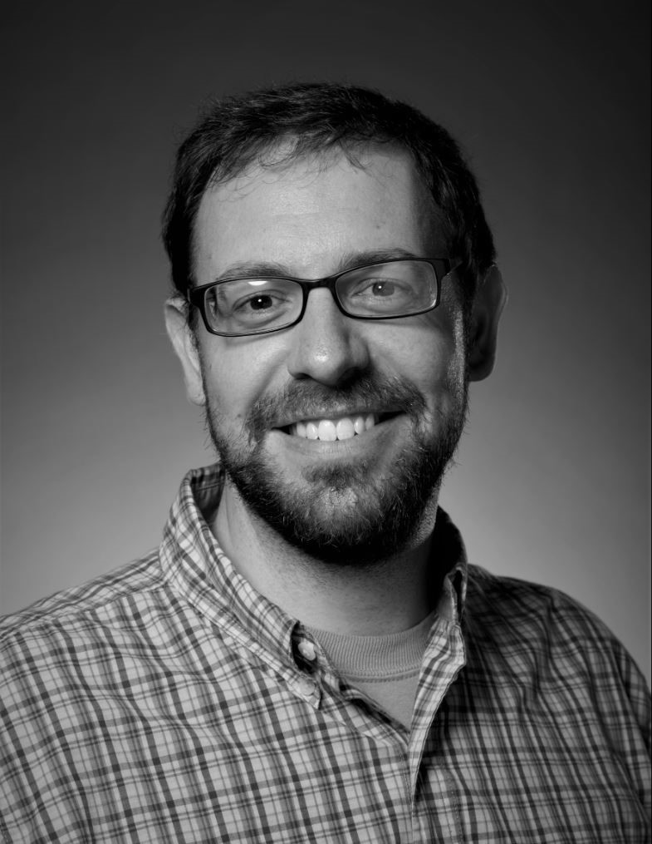  Luke Mehaffie  Media Services Coordinator,  North Carolina Museum of Art  Raleigh, North Carolina | Luke Mehaffie has been on staff at the North Carolina Museum of Art since 2014. He’s currently the Video Producer for the Museum and serves as part of the Marketing and Communications team. As a Raleigh, North Carolina native, the Museum has always been a place he’s called home. He graduated from East Carolina University with a double concentration in Media Performance and Media Production, where he met his wife. Four children later, Luke is still excited to call the NCMA his home and glad to grow with (and contribute to) the Museum and its offerings.
Webinar(s) | Technical Workshop 1: Video Production Basics

Elena Valentine  CEO & Co-Founder,  Skill Scout  Chicago, Illinois | Elena Valentine is a storyteller, researcher, and teacher. Elena's essential intent is to be “a wind” for others to become their highest and best selves by owning their stories through the medium of film. As the CEO & Co-Founder of Skill Scout, Elena supports how companies foster a storytelling culture in their organization by creating powerful films to engage candidates and employees alike. As the Co-Founder & Board President of Mezcla Media Collective, she works to uplift a hub of over 650 women of color filmmakers in the Chicago area.
Webinar(s) | Technical Workshop 2: Video Planning and Distribution

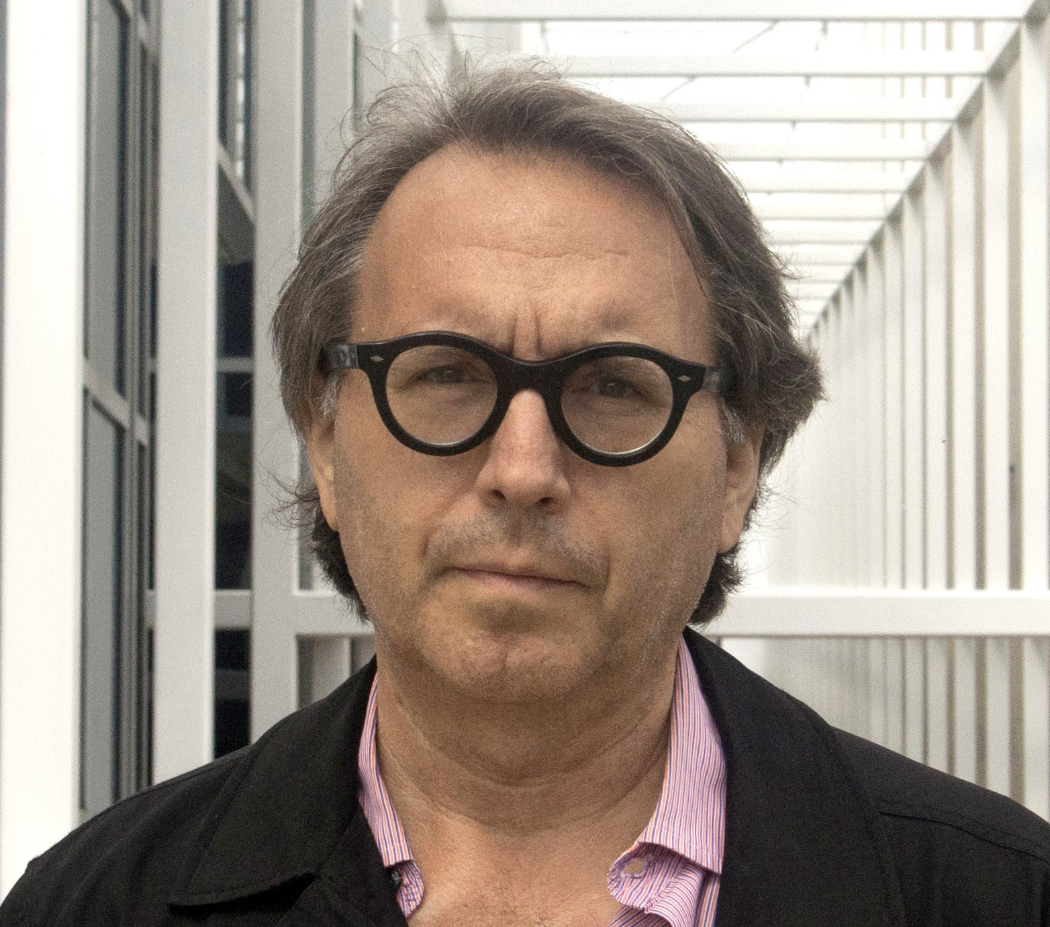  Michael Owen  Principal,  MediaCombo  Brooklyn, New York | Michael Owen is a co-founder of MediaCombo, a digital media studio. With his partner Robin White Owen, he has developed AR and VR experiences for The Morgan Library & Museum, the Carnegie Museum of Natural History and the Pollock-Krasner House & Study Center. In 2016 he went to Lake Baikal in Siberia to create three Google Expeditions. He also produced an impressionistic VR film about the Lake and has used the project to demonstrate a finalist concept for the 2020 XR for Good/ALCOVE competition. Owen has also produced documentaries, music videos, TV commercials, exhibition programs and video art for over 30 years.
Webinar(s) | Technical Workshop 3: Emerging Technology in Video Production

Created by the Museum Learning Hub.
Made possible by the Institute of Museum and Library Services.

Supplemental Resources

These supplemental resources are designed to deepen your understanding on the module’s subject matter and help you to complete this module to the best of your ability.

Articles
- Creately – Viral Video Tip: To Make Better Videos, Start with a Storyboard
- Single Grain – 20 Pre-Production Tips to Create Successful Video Content in 2021
- Landslide Creative – Video Marketing Ideas for Your Museum
- Smartify – 5 Steps to Creating Engaging Video Content For Your Museum
- Vidyard – How to Make Good Interview Videos
- Vidyard – How to Find the Best Background Music for Videos

Websites
- Video Gear
  - Adorama
  - B & H
- Flipgrid – free video discussion platform
  - How to use Flipgrid tutorial
  - Example: Buffalo Bill Center of the West
- Calendly – virtual field trip scheduler
  - How to use calendly tutorial
  - Example: Buffalo Bill Center of the West
- Skillscout - Video Planning & Distribution
  - SkillScout Production Lite Tutorials
  - SkillScout planning form
  - SkillScout resources such as ‘recipe’ cards for different types of videos
- 3D Vista – A Virtual Tour Application and Hosting Services
- Sketchfab - 3D and AR Scanning and Experiences

Guides & Books
- Gearshift.tv – A Step-by-Step Guide to Video Production
- Video Gear Guides
  - Cameras
    - 9 Best Entry Level Video Cameras for 2020
    - The best mirrorless camera in 2021: cameras for beginners, enthusiasts and pros
    - The best cinema cameras in 2021: full size and portable professional video cameras
    - Best GoPro camera in 2021
    - Best beginner drones 2021: top starter drones with cameras for new fliers
  - Lights
    - Choosing the Best Video Lighting Kit
    - Video Lighting Guide Part 1: Different Types of Light
    - How to Get the Perfect Lighting for Video
  - Microphones
    - The 10 Best Budget Filmmaking Microphones in 2021
    - The Best Lavalier Microphones for Video Production
    - The Best Wireless Audio Kits for Filmmaking at Any Budget
    - Best On-Camera Shotgun Microphones For DSLR Video Cameras
    - Best shotgun microphones
    - The Top 10 Best Microphones for Recording Voice Overs
  - Editing Software
    - The best free video editing software in 2021
    - The Best Video Editing Software for 2021
    - HOW TO: Create a time lapse
  - Greenscreen
    - 10 Best Green Screen Backdrops and Kits in 2021
  - B-Roll
    - 24 Websites to Find Affordable or Free B-Roll Footage
    - B-ROLL 101: The Complete Guide for Beginners (With Examples)
- Sharing Video Content
  - How to use and upload to popular social media platforms
    - YouTube
    - Snapchat
    - Instagram
      - How to make an instagram live
    - TikTok
    - Collaborate with microinfluencers
    - How to Repurpose Video Content Across Multiple Channels
  - How to make your videos searchable
    - How to use hashtags on YouTube
    - Optimizing video for search
  - How to create a content calendar
    - 10 Tips for Creating a Content Calendar
    - How to Create a Social Media Calendar: Tips and Templates

Media
- Virtual Museum Field Trips
  - Buffalo Bill Center of the West
  - Tenement Museum
  - Museum of the City of New York
  - Carnegie Museum of Natural History
  - Newark Museum of Art
  - Museum of Jewish Heritage
- Google Street View Tours
  - Lily Pad Gallery
  - The Peale Center for Baltimore History and Architecture
- 3D Vista Tours
  - Millennium Gallery
  - Science Museum
  - Patio de los Perfumes
- Sketchfab Projects
  - Straw Hat
  - Sewing Machine
  - Letterman Jacket
  - Feliciano Guitar

Related Training

Interested in learning more on related topics?

On the Museum Learning Hub, you’ll find a variety of free sessions, workshops, and resources that are similar in subject matter and content. We recommend the following Museum Learning Hub sessions and modules:

Module 1: Digital Accessibility & Inclusion | Digital accessibility ensures access to information and all functions of digital tools, irrespective of a person’s specific needs. This module will provide training on how to integrate accessibility and inclusion into digital programs, social pages, and

Module 2: Live Streaming | Attendees will learn about streaming solutions, broadcasting equipment, how to set up and customize a live stream event (including how to monetize), how to produce and stream pre-recorded material along with live presenters, as well as more advanced options for controlling live event production and virtual tours. Instructors will also offer accessibility considerations.

Module 8: Audiences & Analytics | Learn how to ensure you are delivering the right message to the right people at the right time. Identifying a target audience is essential for knowing where to focus your communication efforts.

