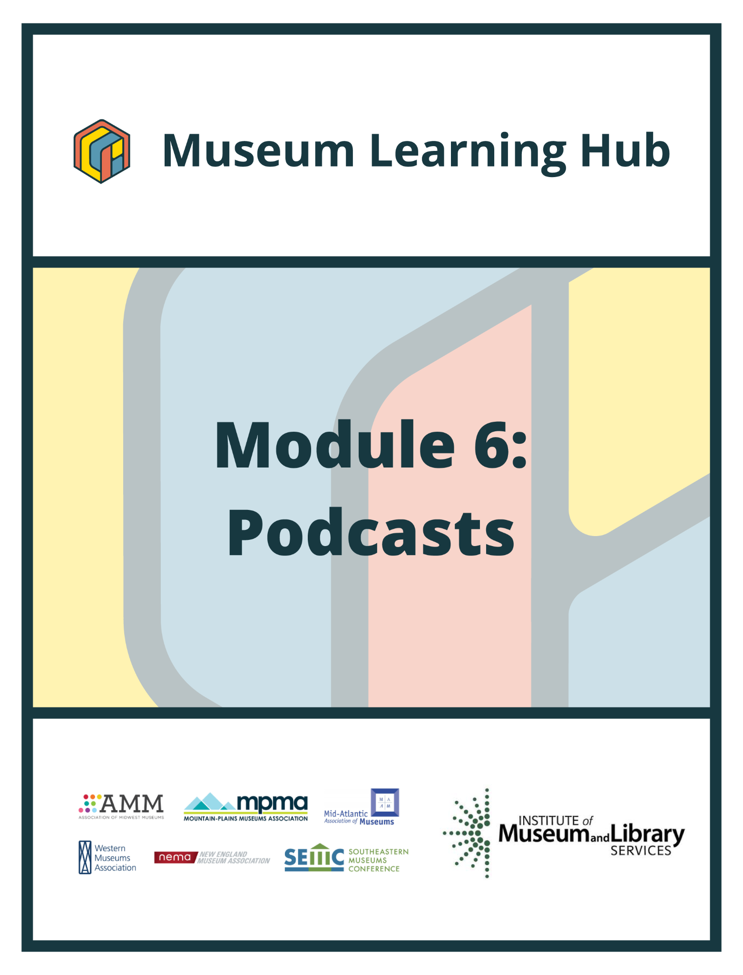
Table of Contents

- About This Module
- Learning Objectives
- Module Contributors
- Supplemental Resources
- Related Training

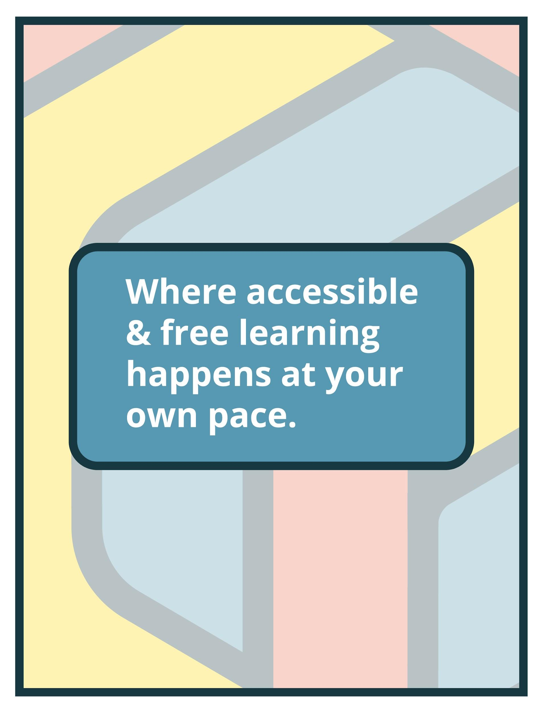

About This Module

Focus Area: | Podcasts
Learning Level: | Beginner, Intermediate, and Advanced
Module Description: | For museum professionals working to connect their institutions with new and existing audiences, it can be hard to know where to focus time and resources. Podcasting, which can be launched from a small budget, has become a popular tool for museums to tell diverse stories and meaningfully engage audiences. This module will review podcast planning and implementation strategies and how museums can share what makes them unique through this engaging technology.
Search Terms: | Podcast, audiences, storytelling, technology

Sessions found in this Module:

Session 1 | Get Inspired!
Technical Workshop 1 | Introduction to Podcasting for Museums
Technical Workshop 2 | Episode Planning: Writing and Recording Your Podcast
Technical Workshop 3 | Podcast Editing and Collaborative Production Models
The views, findings, conclusions or recommendations expressed in this series and toolkit do not necessarily represent those of the Institute of Museum and Library Services.

Learning Objectives

Upon completion of this module, you will have gained the skills and practical knowledge to reach your audiences through podcasting.

Session 1: Get Inspired! | Has your museum considered making a podcast? Podcasting can help small museums engage with the public, educate, entertain, and make connections to collections, creators, and diverse audiences in a cost-effective way. Join this introductory session to get inspired by the talented museum professionals behind the 5 Plain Questions and Before Your Time podcasts, each produced through careful planning, collaboration, determination, and creative grit! One podcast was created pre-pandemic, the other during COVID-19 closures. Hear directly from their creators about their process, challenges, successes, teams, and tools (including podcasting from home studios!). Plus find out what the future looks like for each series.

Technical Workshop 1:  Introduction to Podcasting for Museums | This webinar will introduce the medium of podcasting for museums with a focus on how podcasts are consumed and what is already being done in the sector. Instruction will briefly cover the A-Z of production (to be discussed further in workshops 2 and 3) and podcast planning including how to decide if a podcast is a right fit for your museum, what to podcast about, and how to turn existing expertise and resources into a winning show idea. The session will also introduce podcast distribution, marketing, and evaluation.

Technical Workshop 2:  Episode Planning: Writing and Recording Your Podcast | The second training session in Module 6 will cover technical and creative aspects of planning podcast episodes including recording interviews (in-person and remote) and writing and recording narration. Instruction will cover podcast equipment (at different budget levels) such as types of microphones, and how to prepare for and conduct a great interview. Tips and tricks for recording natural-sounding narration and writing effective scripts will also be addressed.

Technical Workshop 3:  Podcast Editing and Collaborative Production Models | The final technical session in Module 6 will introduce attendees to a variety of free and inexpensive tools for podcast editing. Instruction will cover transcription and editing platforms and online tools that even novice editors can use to fast-track sound engineering. Attendees will be introduced to podcast editing guidelines and a selection of Digital Audio Workstations (DAWs). Different models for collaborative production and outsourcing podcast assistance will also be discussed.

Module Contributors

These are the experts and presenters who are involved in the development and presentation of each session, workshop, resource, and activity you find within this module.

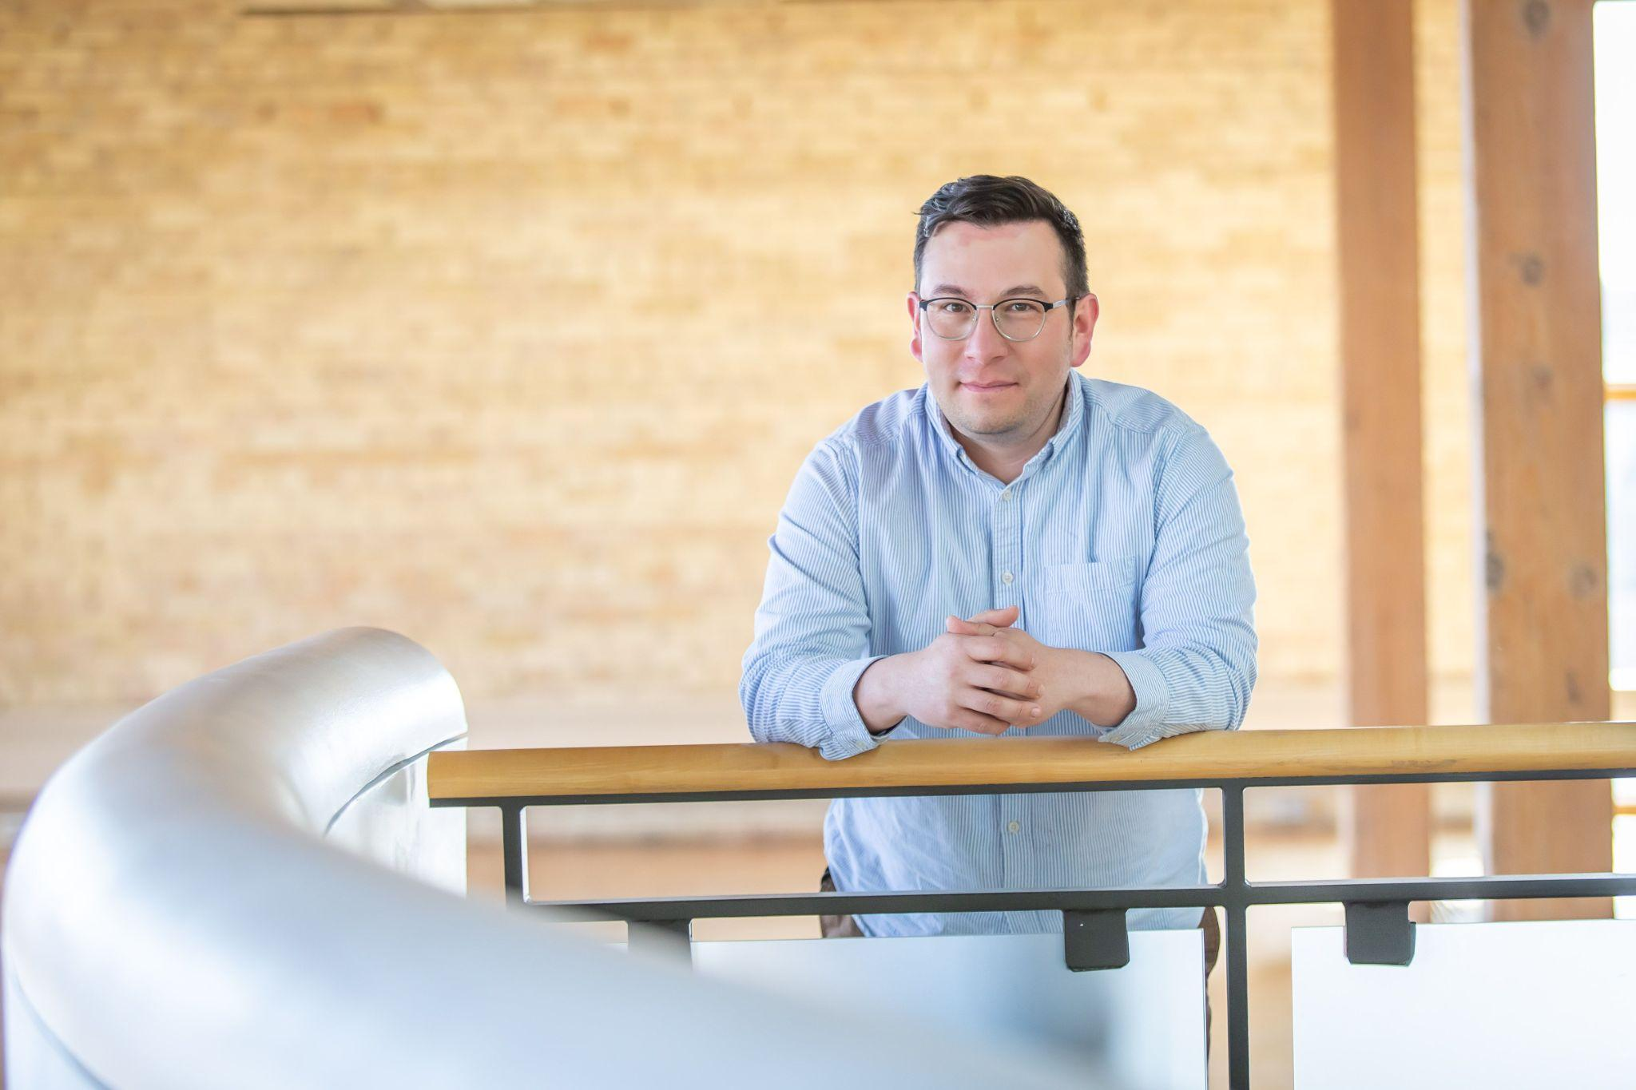Joe Williams  Director - Native American Programs,  Plains Art Museum | Joe Williams is the Director of Native American Programs at the Plains Art Museum in Fargo, North Dakota. He is Waȟpéthuŋwaŋ Dakota and a member of the Sisseton Wahpeton Oyate Reservation from Sisseton, South Dakota. Williams has a Master of Fine Arts in Animation and Visual Effects from the Academy of Art University in San Francisco, and a Bachelor of Arts in American Indian Studies from the University of South Dakota.  Williams is an artist and has worked with Native American youth in the social context as well as in the art field. From 1993 to 2007 Williams was part of a summer arts program, as student and staff, for the Oscar Howe Summer Art Institute which taught art to Native American high school students.  Joe Williams served in the Army National Guard for 20 years. In his last 10 years of service he was a Civil Affairs soldier. Currently, Williams is the creator and host of the 5 Plain Questions podcast, an interview series that poses 5 general questions to Native American artists, creators, musicians, writers, movers and shakers, and culture bearers.
Webinar(s) | Session 1: Get Inspired!

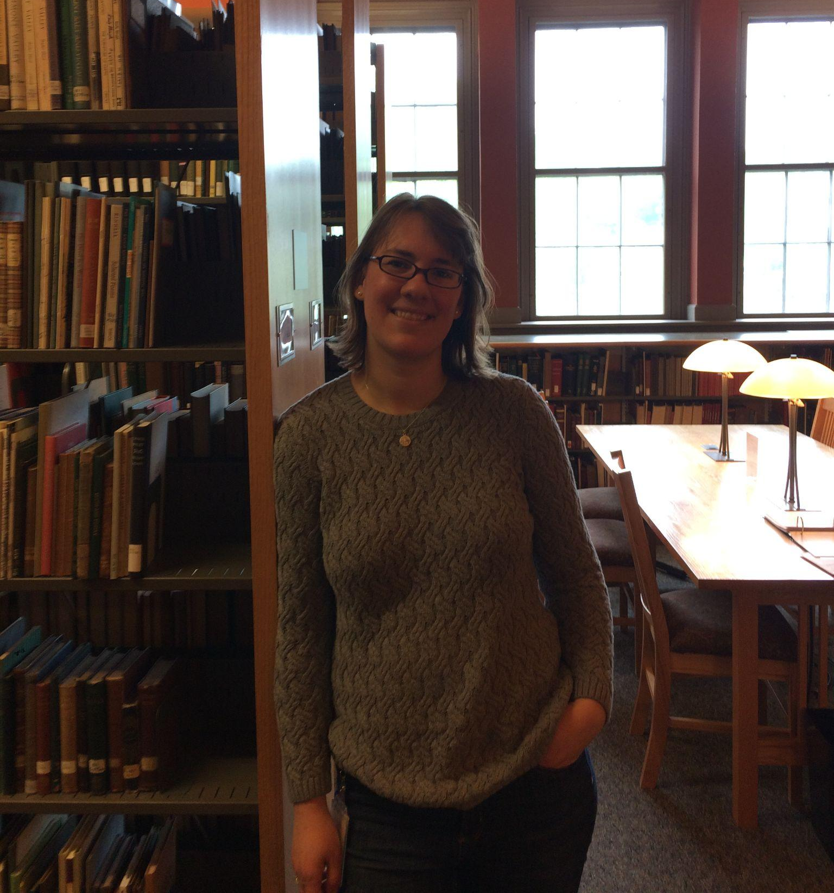Amanda Gustin  Public Program Manager,  Vermont Historical Society | Amanda Gustin is the Public Program Manager at the Vermont Historical Society, where she works on statewide projects that examine and share Vermont’s history, including public programs, research projects, and exhibits. She holds degrees in history and museum studies from Middlebury College and Tufts University and has held leadership positions with the American Association of State and Local History and the New England Museum Association.
Webinar(s) | Session 1: Get Inspired!

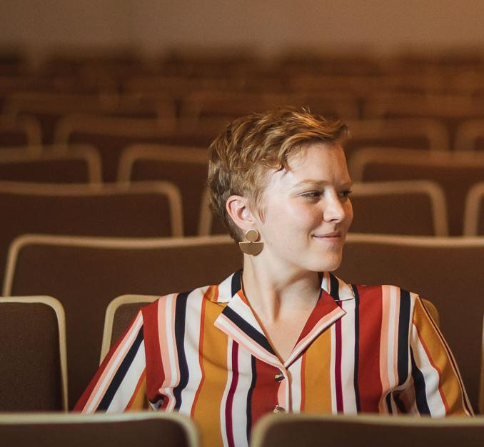Hannah Hethmon  Owner/Executive Producer,  Better Lemon Creative Audio | Hannah Hethmon is the Owner/Executive Producer of Better Lemon Creative Audio, a production company focused exclusively on museums, history organizations, and cultural nonprofits. Hannah holds a B.A. in English Literature from the University of Maryland, College Park, and an M.A. in Medieval Norse Studies from the University of Iceland. After working in the public history field in the United States for several years, Hannah returned to Iceland on a Fulbright Fellowship, where she merged her interests in museums and podcasting. Hannah is the author of the popular handbook, Your Museum Needs a Podcast: A Step-By-Step Guide to Podcasting on a Budget for Museums, History Organizations, and Cultural Nonprofits. She is a three-time winner of the AAM MUSE Awards for podcasting and her first podcast has been selected for collection by the United States Library of Congress. Hannah lives and works in historic Greenbelt, Maryland.
Webinar(s) | Technical Workshop 1, Technical Workshop 2, Technical Workshop 3

Created by the Museum Learning Hub.
Made possible by the Institute of Museum and Library Services.

Supplemental Resources

These supplemental resources are designed to deepen your understanding of the module’s subject matter and help you to complete this module to the best of your ability.

Articles
- Forbes: “As Podcasts Continue To Grow In Popularity, Ad Dollars Follow“
- MuseumNext: “Hannah Hethmon on Podcasting in Museums”
- Vulture: “Yes, Podcast Listenership Is Still on the Rise”
- Podcast Statistics for 2021

Websites
- Audio Editing Tools
  - Hindenburg
  - Audacity
  - Adobe Audition
  - ProTools
  - Ferrite
  - Anchor
  - Auphonic
  - Descript
- Recording Tools
  - Zencastr
  - Squadcast (remote recording)
- Hosting Platforms
  - Libsyn
  - Podbean
  - Blubrry
  - Anchor
- Other Tools
  - Filesharing: Google Drive
  - Linksharing: pod.link
  - Website Hosting: WordPress
  - Transcription: Trint
  - Create social media videos out of audio: Headliner.app

Guides & Books
- Books
  - Your Museum Needs a Podcast: A Step-By-Step Guide to Podcasting on a Budget for Museums, History Organizations, and Cultural Nonprofits, Hannah Hethmon
  - Storycraft: The Complete Guide to Writing Narrative Nonfiction, Jack Hart
  - Out on the Wire: Storytelling Secrets of the New Masters of Radio, Jessica Abel
  - So You Want to Start a Podcast: Finding Your Voice, Telling Your Story, and Building a Community That Will Listen, Kristen Meinzer
- Easy-to-Use Mics and Recording Tools
  - RØDE NT USB Mini
  - Samsung Q2U
  - RØDE Reporter
  - Audio-Technica AT2020 USB+
  - RØDECaster Pro | Podcast Production Studio
  - Zoom H4n Pro Handy Recorder
- Museum Podcasting Resource List

Media
- Podcast Workshop #1: Introduction to Podcast & Show Development
  - Presentation Slides
- Podcast Workshop #2: Episode Planning & Writing and Recording Your Podcast
  - Presentation Slides
- Hannah Hethmon, Interviews and Talks
  - Podcasting for Connection at Smithsonian, Arts Marketing Association
  - The Power of Podcasting, DigitalWorks
  - Museum Podcasts: Dusty Documents to Hold-Your-Breath Stories, MuseumNext
  - Webinar on Podcasting for Cultural Heritage with Hannah Hethmon, Europa Nostra
  - How to Start a Podcast at Your Museum in Ten Steps, MW 2019 Boston
  - How and Why to Podcast: Tips and Tricks, Carroll County Public Library
- Museum Podcasts
  - Better Lemon Audio: Directory of Podcasts by Museums and other Cultural Nonprofits
  - The Object, Minneapolis Institute of Art
  - Q&Abe, President Lincoln’s Cottage
  - Art Matters, ArtUK
  - Sparrow's Point: An American Steel Story, Baltimore Museum of Industry
  - Departures, Migration Museum
  - On the Record at The National Archives, The National Archives (UK)
  - Articulated: Dispatches from the Archives of American Art
  - Preservation Profiles, National Preservation Institute
  - How to Be American, Tenement Museum
  - Distillations, Science History Institute
  - 5 Plain Questions, Plains Art Museum
  - Before Your Time, Vermont Historical Society
  - The Vagina Museum Podcast, Vagina Museum
  - Raw Material, SF MoMA
  - Museum Archipelago
  - Voices of the Royal Pavilion & Museums, Royal Pavillion & Museums
  - Egham Oddities: The Egham Museum Podcast, Egham Museum
  - Heavier! Faster! Louder! The Story of Tyneside Heavy Metal, Tyne & Wear Archives & Museums
  - Museums n'That, Leeds Museums and Galleries
  - Stories from the Eastern West, Culture.pl (Adam Mickieweicz Institute)

Related Training

Interested in learning more on related topics?

On the Museum Learning Hub, you’ll find a variety of free sessions, workshops, and resources that are similar in subject matter and content. We recommend the following Museum Learning Hub sessions and modules:

Module 1: Digital Accessibility & Inclusion | Digital accessibility ensures access to information and all functions of digital tools, irrespective of a person’s specific needs. This module will provide training on how to integrate accessibility and inclusion into digital programs, social pages, and

Module 2: Live Streaming | Attendees will learn about streaming solutions, broadcasting equipment, how to set up and customize a live stream event (including how to monetize), how to produce and stream pre-recorded material along with live presenters, as well as more advanced options for controlling live event production and virtual tours. Instructors will also offer accessibility considerations.

Module 8: Audiences & Analytics | Learn how to ensure you are delivering the right message to the right people at the right time. Identifying a target audience is essential for knowing where to focus your communication efforts.

