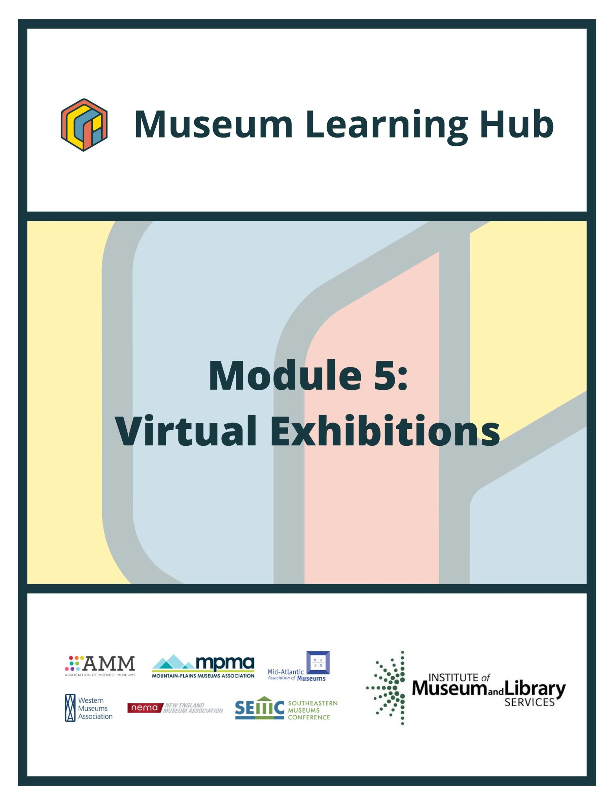
Table of Contents

- About This Module
- Learning Objectives
- Module Contributors
- Supplemental Resources
- Related Training

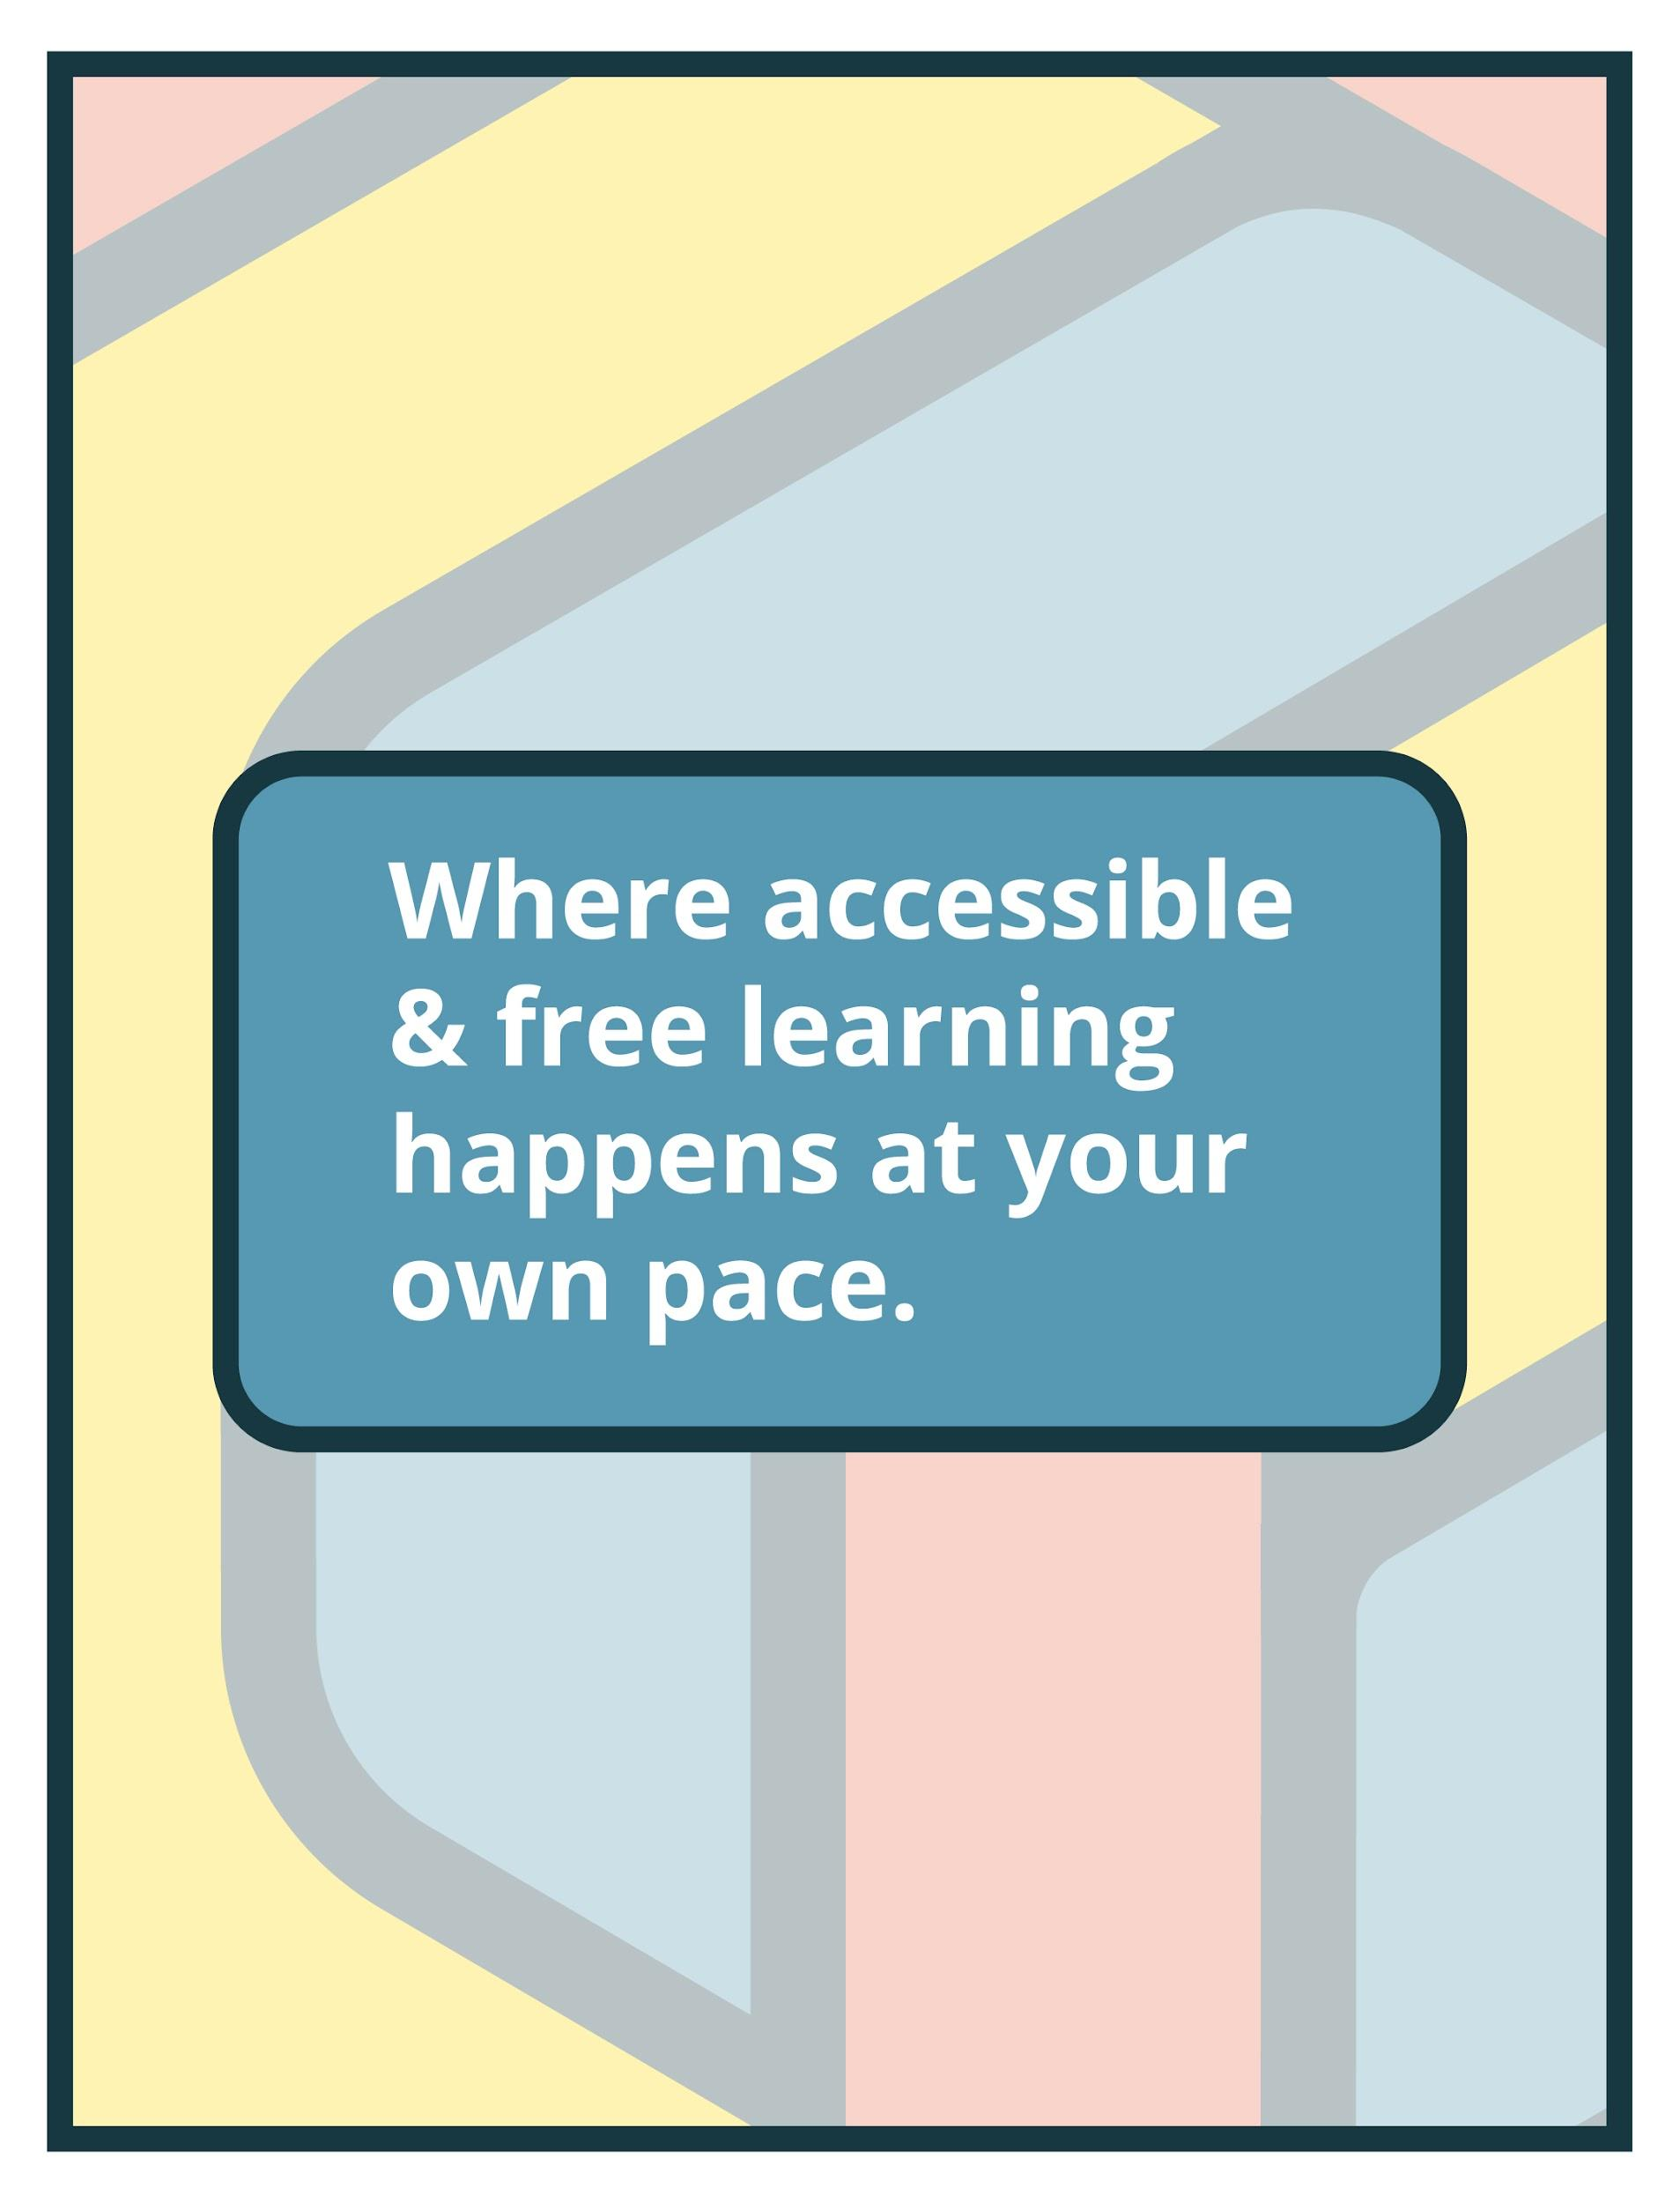

About This Module

Focus Area: | Virtual Exhibitions
Learning Level: | Beginner, Intermediate, and Advanced
Module Description: | Digital exhibitions can offer unprecedented access to museum collections that might never be seen otherwise except by those with physical access. This module will explore how to build an online exhibition and introduce open-source and free software tools available to create exhibition narratives and layouts for online display.
Search Terms: | Exhibitions, collections, virtual displays

Sessions found in this Module:
Session 1 | Get Inspired!
Technical Workshop 1 | Strategies, Project Workflow and Efficient Design
Technical Workshop 2 | Web-Based Curatorial Approaches
Technical Workshop 3 | Exhibition Design in Virtual Environments
The views, findings, conclusions or recommendations expressed in this series and toolkit do not necessarily represent those of the Institute of Museum and Library Services.

Learning Objectives

Upon completion of this module, you will have gained the skills and practical knowledge to successfully create online exhibitions.

Session 1: Get Inspired! | Thinking about adding virtual exhibitions to your museum’s menu of offerings? Looking for guidance on how museums have organized exhibits beyond their galleries, absent four walls and dramatic lighting, and to learn how they pushed the technological and creative limits of their virtual presence? Join this introductory session to hear from museum staff who successfully created online exhibitions. Get inspired by the curatorial possibilities of limitless virtual space and access! Presenters will discuss the virtual exhibit development process including teams, time, budgets, and platforms, and consider how virtual exhibits can accommodate updates and content expansion in ways that physical exhibits cannot. Connect with museum professionals doing this work and keeping their organizations innovative and forward-thinking.

Technical Workshop 1:  Virtual Exhibitions: Strategies, Project Workflow and Efficient Design | When is it appropriate to create an online exhibition? What are the differences between an online exhibition and a physical one? Where does the creation of a virtual exhibit begin? Join this technical session to better understand the methodological framework required to create a virtual exhibition as well as the philosophical challenges involved.

Technical Workshop 2:  Curating a Virtual Exhibition: Demonstration and Approaches | The second technical session in Module 5 will investigate the connective and distinguishing elements between curating an online exhibition and designing a website. When must a digital curator wear the hat of a web developer? Join this workshop to learn strategies for ensuring online curatorial practice is not lost in a myriad of technical issues. Experience demonstrations on WordPress and Squarespace, and learn about costs and benefits of using other content management systems (CMS) for online exhibitions.

Technical Workshop 3: | Dr. Nettrice Gaskins will bring the perspectives of both the digital artist and digital curator to look at exhibition design in virtual environments. What are some design constraints when exhibiting two-dimensional works in three-dimensional virtual spaces? For artists, how should physical work be prepared for virtual exhibition? Dr. Gaskins will present case studies to address these questions.

Module Contributors

These are the experts and presenters who are involved in the development and presentation of each session, workshop, resource, and activity you find within this module.

Meg Salocks  Director of Marketing and Engagement,  Lake Champlain Maritime Museum | Meg Salocks is the Director of Marketing and Engagement at Lake Champlain Maritime Museum and a nonprofit marketing consultant. She specializes in digital marketing and designing affordable, sustainable methods of audience engagement to help organizations grow.  Before joining the team at the Maritime Museum in 2019, Meg worked as a consultant helping nonprofits, arts organizations, and museums in Boston, Rhode Island, and Detroit with digital campaigns and audience growth. She was the Digital Marketing and List Manager at the Smithsonian’s National Museum of American History where she built an avid local audience of returning subscribers to their evening food history events, signature annual festivals, and Smithsonian Jazz concert series.  Meg holds a M.A. in Arts Administration from Columbia University and a B.A. in French from the University of Vermont.
Webinar(s) | Session 1: Get Inspired!

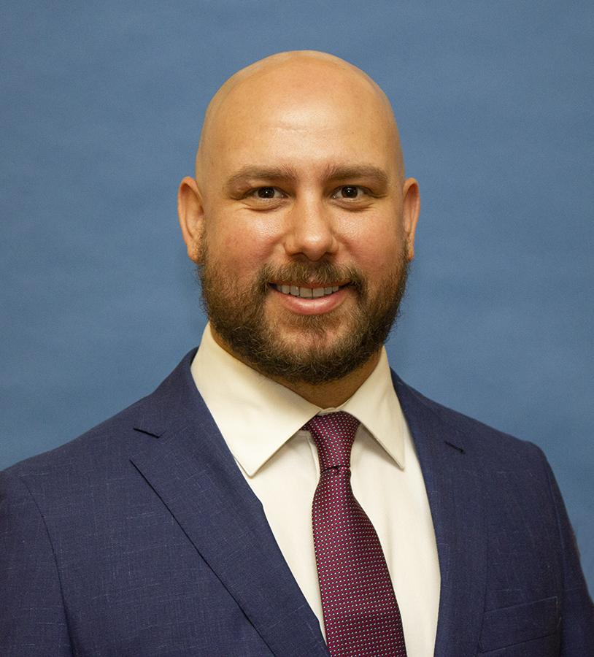Matt Farah  Associate Curator/Exhibitions Coordinator,  The Historic New Orleans Collection | Matt Farah is Associate Curator and Exhibition Coordinator at The Historic New Orleans Collection. He began his career at THNOC in 2010 as a docent and has worked as cataloger, preparator, reference assistant, and curator of travelling exhibitions. A graduate of Tulane University, his graduate work focused on the political history of the American South. His past exhibitions include “From Winnfield to Washington: the Life and Career of Huey P. Long” and “Merry As the Day is Long: Shakespeare’s Hand in New Orleans”.
Webinar(s) | Session 1: Get Inspired!

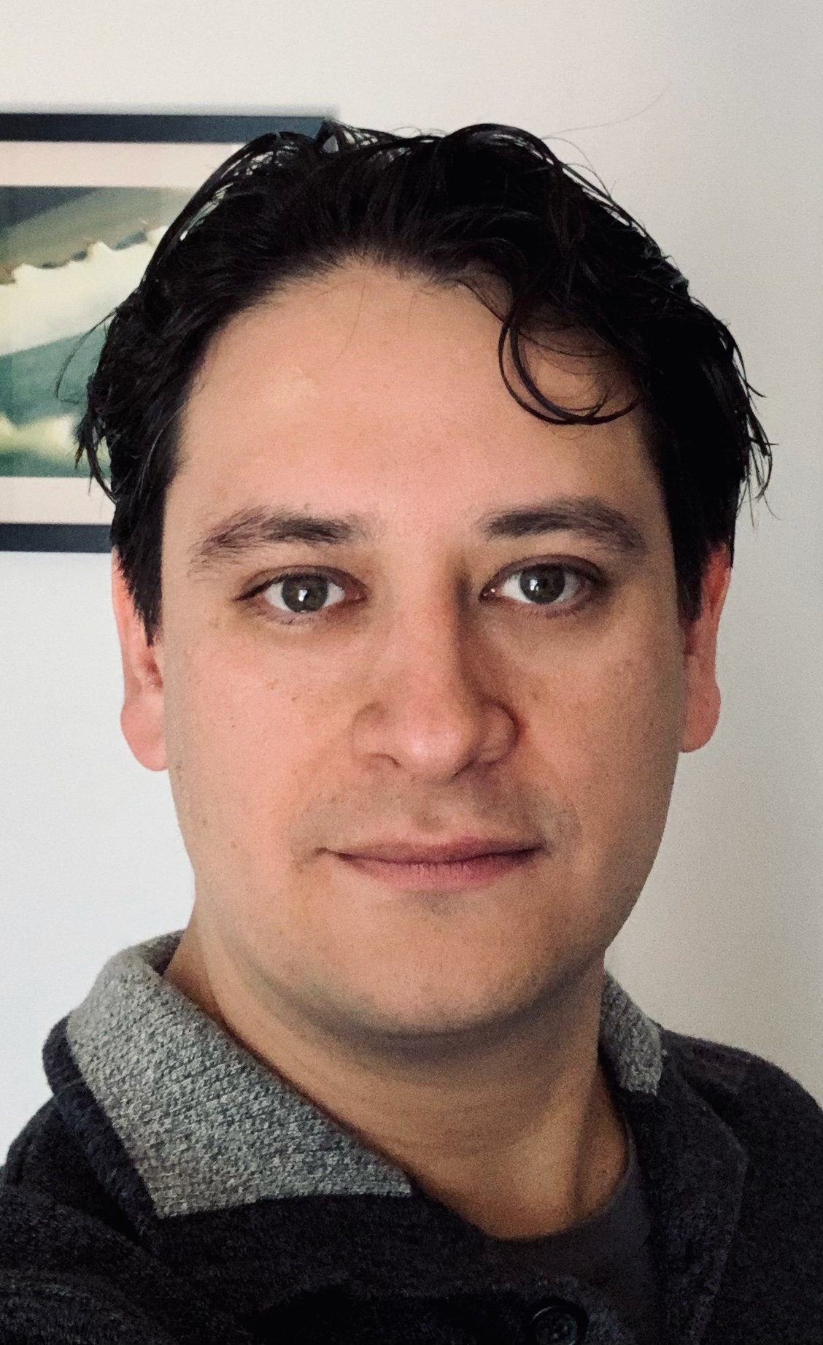Dr. Rene G. Cepeda  Independent art historian and curator,  Puebla, PU, Mexico | Rene G. Cepeda is an independent art historian and curator specializing in New Media Art. He is the author of the Manual for the Curation of Interactive New Media Art and co-editor of the Game Arts Curators Kit. He has taught at UDLAP and currently teaches at UNARTE in Puebla Mexico. His research interests include new media art, digital performance, art video games, interaction and exhibition design.
Webinar(s) | Technical Workshop 1: Strategies, Project Workflow and Efficient Design

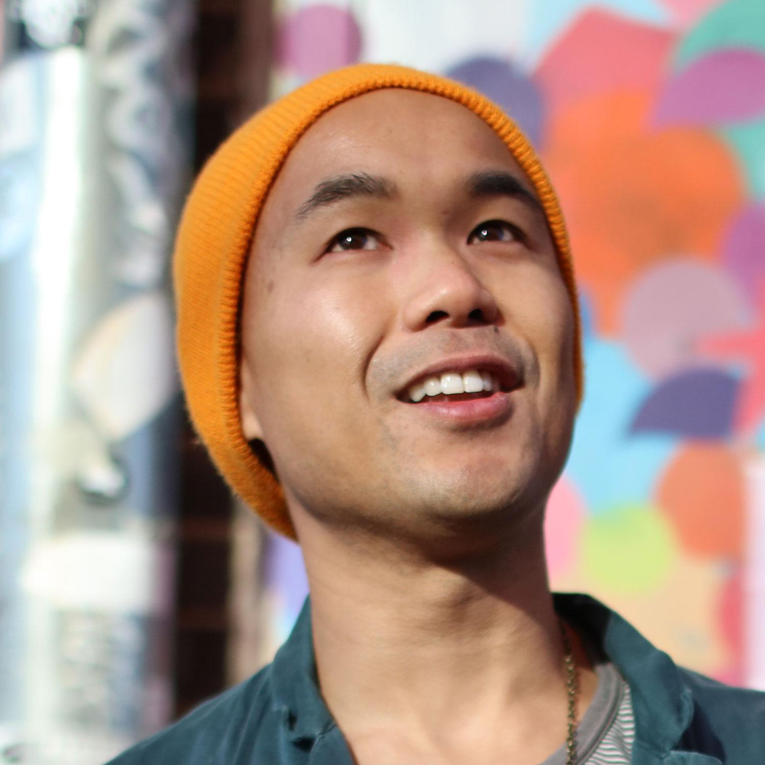Adriel Luis  Curator of Digital and Emerging Practice,  Smithsonian Asian Pacific American Center,  Washington, DC | Adriel Luis is a community organizer, artist, writer, and curator who believes that collective liberation can happen in poetic ways. His life’s work is focused on the mutual thriving of artistic integrity and social vigilance. He is a part of the iLL-Literacy arts collective, which creates music and media to strengthen Black and Asian coalitions, and is creative director of Bombshelltoe, a collaborative of artists and leaders from frontline communities responding to nuclear histories. Adriel is the Curator of Digital and Emerging Practice at the Smithsonian Asian Pacific American Center, where he advocates for equitable practices in museums and institutions. His ancestors are rooted in Toisan, China, and migrated through Hong Kong, Mexico, and the United States. Adriel was born on Ohlone land.
Webinar(s) | Technical Workshop 2: Web-Based Curatorial Approaches

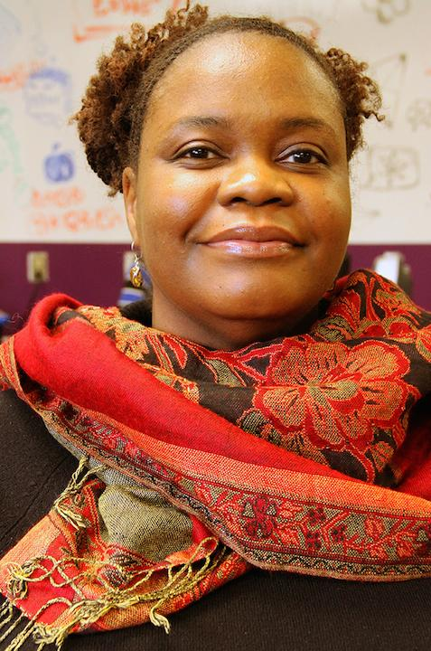Dr. Nettrice R. Gaskins  Digital Artist, Academic, and Cultural Critic,  Boston, MA | Dr. Nettrice R. Gaskins is an African American digital artist, academic, cultural critic and advocate of STEAM fields. In her work she explores "techno-vernacular creativity" and Afrofuturism.  Dr. Gaskins teaches, writes, "fabs”, and makes art using algorithms and machine learning. She has taught multimedia, computational media, visual art, and even Advanced Placement Computer Science Principles with high school students who majored in the arts. She earned a BFA in Computer Graphics with Honors from Pratt Institute in 1992 and an MFA in Art and Technology from the School of the Art Institute of Chicago in 1994. She received a doctorate in Digital Media from Georgia Tech in 2014. Currently, Dr. Gaskins is a resident in the Autodesk Technology Centers Outsight Network. She is the assistant director of the Lesley STEAM Learning Lab at Lesley University. Her first full-length book, Techno-Vernacular Creativity and Innovation through The MIT Press will be available in August.  Gaskins served as Board President of the National Alliance for Media Arts and Culture (The Alliance) and was on the board of the Community Technology Centers Network (CTCNet). She is currently on the board of Artisan’s Asylum.
Webinar(s) | Technical Workshop 3: Exhibition Design in Virtual Environments

Created by the Museum Learning Hub.
Made possible by the Institute of Museum and Library Services.

Supplemental Resources

These supplemental resources are designed to deepen your understanding on the module’s subject matter and help you to complete this module to the best of your ability.

Articles
- Bigger Than the Internet by Adriel Luis

Websites
- Tools
  - Drupal
  - Google Arts and Culture
    - Augmented Reality Google Arts and Culture
  - Unity
  - WordPress
    - WordPress.org
    - WordPress.com
  - Squarespace
  - Blogger
  - ArcGIS StoryMaps
  - ESRI (GIS mapping software)
  - Exhibbit: 3D Virtual Art Galleries
  - 360 ̊ Digital
  - 4th Wall App
  - Unreal Engine
  - KUNSTMATRIX
- The Uncensored Library
- Grants
  - Digitizing Hidden Collections and Archives Grants
  - Terra Foundation Grants

Guides & Books
- Techno-Vernacular Creativity & Innovation by Nettrice R. Gaskins
- A Manual for the Display of Interactive New Media Art

Media
- Historic New Orleans
  - Historic New Orleans Google Arts and Culture
  - Virtual Exhibitions at the Historic New Orleans Collection
  - "Yet She Is Advancing": New Orleans Women and the Right to Vote, 1878–1970
  - New Orleans 360 ̊ Digital Medley
- Lake Champlain Maritime Museum
  - Lake Champlain Maritime Museum Digital Exhibits
  - Women at the Helm Digital Exhibit
- MassArt 2020 MFA Thesis Show
  - Part 1
  - Part 2
- Alternate Futures: Afrofuturist Multiverses & Beyond
- Bombshelltoe
- Care Package by Smithsonian Asian Pacific American Center
- There, There by IA&A at Hillyer
- Virtual exhibition, Identidades
- The Museum of the World exhibit

Related Training

Interested in learning more on related topics?

On the Museum Learning Hub, you’ll find a variety of free sessions, workshops, and resources that are similar in subject matter and content. We recommend the following Museum Learning Hub sessions and modules:

Module 1: Digital Accessibility & Inclusion | Digital accessibility ensures access to information and all functions of digital tools, irrespective of a person’s specific needs. This module will provide training on how to integrate accessibility and inclusion into digital programs, social pages, and

Module 4: Managing Website Projects | A good project management process with a checklist of essential elements to cover can help organizations successfully create and/or optimize a website. Whether using a website developer or managing all website content in-house, this module will provide training sessions to help users develop a project with time devoted to planning and execution including collecting information (what are the purpose, goals and target audience), organizing a design (prototyping and wire frames), development, project schedules, milestones and future expectations.

Module 8: Audiences & Analytics | Learn how to ensure you are delivering the right message to the right people at the right time. Identifying a target audience is essential for knowing where to focus your communication efforts.

