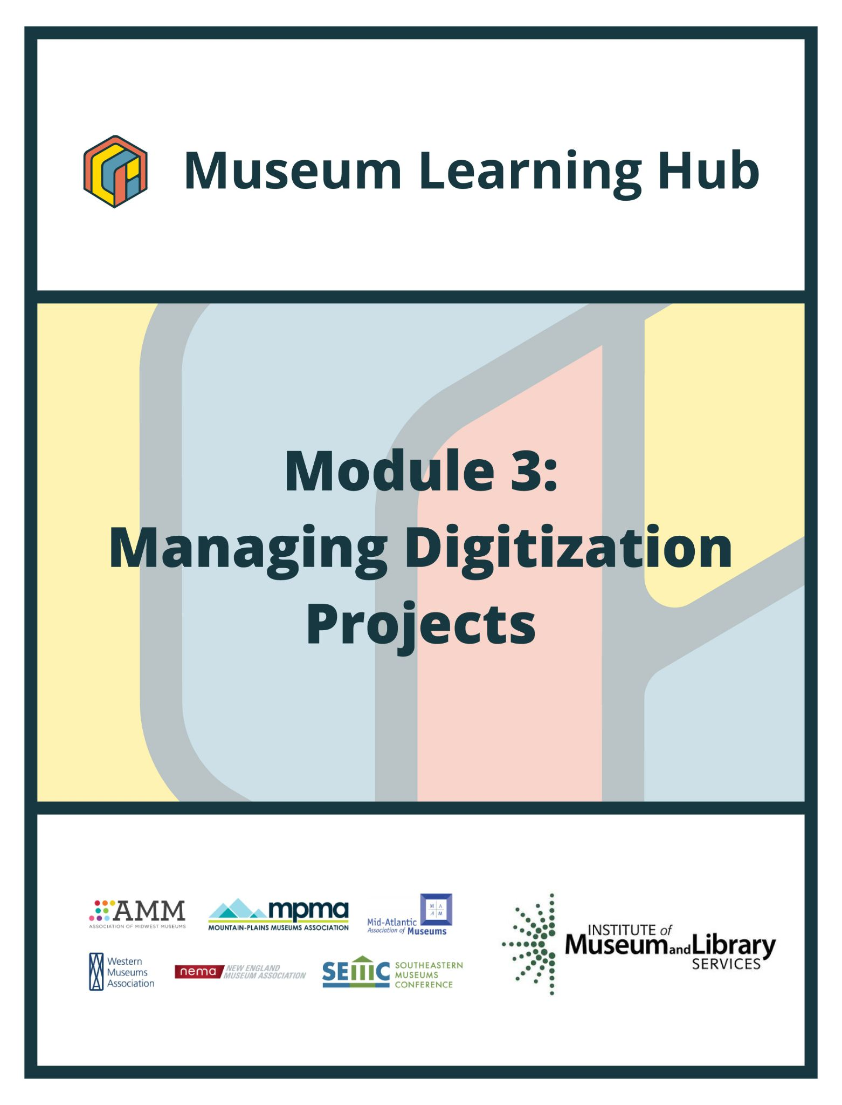
Table of Contents

- About This Module
- Learning Objectives
- Module Contributors
- Supplemental Resources
- Related Training

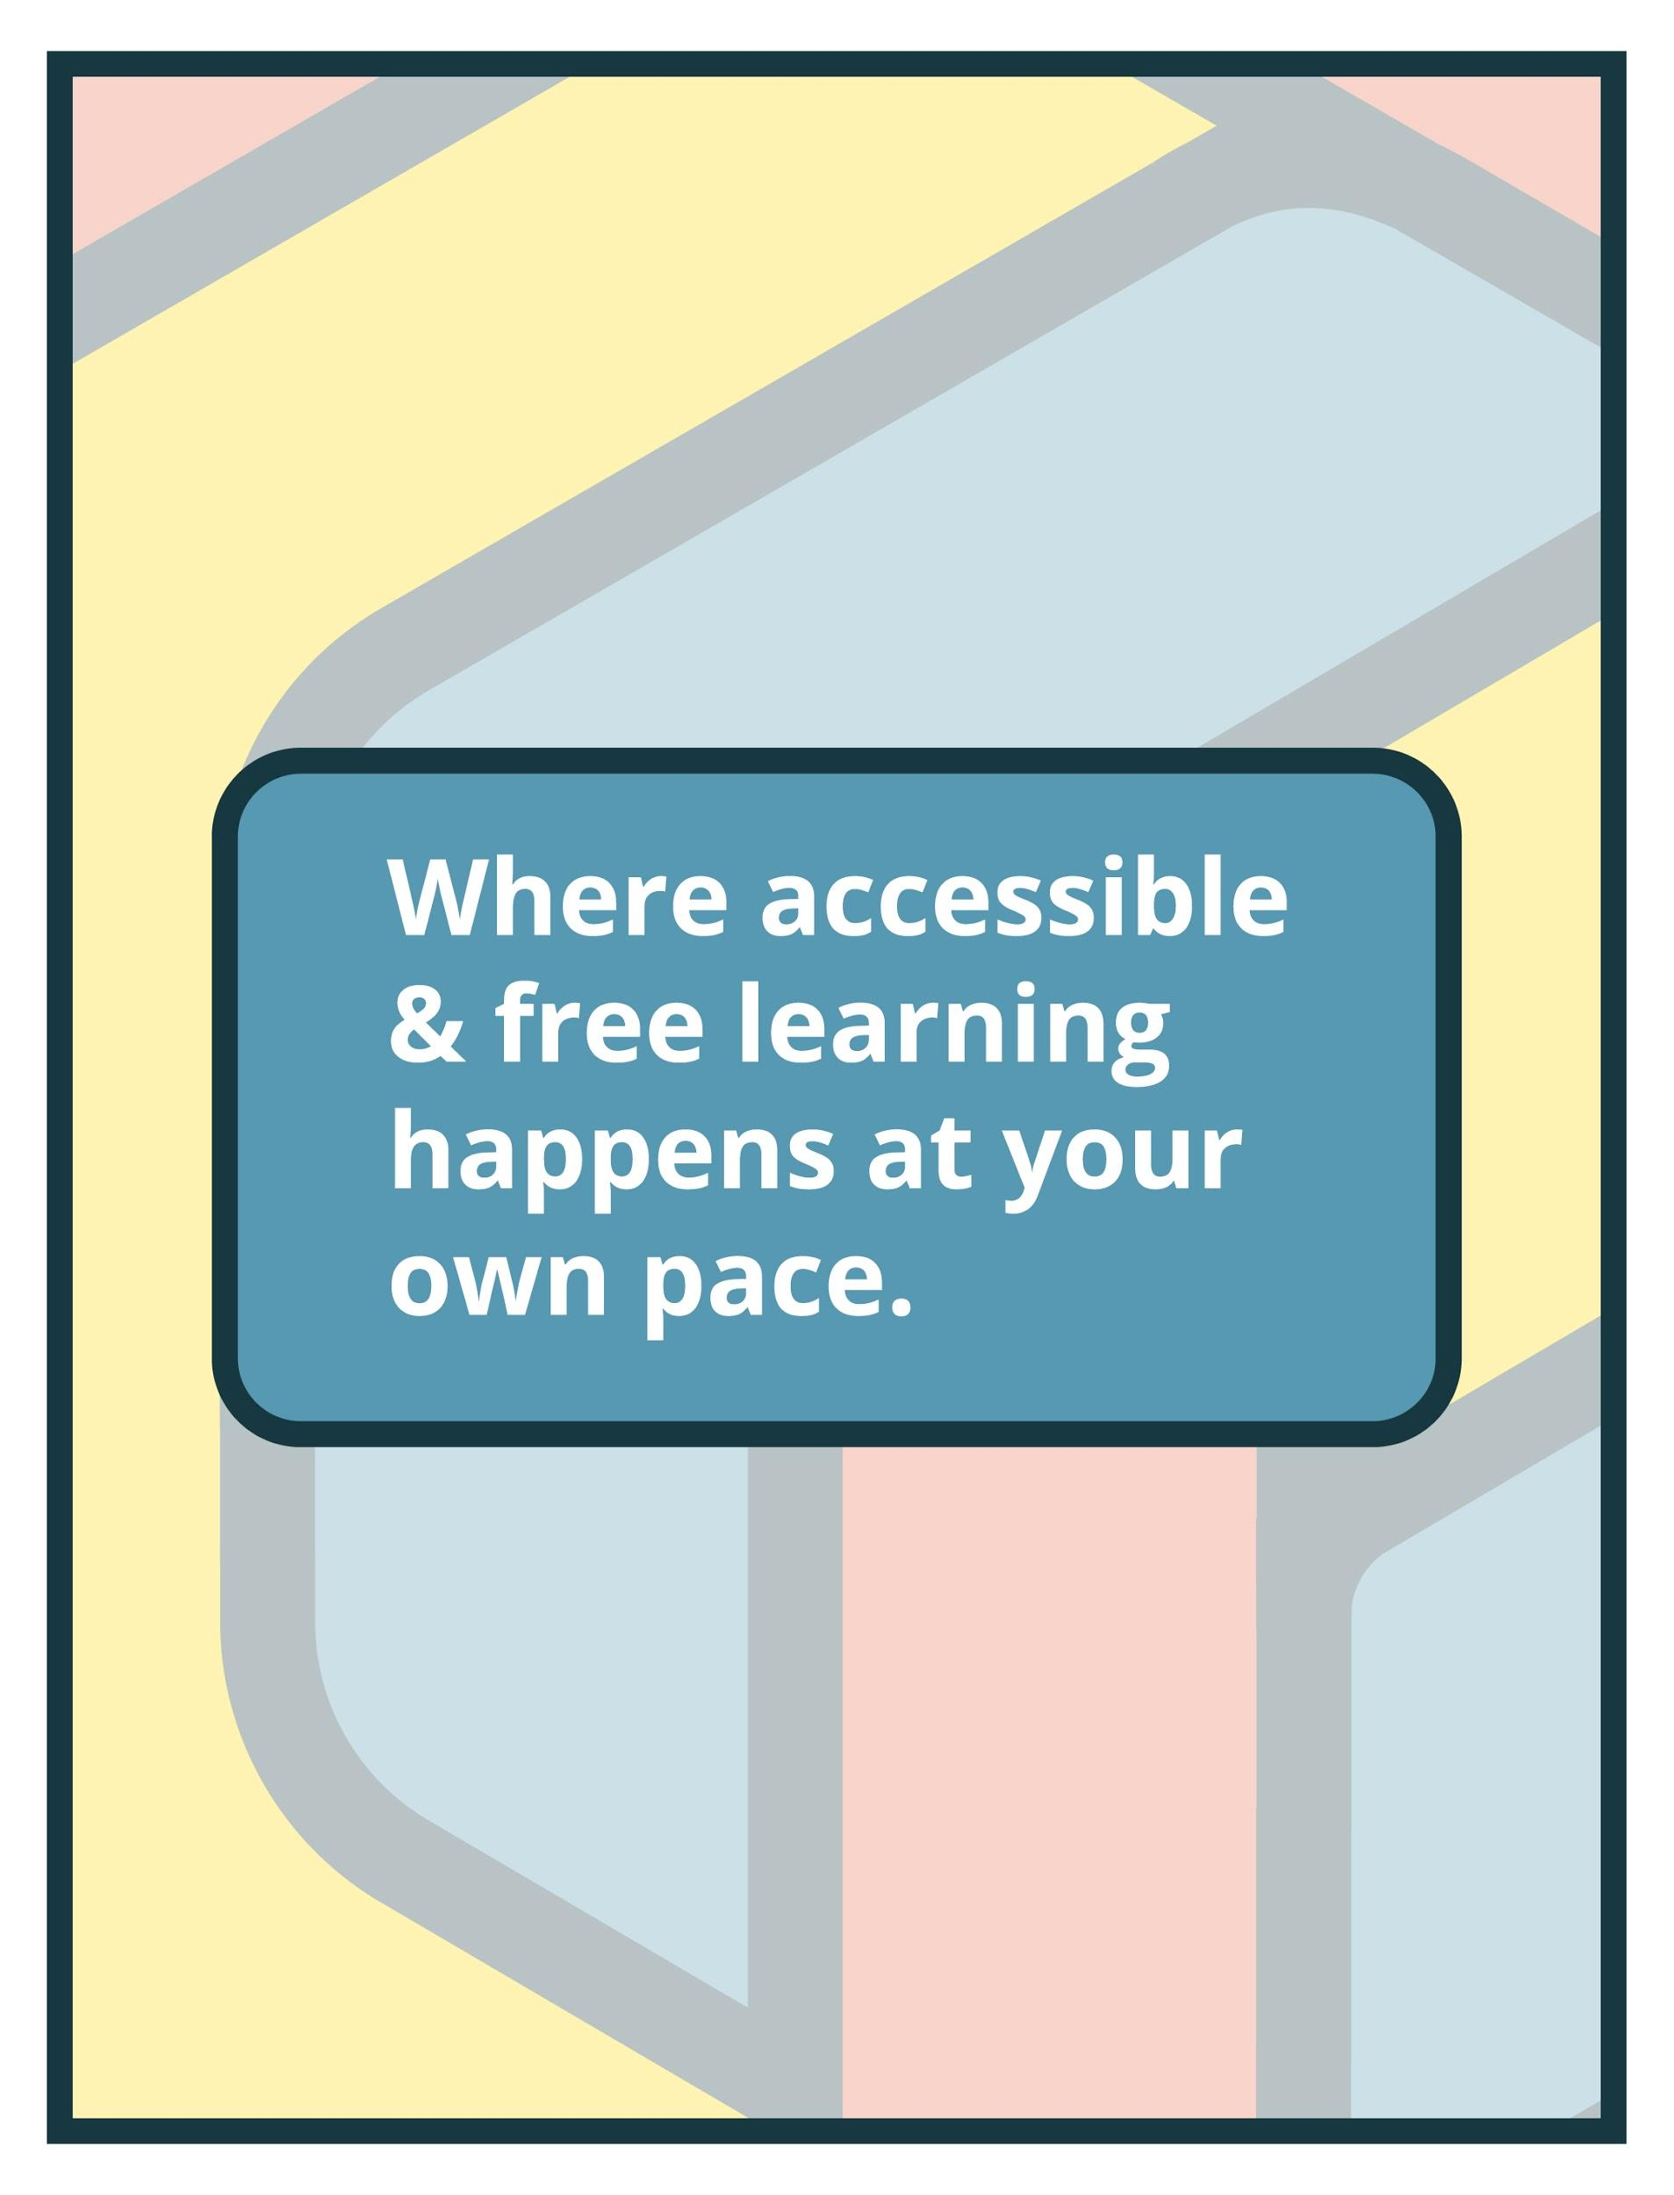

About This Module

Focus Area: | Module 3: Managing Digitization Projects
Learning Level: | Beginner, Intermediate, and Advanced
Module Description: | Many museums, archives and cultural institutions have digital collections. This module focuses on tools, resources, best practices, and descriptive standards for building a robust digital collection program and structuring digital collection projects correctly covering common decision points in digital project planning, project implementation, and long-term maintenance of digitized records.
Search Terms: | Digitization, Collections, Archives, Project Management

Sessions found in this Module:
Intro Session | Get Inspired!
Technical Workshop 1 | Digitization: Strategy and Purpose
Technical Workshop 2 | How to Build a Digitization Project
Technical Workshop 3 | Imaging Standards and Logistics in Digitization Projects
The views, findings, conclusions or recommendations expressed in this series and toolkit do not necessarily represent those of the Institute of Museum and Library Services.

Learning Objectives

Upon completion of this module, you will have gained the skills and practical knowledge to successfully assess existing and potential digital collections, review recommended digitization tools and equipment, and be introduced to digital preservation practices.

Intro Session | Thinking about tackling a digitization project? Join this introductory session to hear from museum staff who successfully conceptualized, planned and implemented projects to expand the online presence of collections. Presenters will share different approaches to digital projects and discuss goals, budget (or lack thereof,) planning process, partnerships and technologies utilized to turn museums inside out and make collections accessible online.

Technical Workshop 1 | The first technical workshop will address the “why” and “who” of collections digitization projects - why your digitization project matters and to whom; the importance of defining your digital collection project’s purpose, audience, and interfaces; the role of digitization in your museum’s access strategies and how communities will use your digital collection; how to use metadata for findability and to support public use/access.

Technical Workshop 2 | Now that you know why, how: How do you plan a successful project, where do you start, how do you identify priorities? What should you include? Should you digitize in-house or use a vendor? What are your short- and long-term goals and considerations? Tech workshop 3 in the Managing Digitization Projects module will address these questions and offer tips for digitization project managers as they get started.

Technical Workshop 3 | Let’s get down to the nuts and bolts of how to work with the resources you have to achieve your digitization goals. During Tech Workshop 3, we'll take a look at equipment and space setups; technical imaging standards and how these standards contribute to long term digital preservation plans; tools for ensuring that the digital files have the longest lifespan possible; an overview of QA/QC models in the cultural heritage imaging field; and how to scale up over time.

Module Contributors

These are the experts and presenters who are involved in the development and presentation of each session, workshop, resource, and activity you find within this module.

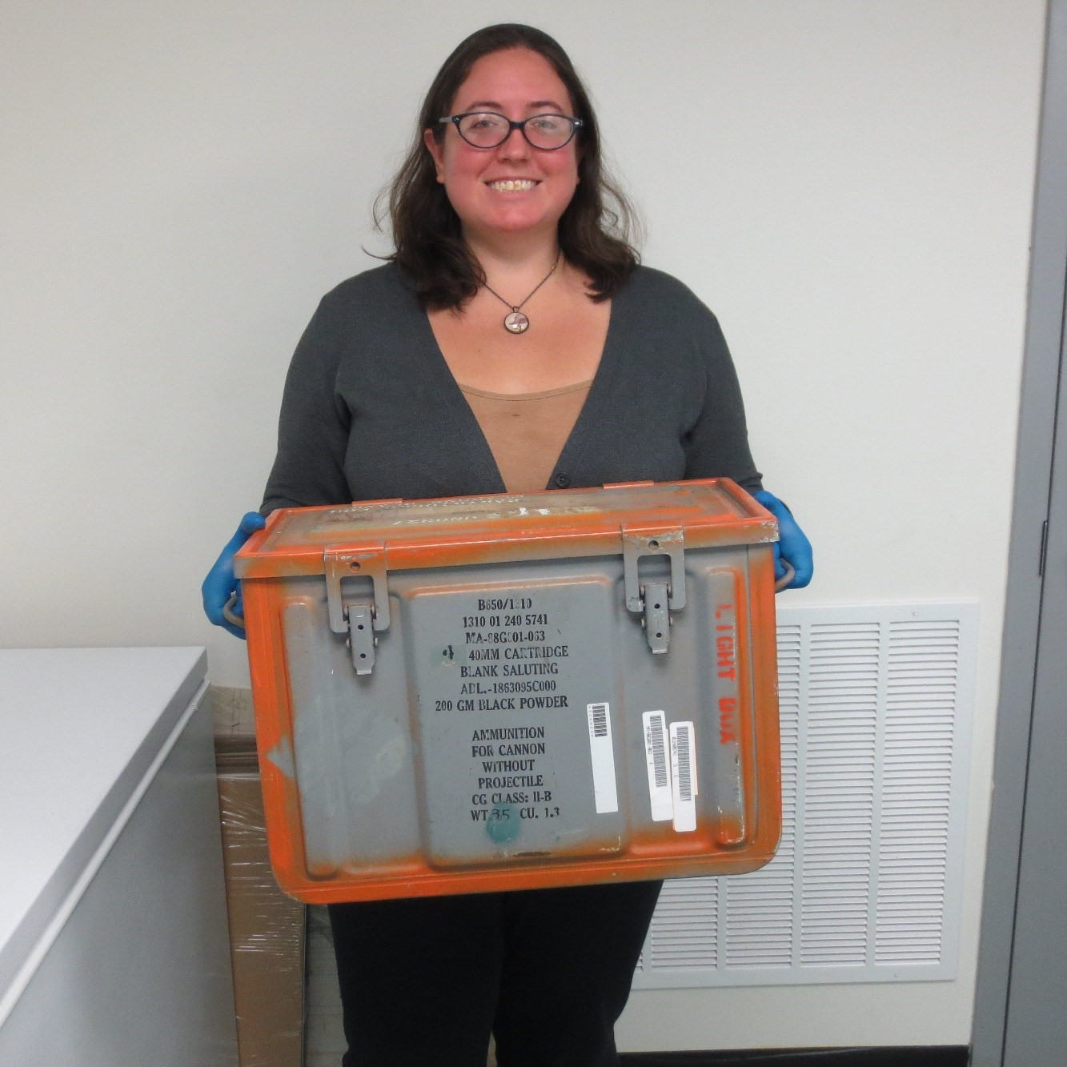  Ann Stegina  Senior Collections Manager,  Anchorage Museum | Ann Stegina moved to Alaska in mid-2019 to be the senior collections manager at the Anchorage Museum. She started her museum career in 2009 and has worked as the senior collections manager at the Intrepid Sea, Air & Space Museum and registrar at the South Street Seaport Museum, both based in New York City. Ann has a BA from New York University in Anthropology and Spanish. She earned her MA in Museum Studies from Johns Hopkins University. She is an enthusiastic learner and interested in under-told histories.
Webinar(s) | Intro Session: Get Inspired!

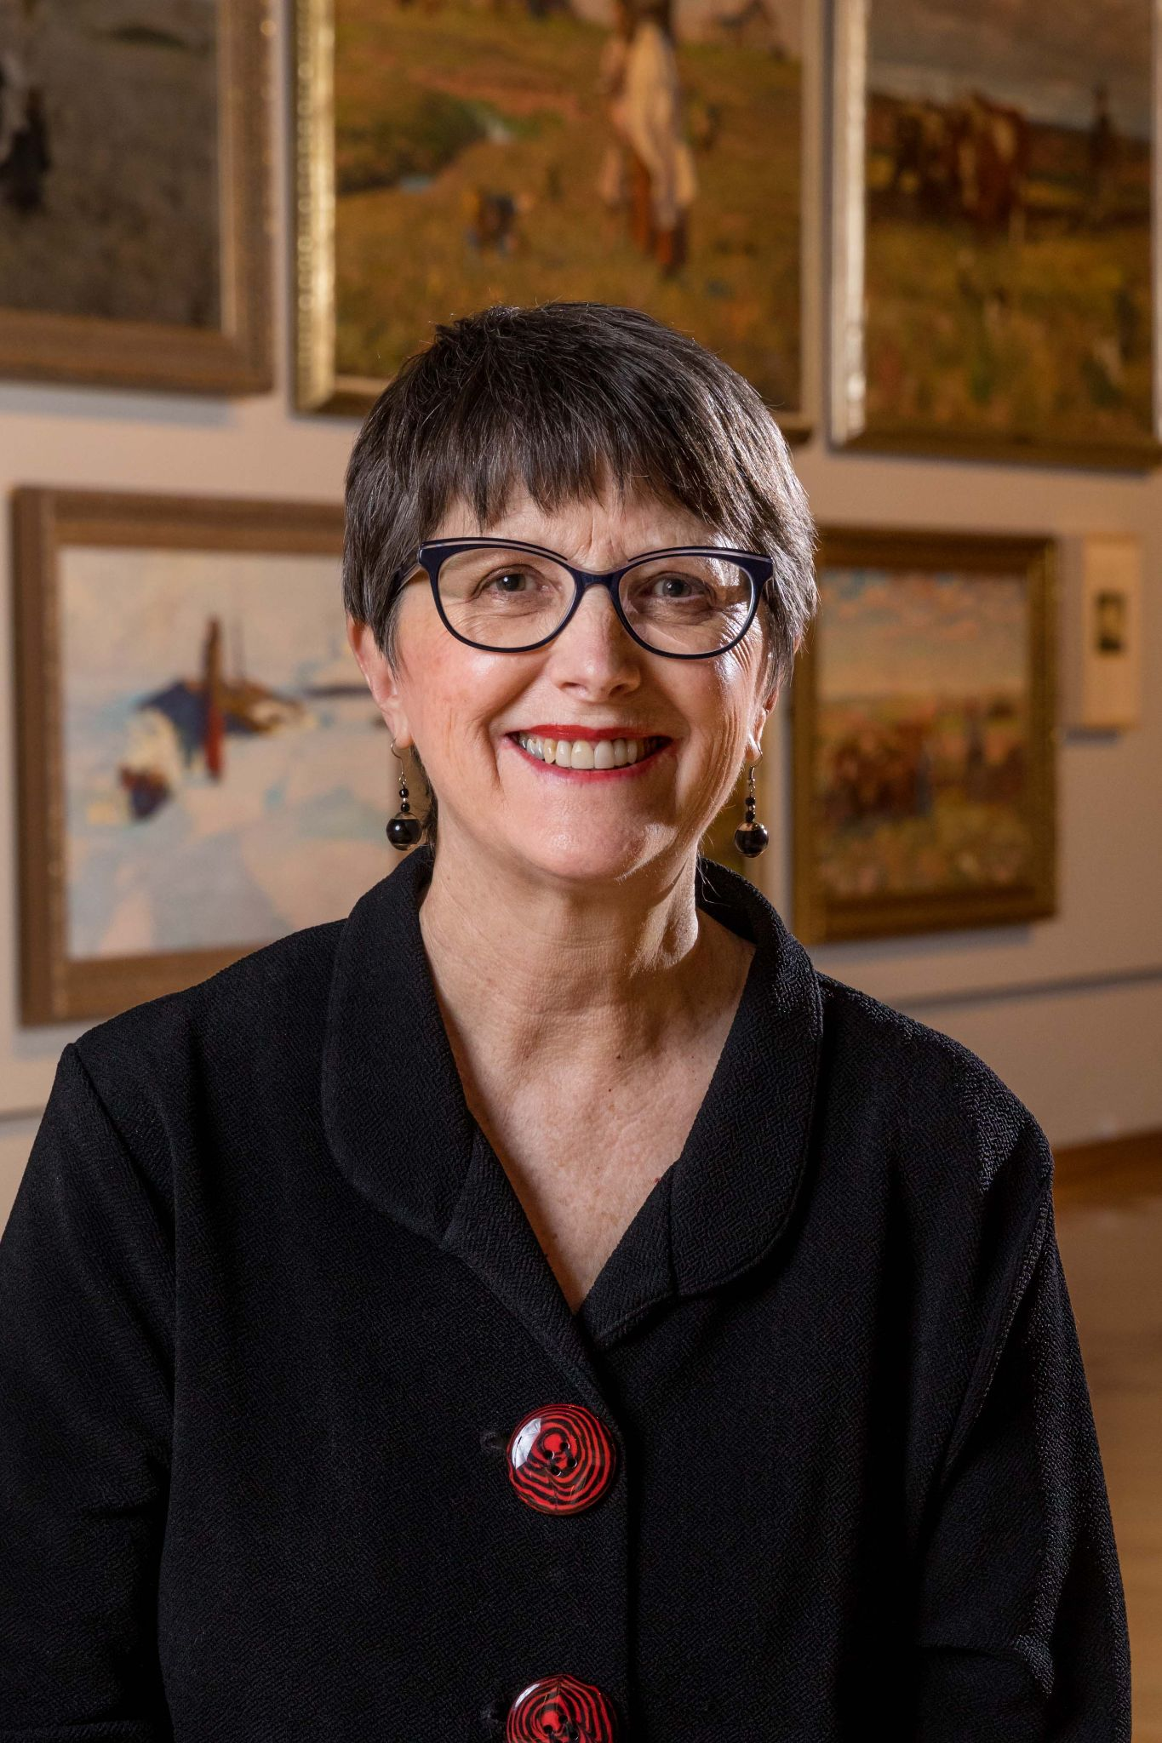Carolyne Hart  Marketing and Membership Coordinator,  South Dakota Art Museum | Carolyne Hart joined the museum staff in April 2017, moving from Fort Collins, Colorado to lead Marketing and Membership Development. Her focus is raising the museum’s visibility as a tourist destination and in the art community, and as a favorite place for locals and SDSU students and staff to come with family and friends. Also important is developing membership and sponsorship programs that encourage people to support the museum financially and with their time and influence.  Finding creative ways to communicate and connect people has been the hallmark of Carolyne’s career. During her 24 years with Hewlett Packard (HP), Carolyne led strategic marketing and business development project teams throughout Asia, Europe and the United States. In 2007, she followed a creative passion, launching Pressed In Press® where she designed and published devotional gift books featuring her own photography and over 50 family heirloom books that honor past generations, preserve memories for current generations and impart vision to future generations.  Most recently Carolyne served as the Director of Social Media and Digital Marketing for IBEC Ventures, a consulting firm for businesses creating jobs in impoverished communities throughout Asia and Africa. Her interest in international business and culture was sparked early in life, growing up in Ames, Iowa in a family of travelers (including her mother, retired SDSU faculty member, Harriet Swedlund). Carolyne pursued that interest earning degrees in Far Eastern Studies from The University of Chicago and Business Administration from Stanford Graduate School of Business as well as doing thesis research at London Business School and The East West-Center in Hawaii.
Webinar(s) | Intro Session: Get Inspired!

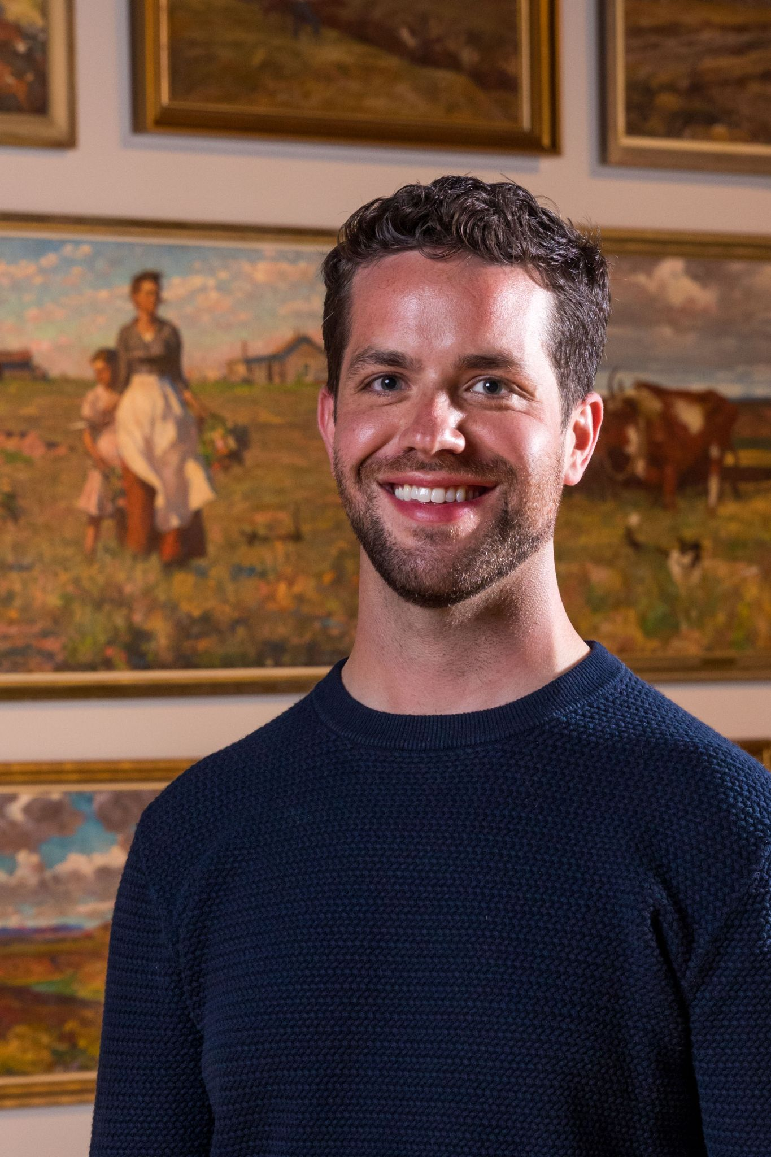Taylor McKewon  Collections Curator,  South Dakota Art Museum | Taylor McKeown is a curator interested in the rich art history of the Northern Great Plains. As Coordinator of Collections at the South Dakota Art Museum, McKeown focuses on curating, preserving, and providing access to the Museum’s permanent collection. He holds an undergraduate degree in history from South Dakota State University, and a graduate degree in museum studies from Johns Hopkins University.
Webinar(s) | Intro Session: Get Inspired!

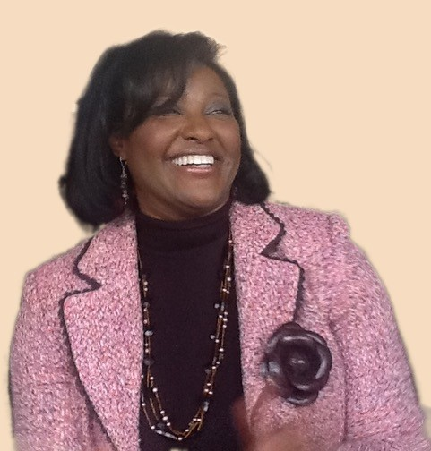Dr. Rhonda D. Jones  Community Digital Archivist, Special Collections/University Archives,  The University of North Carolina-Greensboro | Working at the intersections of Public History and archives, Dr. Rhonda D. Jones is an international scholar who specializes in cultural memory and digital heritage informatics. Currently working as a Community Digital Archivist at Special Collections and University Archives at the University of North Carolina-Greensboro, she is passionate about reducing barriers to information by addressing the capacity gaps of cultural heritage traditions in underrepresented communities. Whether the task is teaching, conducting research, scheduling programs, audience engagement, public relations, or public speaking, her work centers on managing innovative research projects that help individuals and community organizations document and preserve their own history.
Webinar(s) | Technical Workshop 1: Digitization: Strategy and Purpose

Lindsey Richardson  Owner,  Museum Person | Lindsey Richardson has more than 20 years' experience working with museum collections in all kinds of museum settings, including history, art, university, municipal, historic house and children's museums. She has planned and implemented major collections projects involving digitization, cataloguing, moving to other locations, deaccessions, inventory and rehousing, as well as written grants to fund those projects. Lindsey also consults with museums about strategic planning, collections and digital collections assessments, grant-writing and interpretive projects such as exhibits or object-based programs. She has anthropology degrees from Harvard and Oxford, and has worked with museums on three continents. To learn more please visit her website: museumperson.com.
Webinar(s) | Technical Workshop 2: How to Build a Digitization Project

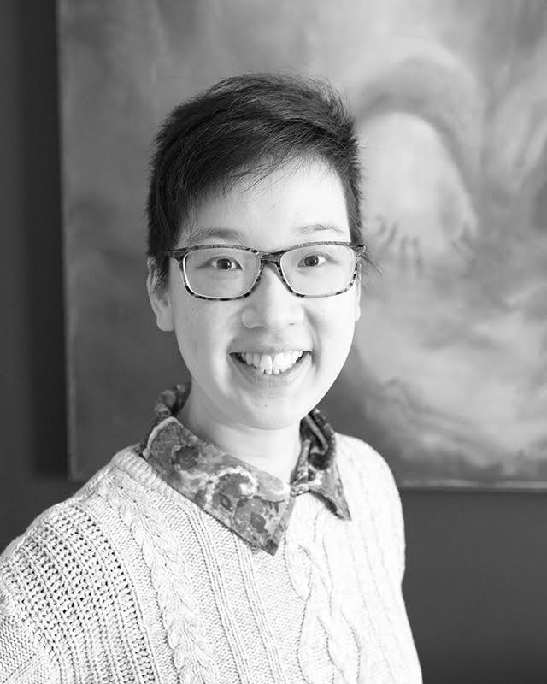Elizabeth Chiang  Staff Photographer,  George Eastman Museum | Elizabeth Chiang is a professional photographer who specializes in cultural heritage imaging. With over fifteen years of experience in non-profit and private sectors, Elizabeth has extensive expertise in studio photography, image colour management, and has an ongoing interest in streamlining digitization workflows. She is currently the staff photographer at the George Eastman Museum, where she manages the studio and is in charge of digitization initiatives at the museum. Elizabeth is a member of the Rochester chapter of the Society for Imaging Sciences and Technology. She holds a Masters of Arts in Photographic Preservation and Collections Management from Ryerson University.
Webinar(s) | Technical Workshop 3: Imaging Standards and Logistics in Digitization Projects

Created by the Museum Learning Hub.
Made possible by the Institute of Museum and Library Services.

Supplemental Resources

These supplemental resources are designed to deepen your understanding on the module’s subject matter and help you to complete this module to the best of your ability.

Articles
- How to detect Facebook Metadata Link
- Four Foundations Team Up to Buy the Historic Archives of ‘Ebony’ Magazine for $30 Million in a Bankruptcy Sale
- Overwhelmed to action: digital preservation challenges at the under-resourced institution
- From Theory to Action: Good Enough Digital Preservation for Under-Resourced Cultural Heritage Institutions

Websites
- General Digital Collection Resource Sites:
  - Library of Congress Digital Preservation
  - Digital Library Federation (DLF)
  - Council on Library and Information Resources (CLIR)
  - National Archives Records Administration (NARA)
  - Sustainable Heritage Network
  - Maryland Institute for Technology in the Humanities (MITH)
  - Portal to Texas History - technology
  - Metadata encoding and transmission standard
  - The endangered archives programme (EAP)
  - Digital Print Preservation Portal
- Collections Content Management:
  - PastPerfect
- Open-source content management systems:
  - Mukurtu CMS
  - Omeka
  - Reclaim Hosting
  - Scalar
  - Storymap JS
  - Timeline JS
  - Islandora
- Photo scanning apps:
  - SnapSeed
  - Google Photos scan (free)
  - Adobe Bridge for editing (free)
- Digitization Vendors
  - Colorlab (film and video digitization)
  - Crowley (image digitization)
  - George Blood Audio (audio recordings)
- Digitization Training
  - “Digital Directions” - NEDCC annual conference
  - Lyrasis Learning Catalog
  - Digitization Cost Calculator
- Cloud Storage for Museum Collections
  - Preservica
  - Amazon
  - Shared Shelf
- Grants
  - IMLS Museums for America
  - NEH Preservation Assistance Grants
  - CLIR Digitizing Hidden Special Collections and Archives
  - NEDCC-provided list of grant opportunities
- Photo Editing Software
  - Adobe creative suite
  - GNU Image Manipulation Program
  - Capture One

Guides & Books
- Federal Agencies Digital Guidelines Initiative
- Digital History: A guide to gathering, preserving, and presenting the past on the web
- Still Image Working Group Technical Guidelines for Digitization Cultural Heritage Materials
- Capture your Collections, Training Course
- Dublin Core Metadata Initiative - basics
- Copyrights, Rights and Reproductions
  - Society of American Archivists Copyright and Unpublished Materials
  - Association of Art Museum Directors Guidelines for Use of Copyrighted Materials and Works of Art by Museums
  - Rights statements for cultural institutions
  - The Handbook: Rights and Reproductions
- NEDCC - Fundamentals of AV Preservation online textbook
- Digital Preservation Handbook
- Digital Preservation: A Planning Guide for the Five Colleges by the Five College Consortium
- Stanford - File Naming Best Practices
- Library of Congress - Metadata Standards and Best Practices
- Imaging/Photographic Laboratories and Studios Paints and Laminates Reflectance Spectra
- Rijksmuseum Manual for the photography of 3D objects

Media
- SD Art Museum exhibit: “50 Works for 50 Years Collections Retrospective”
- Digital Collections:
  - Smithsonian open access
  - Anchorage Museum Collection database
  - Anchorage Museum Library
  - Alaska’s Digital Archives
  - Anchorage Museum Archive Image Search
  - American Folk Art Museum Archives
  - N.C. Runaway Slave Advertisements
  - Gateway:
    - Pride of the Community
    - Well Crafted NC
- Shared collections online
  - Online Archive of California
  - Digital Public Library of America

Related Training

Interested in learning more on related topics?

On the Museum Learning Hub, you’ll find a variety of free sessions, workshops, and resources that are similar in subject matter and content. We recommend the following Museum Learning Hub sessions and modules:

Digital Accessibility and Inclusion | Digital accessibility ensures access to information and all functions of digital tools, irrespective of a person’s specific needs. This module will provide training on how to integrate accessibility and inclusion into digital programs, social pages, and websites.

How to Create/Present Virtual Exhibitions | Digital exhibitions can offer unprecedented access to museum collections that might never be seen otherwise except by those with physical access. This module will explore how to build an online exhibition and introduce open-source and free software tools available to create exhibition narratives and layouts for online display

How to Digitize 3D Collections | There are many advantages to the digitization of museum collections including making collections more accessible and providing an option for museum professionals to handle and examine replicas of fragile artifacts, aiding in long-term preservation. The first step to starting any digitization work is to scan an object. This module will focus on the particulars of scanning three-dimensional objects and volumetric spaces.

