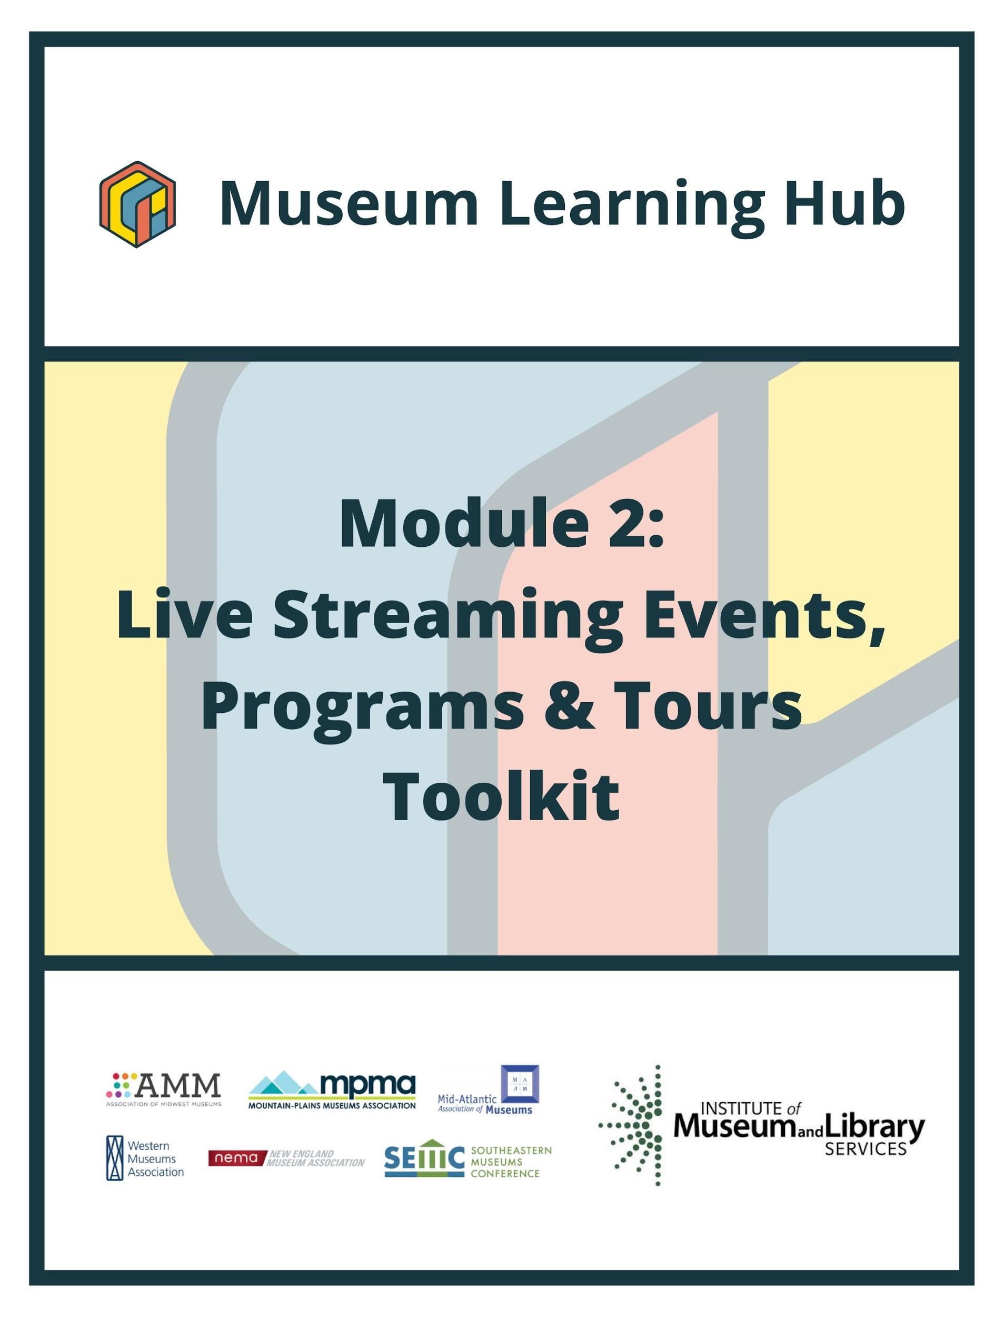
Table of Contents

- About This Module
- Learning Objectives
- Module Contributors
- Supplemental Resources
- Related Training

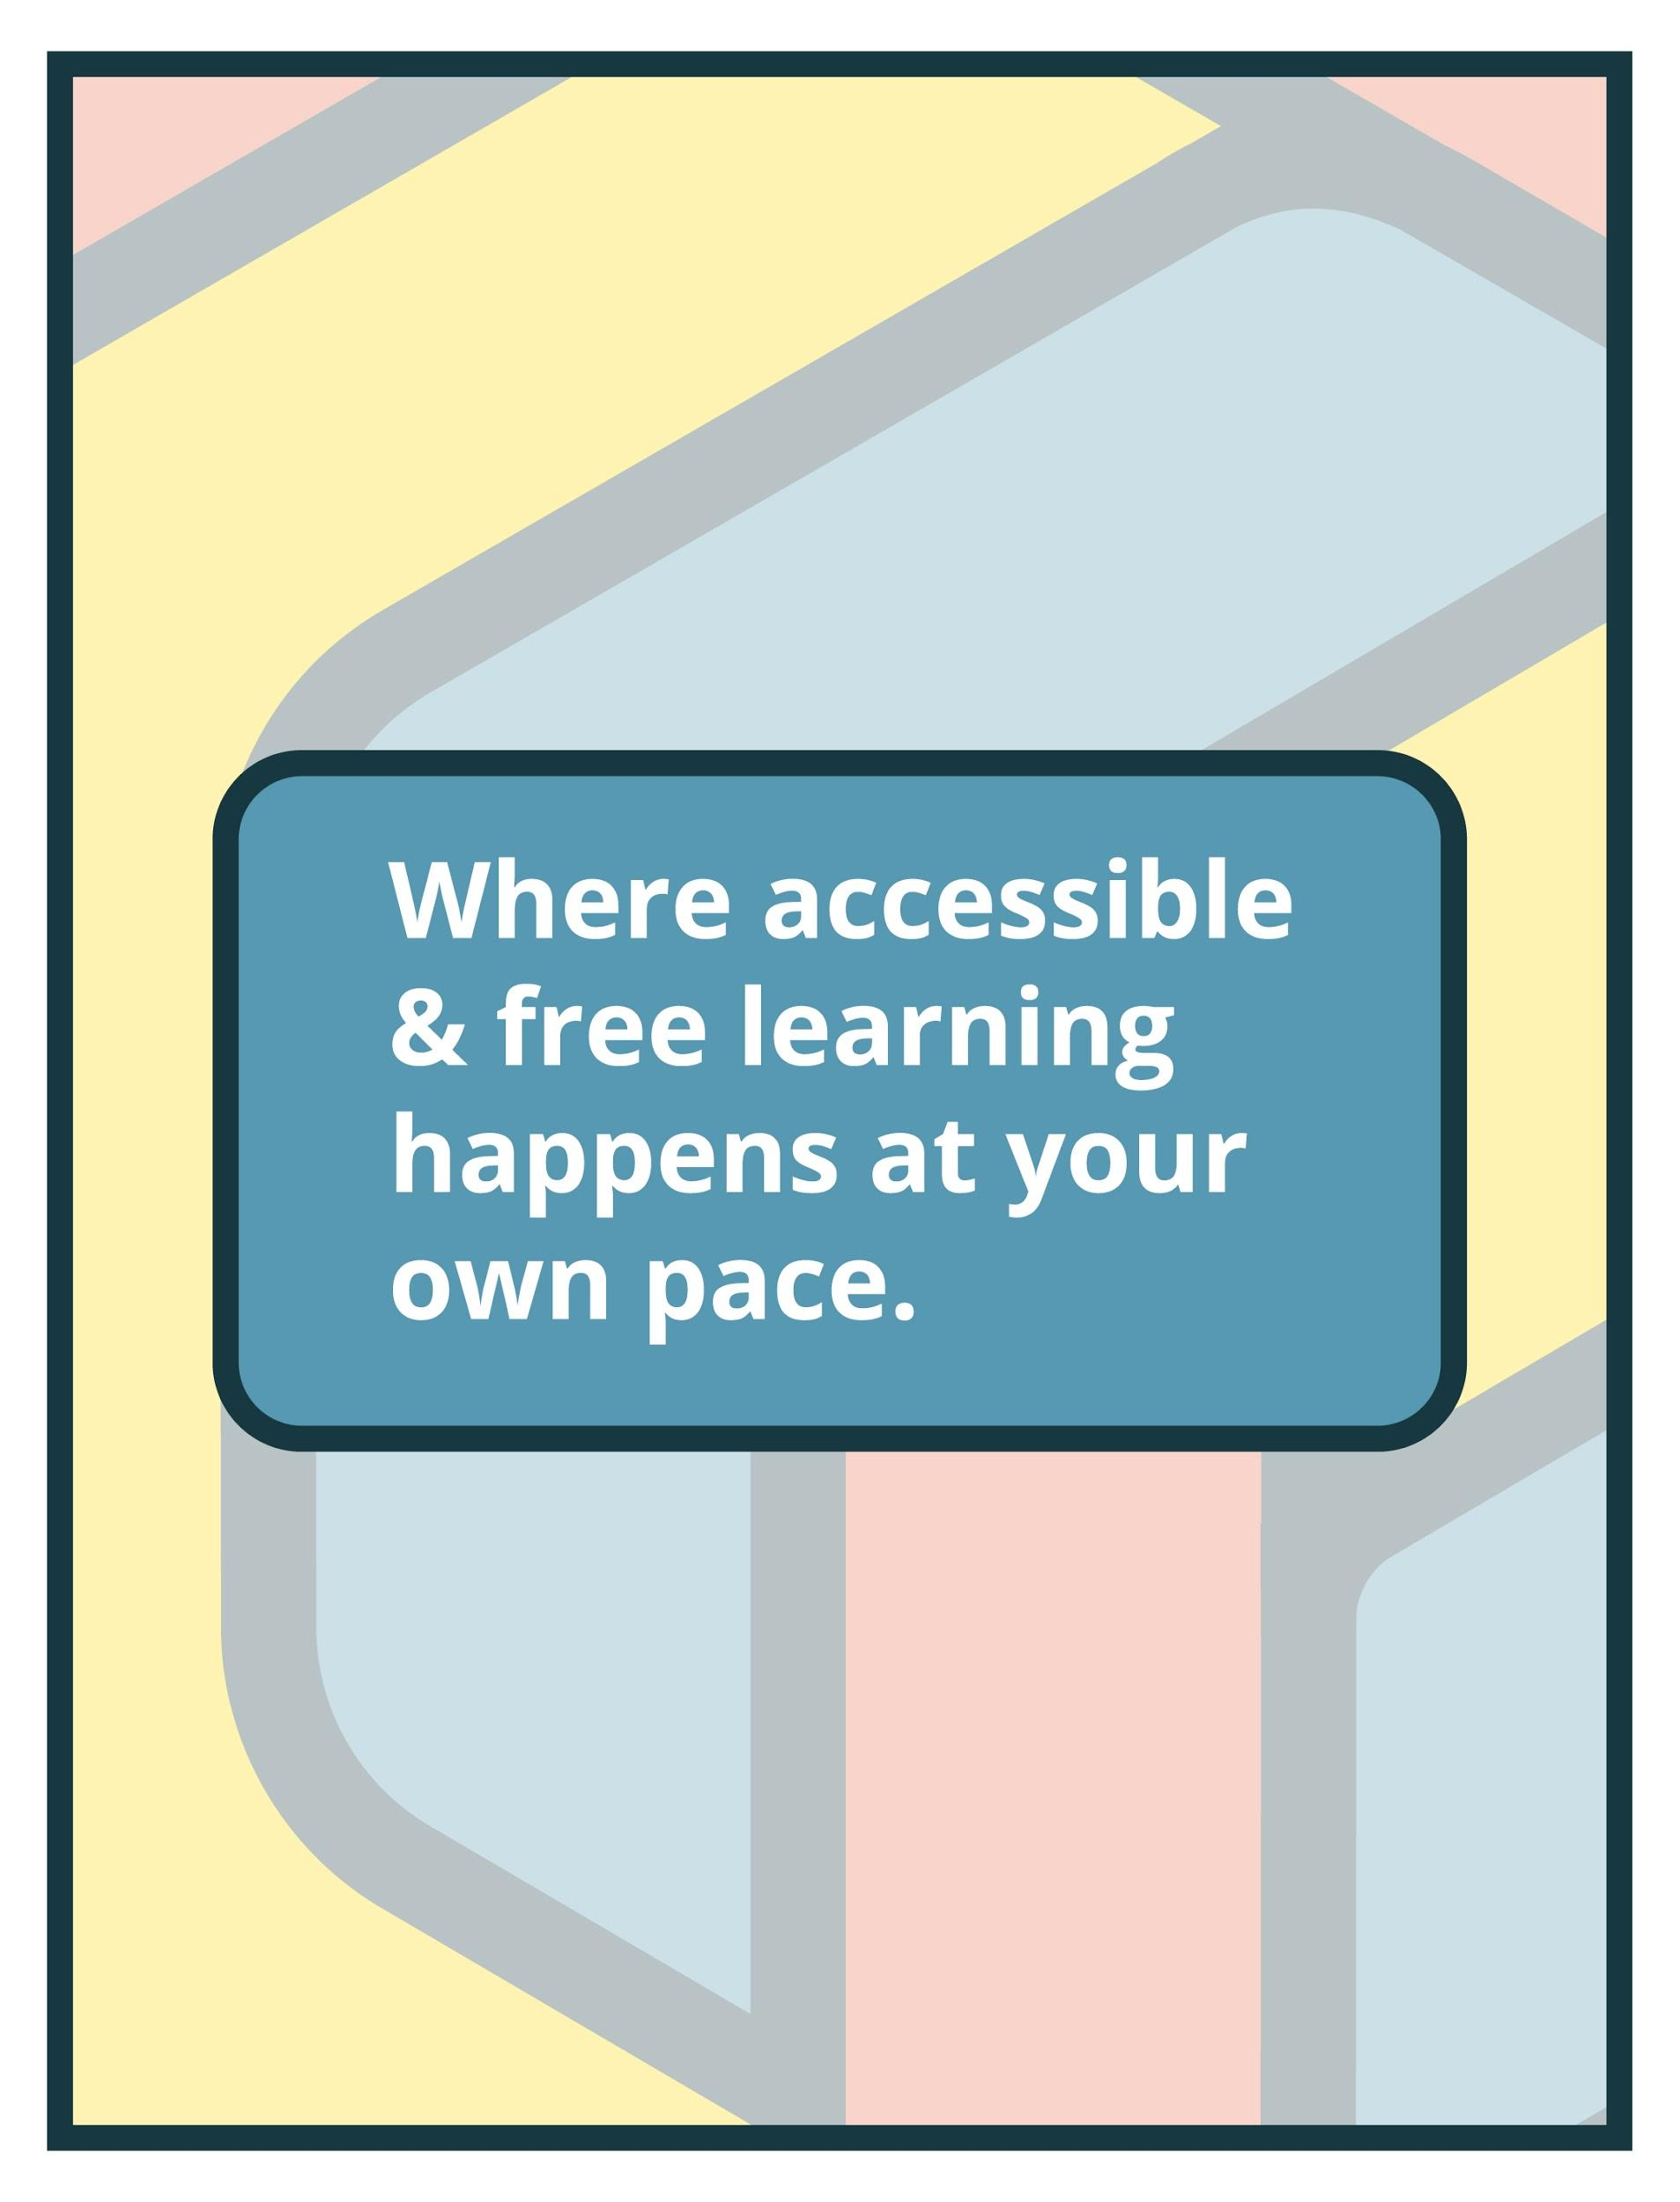

About This Module

Focus Area: | Live Streaming Events, Programs, and Tours
Learning Level: | Beginner, Intermediate, and Advanced
Module Description: | Attendees will learn about streaming solutions, broadcasting equipment, how to set up and customize a live stream event (including how to monetize), how to produce and stream pre-recorded material along with live presenters, as well as more advanced options for controlling live event production and virtual tours. Instructors will also offer accessibility considerations.
Search Terms: | Streaming, Live Presentations, Virtual Events, Accessibility, Broadcasting

Sessions found in this Module:
Intro Session | Get Inspired!
Technical Workshop 1 | Intro to Live Streaming
Technical Workshop 2 | Audience Participation in Live Streamed Programs
Technical Workshop 3 | Live Streaming with Multi-Source Content
The views, findings, conclusions or recommendations expressed in this series and toolkit do not necessarily represent those of the Institute of Museum and Library Services.

Learning Objectives

Upon completion of this module, you will have gained the skills and practical knowledge to successfully stream live events, produce and stream pre-recorded material, and advanced options for controlling live event production and virtual tours.

Intro Session | Attendees will learn about streaming solutions, broadcasting equipment, as well as. Instructors will also offer accessibility considerations.  Seeking inspiration to tackle a live streamed event or virtual tour? Join this introductory session to hear from museum staff who successfully developed live virtual programs, tours, and events with small budgets and basic technology tools. Presenters will discuss virtual tours and live-streamed, collaborative community events with focus on project details including creative partnerships, intended audiences, translating physical into virtual experiences and the life cycle of virtual events.

Technical Workshop 1 | How to set up and customize a live stream event (including how to monetize)  The first workshop in Module 2: Live Streaming will focus on tools, technologies, and tips for one-way live streamed broadcasts and will lay the groundwork for more complicated streaming needs and audience interaction. During this workshop, learn about available tools and technologies available for live broadcasts involving presenters and simple, pre-recorded content and how to get started. Our instructor will outline basic equipment needed for live streamed programs and events, options for captioning and other accessibility considerations, and an overview of factors that can affect live streaming success or quality. In addition, our instructor will offer comparisons of platforms and their features and common setup considerations across all platforms.

Technical Workshop 2 | How to produce and stream pre-recorded material along with live presenters  The second workshop in Module 2 will address technologies and tools that enhance audience participation and interaction in live streamed programming. Learn more about when and how live stream features such as chats and breakout rooms can be used alone or in combination with other available online tools to provide a participatory virtual experience. Gather best practices and tips for live audience participation (with or without audio and video) and how to manage the logistics of interactive live-streamed programs and events.

Technical Workshop 3 | More advanced options for controlling live event production and virtual tours  This workshop will be a deep dive into streaming virtual tours and events using multi-source content. Learn tools to manage multi-layered presentations using live production studio software to combine pre-recorded media and live presenters, including sign language interpreters. The session will offer insight and training on specific software that have been vetted and used by others and will provide a deeper understanding of live mixing tools, and available technology. A variety of hardware considerations will also be discussed.

Module Contributors

These are the experts and presenters who are involved in the development and presentation of each session, workshop, resource, and activity you find within this module.

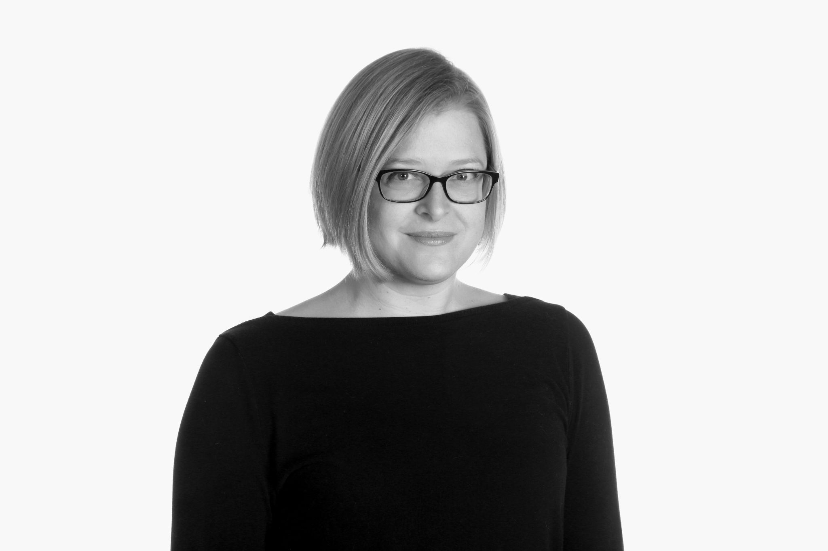  Kristi McMillan  She/Her | A professional art museum educator since 2003, Kristi McMillan joined the Asheville Art Museum's staff in 2015. In her role as director of learning & engagement, she plans and implements programs for college-age through older adults, including tours, talks, classes, films, performances, travel, and more. She also oversees the learning & engagement team, internship and docent programs, and has particular interests in interpretation, accessibility, collaboration, and technology. She holds an undergraduate degree in art history and French, and a graduate degree in art history, from the University of Virginia.
Webinar(s) | Intro Session: Get Inspired!

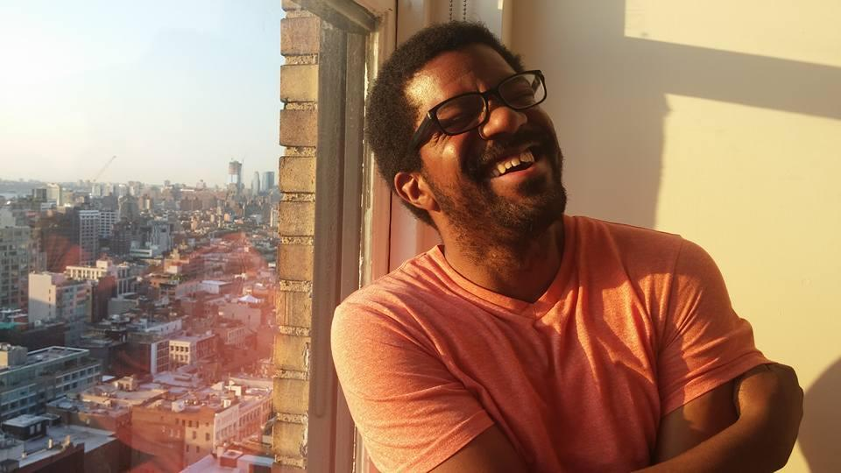  Ross Stanton Jordan  He/Him | Ross Stanton Jordan is a curator interested in the confluence of politics, history, and visual culture. As Interim Director and Curatorial Manager at the Jane Addams Hull-House Museum, Ross supports the production of exhibitions and programs that connect the social justice issues of the past to the present via collaboration with artists who work with the community. He holds dual master’s degrees in art history and arts administration and policy from the School of the Art Institute of Chicago.
Webinar(s) | Intro Session: Get Inspired!

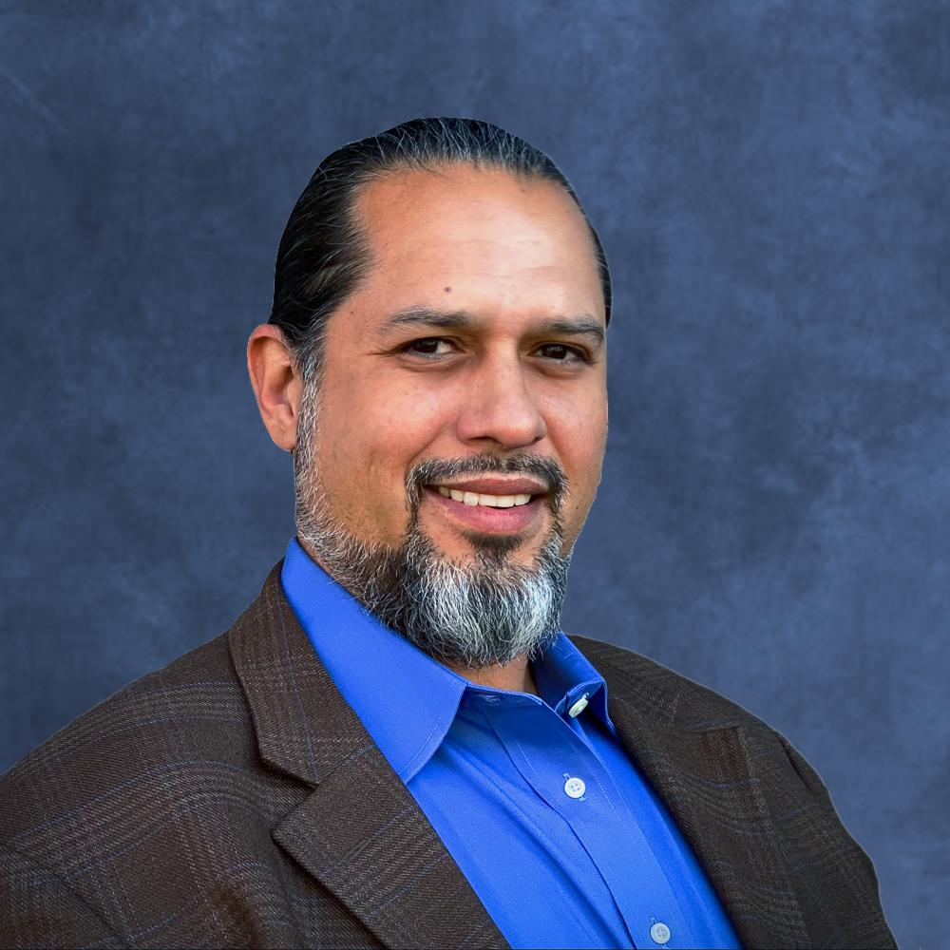  Alex Freeman  He/Him | Alex Freeman is the Executive Director of the Texas Association of Museums. Since 2012, Freeman's work has focused on how new technologies impact teaching and learning in formal and informal learning spaces. Prior to TAM, he served nearly 6 years at the New Media Consortium in a variety of capacities. At the NMC, Freeman served as the Senior Director of Membership and Special Projects where he managed membership services, produced online professional development programs, and was a co-author and researcher for the NMC Horizon Report series, which analyzed technology uptake across global museums, higher education, K-12 education, and a few other sectors and regions. Prior to the NMC, he was the Education Director at Mexic-Arte Museum in Austin and Education Curator at Artpace San Antonio.
Webinar(s) | Technical Workshop 2: Audience Participation in Live Streamed Programs

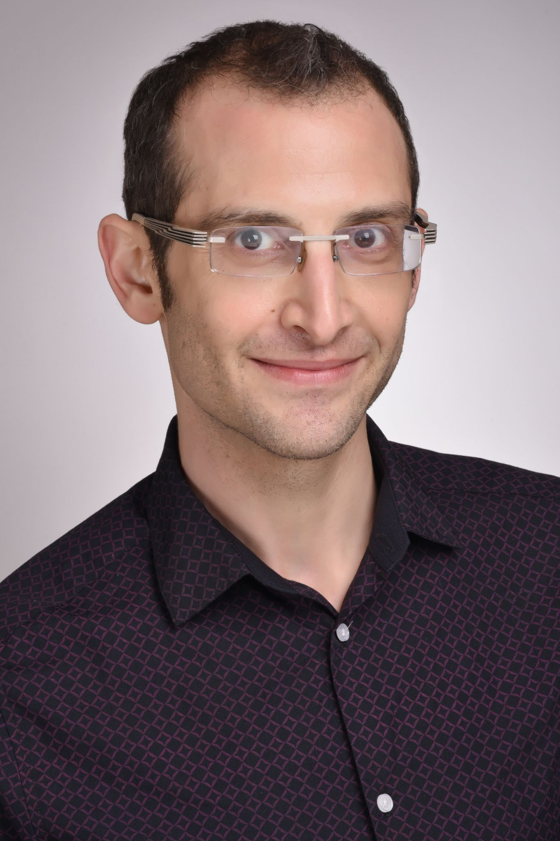  David London  He/Him | David London is curator, storyteller, magician and producer based in Baltimore, MD, who has spent over 15 years creating theatrical and interactive experiences designed to spark the imagination and inspire new ways to see and engage with the world around us. After discovering that he was a magician at 7 years old, he has since spent over 20 years utilizing magic to tell stories and explore ideas. He has created 10 original theatrical magic productions, and regularly presents talks and workshops on both magic and “the show business” across the country. In the last several years, David has shifted his energies to using his unique form of storytelling to illuminate history. Recently, he served as guest curator at the Jewish Museum of Maryland for INESCAPABLE: The Life & Legacy of Harry Houdini, and also created HUMBUG: The Great P.T. Barnum Seance and Traveling Museum, both of which are now touring the country.
Webinar(s) | Technical Workshop 1: Intro to Live Streaming,  Technical Workshop 3: Live Streaming with Multi-Source Content

Created by the Museum Learning Hub.
Made possible by the Institute of Museum and Library Services.

Supplemental Resources

These supplemental resources are designed to deepen your understanding on the module’s subject matter and help you to complete this module to the best of your ability.

Articles
- Ithaka S+R: To Survive This Pandemic, Some Museums are Pivoting to Virtual Engagement
- Cuseum: Tips for Choosing a Webinar Platform for your Museum or Organization
- Art Museum Teaching: What Might Museums Look Like in the Future? NMC Virtual Symposium
- Museum Hack
  - The Only List of Icebreaker Questions You’ll Ever Need
  - 37 Best Virtual Team Building Activities for Remote Teams in 2021
- Entrepreneur: 25 Ways to Make Your Zoom Meetings Awesome!
- Thinking Museum: 6 quick-fire ways to improve your Zoom confidence
- Educause: Horizon Report: Museum Edition, 2010-2016
- Markletic: How To Host A Hybrid Event With Zoom?
- Harvard Business Review: Break Up Your Big Virtual Meetings
- GEM: Breakout Rooms
- Ryerson University: How to create polls in Zoom
- Valiant: Using a Virtual Whiteboard in Video Conferencing

Websites
- Third Thursdays / Asheville Art Museum
  - Coloring & Cocktails: https://www.ashevilleart.org/event/coloring-cocktails-2/
  - Artful Trivia: https://www.ashevilleart.org/event/artful-trivia-2/
  - Gamenight: https://www.ashevilleart.org/event/game-night/
  - BYO Craft Night: https://www.ashevilleart.org/event/byo-craft/
- Nonprofit Tech Marketplaces
  - TechSoup
  - NonProfit Rate
- American Alliance of Museums: EdCom
  - Distance Learning Database
- Broadcasting and Video Conferencing Services
  - Zoom
  - Zoom Webinar
  - Streamyard
  - StreamText
  - Manycam
    - Step-by-Step Guide to Start Using ManyCam for Beginners
    - Invite Guests with NDI, Picture-In-Picture, Virtual Backgrounds and More!
- Live Polling and Survey Tools
  - SurveyMonkey
  - PollEverywhere
  - Google
  - Qualtrics XM
  - Alchemer
- Whiteboard Tools
  - Microsoft
  - Jamboard
  - Mural
  - Miro
- 3D Scanning and Advanced Tour Assets
  - Direct Dimensions
  - Google Streetview Tour
  - 360 Video (Garden)

Guides & Books
- Museum Programs List
- Teambuilding Activities & Icebreakers for the Virtual Environment

Media
- Jane Addams-Hull House Museum Virtual Tour
  - Virtual Tour Partners
    - ColorWorld Creative (a graphic design firm): https://www.colorwordcreative.com/about
    - 8tiv Labs (Marketing & Advertising): http://www.8tivlabs.com/
- Presentation Slides: Ross Jordan, Jane Addams Hull-House Museum
  - Video
  - Audio
- Presentation Slides: Kristi McMillan, Asheville Art Museum
- #ZoomJam (making games through Zoom): Night at the Museum
- Hybrid Meeting with Zoom: How to Set Up Your Room
- Everson Museum of Art: Past Ceramic Object Study Sessions
- Teen Council Presents: ARTivism
- Abbe Museum: Digital AMIN
- Nasher Museum of Art at Duke University: Zoom Tours
- Peale Center
  - Tours: Virtual Tours
  - Utilizing Second Life 3D browsing software: Virtual Peale
- Matterport: Virtual Tours
- Baltimore Museum of Art: Sculpture Garden

Related Training

Interested in learning more on related topics?

On the Museum Learning Hub, you’ll find a variety of free sessions, workshops, and resources that are similar in subject matter and content. We recommend the following Museum Learning Hub sessions and modules:

Digital Accessibility & Inclusion | Digital accessibility ensures access to information and all functions of digital tools, irrespective of a person’s specific needs. This module will provide training on how to integrate accessibility and inclusion into digital programs, social pages, and websites.

Video Production Tools | Creating a quality online program does not require you to have the most expensive, top-of-the-line equipment. Nor do you have to hire a professional crew or go to film school. Techniques that are popular amongst experienced video production professionals have become available to beginners too. Affordable software and easy-to-use apps can empower anyone to unleash their creativity with video production. Whether a museum is interested in creating videos, virtual hands-on activities or interactive video lessons, there's no shortage of production tools to assist. This module will offer training and guidance on where to begin and cover available video production tools to move education programs and tours (pre-recorded and 360 videos) to a virtual realm.

Podcasts | For museum professionals working to connect their institutions with new and existing audiences, it can be hard to know where to focus limited time and resources. Podcasting, which requires very little outlay and can be launched from a small budget, has become an increasingly popular tool for museums to tell diverse stories and meaningfully engage audiences. This module will review podcast planning and implementation strategies and how museums can share what makes them unique through this engaging technology.

