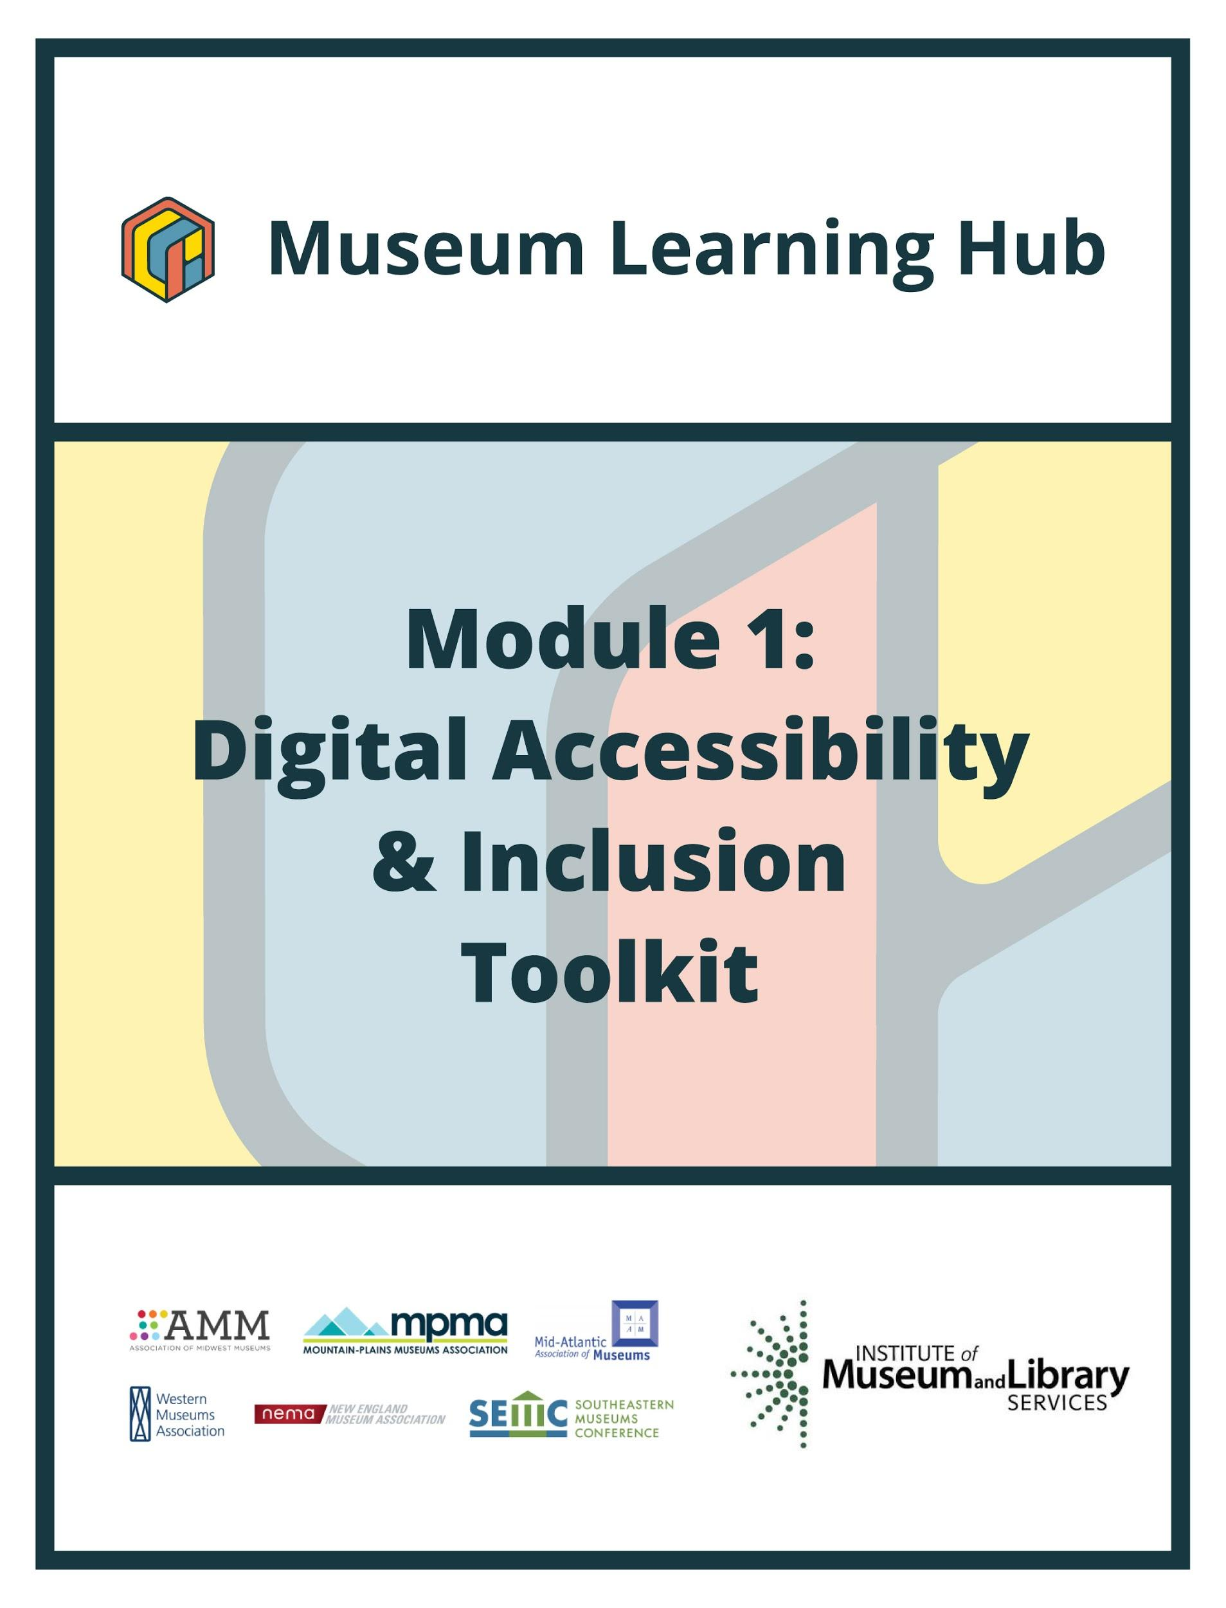

**Table of Contents**



* About This Module
* Learning Objectives
* Module Contributors
* Supplemental Resources
* Related Training

# 

# 

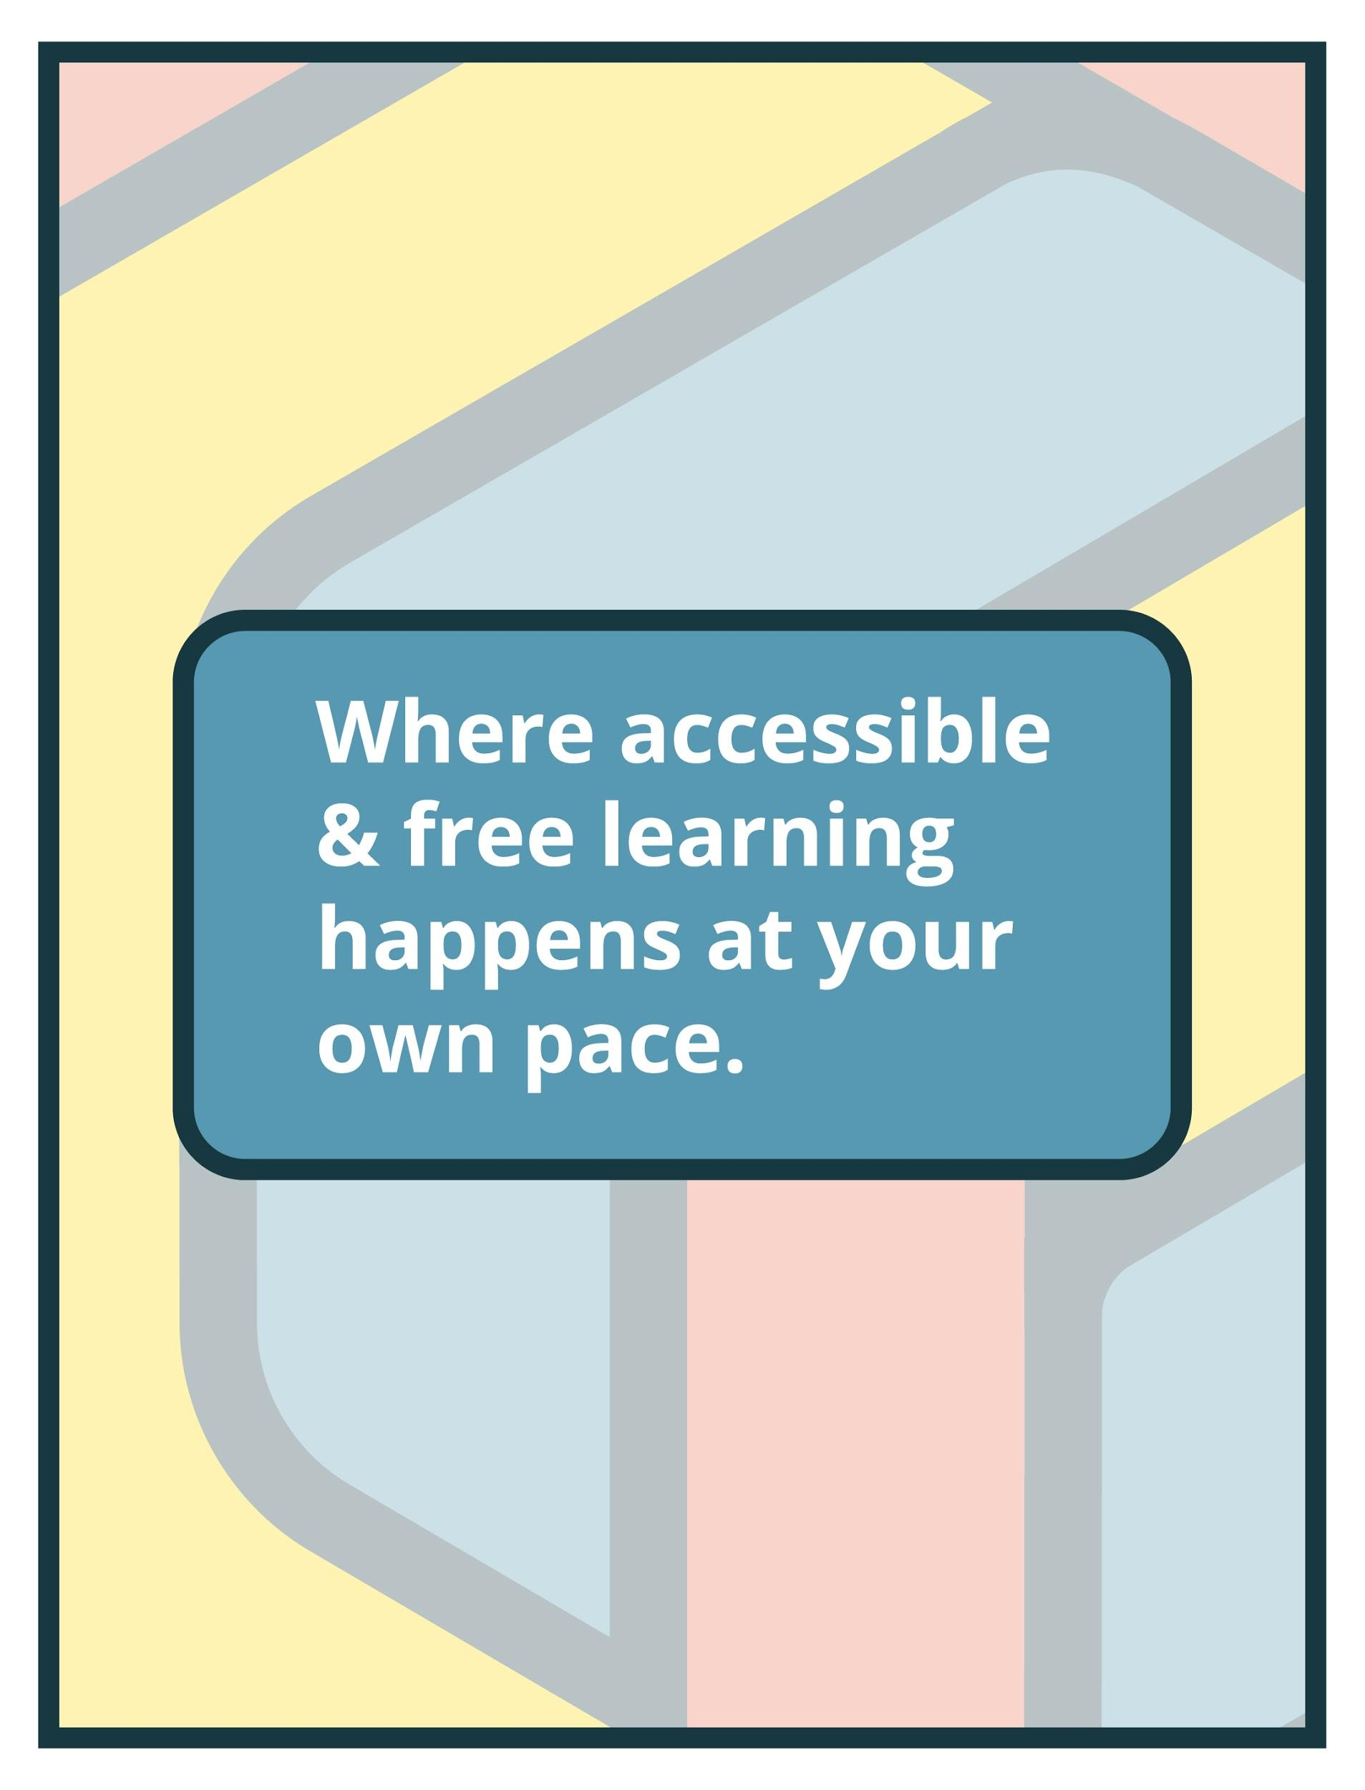

# About This Module

|  |  |
| --- | --- |
| **Focus Area:** | Digital Accessibility and Inclusion |
| **Learning Level:** | Beginner |
| **Module Description:** | Digital accessibility ensures access to information and all functions of digital tools, irrespective of a person’s specific needs. This module will provide training on how to integrate accessibility and inclusion into digital programs, social pages, and websites. |
| **Search Terms:** | Accessibility, Inclusion, Usability, Streaming, Collections, Programs, Exhibits, Design |

**Sessions found in this Module:**

|  |  |
| --- | --- |
| **Intro Session** | Get Inspired! |
| **Technical Workshop 1** | Intro to Digital Accessibility and Inclusion |
| **Technical Workshop 2:** | Live/Streamed Program Accessibility |
| **Technical Workshop 3:** | Accessibility in Digital Collections |

**The views, findings, conclusions or recommendations expressed in this series and toolkit do not necessarily represent those of the Institute of Museum and Library Services.**

# Learning Objectives

**Upon completion of this module, you will have gained skills and practical knowledge in digital accessibility, usability and design of digital programs and exhibits, and digital inclusion that ensures access for everyone to the greatest extent possible.**

|  |  |
| --- | --- |
| **Intro Session** | This introductory session brings together staff of small museums to share their approach to ensuring that their digital projects are accessible and inclusive of people with disabilities.  Learn about their organizations’ access journeys, discover how they pivoted during the pandemic, hear how they balance the wide-ranging accessibility needs of visitors - all while navigating limited budgets and staff capacities. |

|  |  |
| --- | --- |
| **Technical Workshop 1** | The first workshop will introduce best practices for a wide range of digital projects including web and social media. Instructors offer practical advice, tips and tricks for small museums who wish to identify areas for improvement in existing projects and/or implement inclusive and accessible design standards from the start. |

|  |  |
| --- | --- |
| **Technical Workshop 2** | The second workshop focuses on the ways that small museums can ensure that live-streamed and video programming are accessible to and inclusive of individuals of all abilities. Instructors address the pros and cons of different video platforms and how to incorporate live captioning, American Sign Language (ASL), image descriptions, and other services. |

|  |  |
| --- | --- |
| **Technical Workshop 3** | The final workshop focuses on digital collections. From the time an object is acquired, cataloged, entered in the database, to when and how it is published online, there are many opportunities to ensure that collections are accessible and encourage exploration and participation by all. |

# Module Contributors

**These are the experts and presenters who are involved in the development and presentation of each session, workshop, resource, and activity you find within this module.**

|  |  |
| --- | --- |
| **Robin Marquis**  **They/Them** | Robin Marquis is an artist, facilitator, disability activist and accessibility consultant. They have over a decade of experience leading initiatives, programming, and community collaborations with institutions of all sizes and people of all ages. Marquis currently serves as the Community Outreach Coordinator for Access Smithsonian and as the Accessibility Coordinator for The Peale Center. As an artist with a disability, Marquis is part of a national network of thought-leaders shaping the conversation about accessibility in the arts, while contributing to local efforts that combine creativity, education and activism to achieve positive social change. |
| **Session** | Intro Session: Get Inspired! |

|  |  |
| --- | --- |
| **Katy Menne**  **She/Her** | Katy earned her BA in History and Masters in Teaching Secondary Social Studies at the University of South Carolina. Since 2011 she has been teaching in formal and informal settings and joined the staff at NC Maritime Museum at Southport in 2018 as the Curator of Education. She started inclusion and diversity initiatives, spearheaded the museum becoming the first Certified Autism Center in the state of North Carolina, and has gained the distinction of Certified Educator by National Geographic. Menne was the 2020 recipient of Southeastern Museum Conference’s Emerging Museum Professional Award.  In addition to her job duties at the museum, she also serves on the Planning Committee Member for Able Buddies, Special Needs Community of Pender and Onslow County; Brunswick County Local Interagency Coordinating Council; Environmental Educators of North Carolina’s Diversity Equity and Inclusion Action Team; Southeastern Museum Conference's Equity and Inclusion Action Team Program Coordinator; North Carolina Museums Council Programs Committee and Assistant Communications Chair; and Community in Schools Board of Young Professionals. |
| **Session** | Intro Session: Get Inspired! |

|  |  |
| --- | --- |
| **Meredith Peruzzi**  **She/Her** | Meredith Peruzzi is a public historian and museum professional. Her primary research field is the history of Gallaudet University, and the history of deaf education and the deaf community in the United States. In addition to her work as a museum curator and administrator, she is a frequent consultant on the topic of making exhibitions and programming more accessible to Deaf visitors, which is the subject of her current PhD research at the University of Leicester. |
| **Session** | Intro Session: Get Inspired! |

|  |  |
| --- | --- |
| **Sina Bahram**  **He/His** | Founder of the inclusive design firm Prime Access Consulting (PAC), Sina Bahram is an accessibility consultant, computer scientist, researcher, speaker, and entrepreneur. In 2012, Sina was recognized as a White House Champion of Change by President Barack Obama for his doctoral research work enabling users with disabilities to succeed in Science, Technology, Engineering, and Math (STEM) fields.    Believing that accessibility is sustainable when adopted as a culture, not just a tactic, Sina and his team work with executive management, policy makers, engineering teams, content creators, designers, and other stakeholders within institutions to promulgate accessibility and inclusive design throughout the fabric of an organization. Under Sina's direction, PAC has helped over 100 organizations to meet and exceed their inclusivity goals, from the creation of accessible websites and mobile apps to achieving a comprehensive inclusive design methodology across the enterprise.    In addition to serving on and chairing various boards, conferences, committees, and working groups across corporate, non-profit, and research entities, Sina serves as an invited expert on the World Wide Web Consortium (W3C) Accessible Rich Internet Applications (ARIA) working group where he helps shape the next generation of digital accessibility standards and best practices. |
| **Session** | Technical Workshop 1: Intro to Digital Accessibility and Inclusion  Technical Workshop 2: Live/Streamed Program Accessibility  Technical Workshop 3: Accessibility in Digital Collections |

|  |  |
| --- | --- |
| **Corey Timpson**  **He/His** | Corey Timpson is an active collaborator and thought leader in the experience design and inclusive museum discourses within the cultural sector.    As Vice President, Exhibition, Research, and Design, at the Canadian Museum for Human Rights (CMHR) Corey was responsible for the direction and oversight of exhibition programs, research and curation, design and production across all media, digital platforms, and collections. As the project director for the design-build of the CMHR, his focus was on collecting and interpreting difficult knowledge and presenting it through a multi-sensory, inclusive, transmedia storytelling approach. Corey also championed the creation of and directed the museum’s internationally recognized inclusive design and accessibility practices.    Prior to his role at the Human Rights Museum, Corey led the design and architecture teams, and the Virtual Museum Labs Program, at the Canadian Heritage Information Network, working on projects of digital innovation with a large number of cultural institutions internationally.    Having collaborated with over 80 museums internationally, Corey’s primary focus is to facilitate dialogic and meaningful experiences among audiences (on-site and online) through mixed-media, digital technology, and inclusive environmental design. Emphasizing museological due diligence, his design leadership has accounted for over 30 international awards in the fields of environmental, exhibition, and graphic design, digital and interactive media, digital systems, film and linear media, and universal design. |
| **Session** | Technical Workshop 1: Intro to Digital Accessibility and Inclusion  Technical Workshop 2: Live/Streamed Program Accessibility  Technical Workshop 3: Accessibility in Digital Collections |

# 

|  |  |
| --- | --- |
| **Anna Chiaretta Lavatelli**  **She/Her** | Anna Chiaretta Lavatelli, the owner behind Solid Pink Productions, has been working in moving image for over 20 years as an artist, director, and producer. She has collaborated with museums across the country to create original content that illuminates the work of the most important artists and thinkers of our time.  In her previous position as the Director of Digital Media at the Museum of Contemporary Art Chicago she managed and developed digital content and platforms, including the creation of dozens of short documentary films, the redesign of mcachicago.org, and over a half dozen websites to support contemporary art scholarship and visitor engagement with artists and exhibitions. There, she also began a lifelong commitment to accessibility with the co-founding of the Coyote Project to improve access to artworks for people with low or no vision. Lavatelli is currently the digital strategist for MCN (The Museum Computer Network), while continuing to support Coyote and produce independent video projects. |
| **Session** | Technical Workshop 2: Live/Streamed Program Accessibility |

**Created by the Museum Learning Hub.**

**Made possible by the Institute of Museum and Library Services.**

# 

# Supplemental Resources

**These supplemental resources are designed to deepen your understanding on the module’s subject matter and help you to complete this module to the best of your ability.**

**Articles**

* American Alliance of Museums:
  + [How to start an accessibility movement at your museum](https://www.aam-us.org/2020/11/05/how-to-start-an-accessibility-movement-at-your-museum/?fbclid=IwAR0Bvo2ie2t0d19n8d0Fa4OdtvDw59ZhV3kIngqWVV-1kkDQP14AUJl8IPc)
  + [Mind the Accessibility Gap](https://www.aam-us.org/2020/09/04/mind-the-accessibility-gap/)
* Common Field: [Accessibility in the Arts: A Promise and a Practice](https://www.commonfield.org/projects/2879/accessibility-in-the-arts-a-promise-and-a-practice)
* MuseWeb: [How to Give an Accessible Presentation](https://www.youtube.com/watch?v=9n9KacDbpzw)
* Rooted in Rights: [How to Make your Virtual Events Accessible: Rooted in Rights](https://rootedinrights.org/how-to-make-your-virtual-meetings-and-events-accessible-to-the-disability-community/)

**Websites**

* Tools
  + [Amara: Free Subtitling Platform](https://amara.org/en/)
  + [WAVE: Web Accessibility Evaluation Tool](https://wave.webaim.org/)
* ADA National Network: [Resources and Training](https://adata.org/)
* WebAIM
  + [Web accessibility resources](https://webaim.org/resources/)
  + [Testing with Screen Readers](https://webaim.org/articles/screenreader_testing/)
* VocalEyes: [Visual Accessibility Resources](https://vocaleyes.co.uk/services/resources/)
* New York University: [Digital Accessibility Checklist](https://www.nyu.edu/life/information-technology/help-and-service-status/accessibility/accessibility-checklist.html)
* W3C: [Making Audio and Video Media Accessible](https://www.w3.org/WAI/media/av/)

**Guides & Books**

* Mozaic
  + [Inclusive Design Reading List](https://www.m4c.space/?page_id=139)
  + [Inclusive Design Glossary](https://www.m4c.space/?page_id=154)
* National Endowment for the Arts: [Design for Accessibility: A Cultural Administrator's Handbook](https://www.arts.gov/about/publications/design-accessibility-cultural-administrators-handbook)
* National Center on Disability and Journalism: [Style Guide](https://ncdj.org/wp-content/uploads/2018/10/NCDJ-styleguide-2018.pdf)
* Facebook: [Facebook LIVE caption guide](https://scontent-ort2-1.xx.fbcdn.net/v/t39.8562-6/66086585_1127049914146262_5362522782250827776_n.pdf?_nc_cat=100&ccb=1-3&_nc_sid=ae5e01&_nc_ohc=8MYWVdzc3oQAX9uPX1t&_nc_ht=scontent-ort2-1.xx&oh=16afe7a6502c74dbe3d0216ff94a113e&oe=608827A4)
* Zoom: [Closed captioning and live transcription](https://support.zoom.us/hc/en-us/articles/207279736-Closed-captioning-and-live-transcription)
* Cooper Hewitt: [Cooper Hewitt Guidelines for Image Description](https://www.cooperhewitt.org/cooper-hewitt-guidelines-for-image-description/)

**Media**

* Presentation Powerpoint: [Technical Workshop 1: Intro to Digital Accessibility and Inclusion](https://drive.google.com/file/d/1DlspVWOVEMsAhgsvT8KXadJu7uYI0V3u/view?usp=sharing)
* Presentation Powerpoint: [Technical Workshop 2: Live/Streamed Program Accessibility](https://drive.google.com/file/d/14IghfcqLvyNVVof_N3JFZpOM4jwa0k-9/view?usp=sharing)
* Presentation Powerpoint: [Technical Workshop 3: Accessibility in Digital Collections](https://drive.google.com/file/d/19V7pJMCLRJ87BeZdpCUaiJozZM35zDRd/view)

# 

# 

# Related Training

**Interested in learning more on related topics?**

**On the Museum Learning Hub, you’ll find a variety of free sessions, workshops, and resources that are similar in subject matter and content. We recommend the following Museum Learning Hub sessions and modules:**

|  |  |
| --- | --- |
| **Live Streaming** | Streaming presentations, programs and events has become an integral form of content delivery in our technology-driven and globally-connected society. Today, it’s possible for even the smallest museums and cultural institutions to record and present podcasts and live streamed events..  This module will cover the basics of live streaming and streaming pre-recorded programs, and help users understand the major parts involved in successful broadcasts. |

|  |  |
| --- | --- |
| **Virtual Exhibitions** | Digital exhibitions can offer unprecedented access to museum collections that might never be seen otherwise except by those with physical access.  This module will explore how to build an online exhibition and introduce open-source and free software tools available to create exhibition narratives and layouts for online display |

|  |  |
| --- | --- |
| **Video Production Tools** | Whether a museum is interested in creating videos, virtual hands-on activities or interactive video lessons, there's no shortage of apps and web-based tools to assist.  This module will offer training and guidance on where to begin and available digital tools to move education programs to a virtual realm. |

